Comments on Metropolitan Wastewater Treatment Plant Solids Management Improvements Project
Dale R. Lutz, Ph.D., Maplewood, MN, July 2023
SUMMARY: The Metro Wastewater Treatment Plant wastewater sludge incinerators should be modified to capture and “recycle” their anthropogenic AND BIOGENIC CARBON DIOXIDE (CO2), using existing technologies such as those described below.
BACKGROUND
In section 18 on page 45 of the Environmental Assessment Worksheet (EWA) document for this Met Council Wastewater Treatment Plant (St. Paul) 4th wastewater sludge incinerator project (found at mcpa.commentinput.com under “Ramsey County”) it states:
“Scope 1 Greenhouse gas (GHG) emissions from anthropogenic (man-made) sources were reported on the Metro Plant 2019 Air Emission Inventory Report. These emissions include only emissions from fossil fuel combustion at the Metro Plant and do not include biogenic greenhouse gases generated from treatment of wastewater or from carbon in the wastewater sludge.” (Emphasis added.)

The explanation for this accounting practice is given in Table 2 on page 10, as follows:

“Carbon dioxide emissions generated from sludge treatment at Metro Plant are biogenic (naturally
occurring). These emissions would be expected to occur regardless of how the sludge is treated.”

While this somewhat dubious approach simplifies accounting and reporting, it ignores the fact that addressing climate change requires quickly reducing the concentration of carbon dioxide (CO2) greenhouse gas in the atmosphere from the present 420+ parts per million (ppm) to at most 350 ppm, and preferably to the 280 ppm that existed before the Industrial Revolution. Technology now exists that can capture CO2 from point sources and “recycle” the carbon into needed chemicals and “electrofuels”. The proposed wastewater sludge incinerator provides an opportunity for “carbon negative” operation to offset other current emission sources, such as cement and steel making.

The draft “Metropolitan Solid Waste Management Policy Plan 2022-2042” stresses greenhouse gas emission reduction and openness to new technologies, as indicated by the quotes below.
“Purpose of this Plan (MPP)
… The MPP supports the goals of the WMA [Waste Management Act] hierarchy [Figure 4, copied below]; improving public health; reducing the reliance on landfills; conserving energy and natural resources; and reducing pollution and greenhouse gas emissions.” (Page 1, emphasis added.)
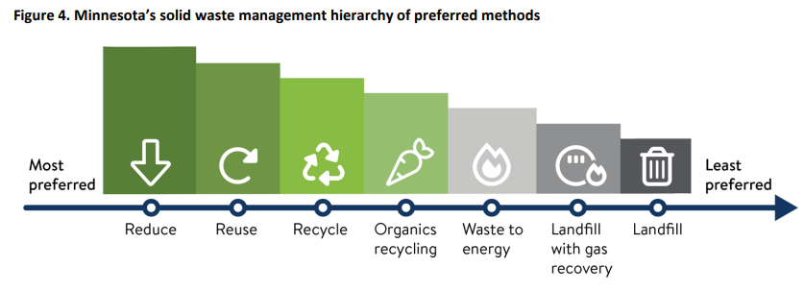
“Goal 1: Protect and conserve. Manage materials in a manner that will protect the environment and public health, reduce greenhouse gas emissions, conserve energy and natural resources, and reduce toxicity and exposure to toxics.” (Page 8, emphasis added.)
“Emerging technology
The solid waste system is evolving. … As a result, MPCA and others need more time to understand the new technologies to determine what permits they may need and how they may fit into the Solid Waste Management hierarchy.
An example is whether new technologies meet the technical requirements for recycling. If they do, this brings the benefit of tax-exemption status for facilities.” (Page 39, emphasis added.)

Capturing and recycling or sequestering the greenhouse gas carbon dioxide (CO2) from waste-to-energy facilities can qualify for federal 45Q tax credits, a possible state tax credit, and other incentives, including product sales.

New Technology: Waste-to-Energy with CO2 Recycling
One significant opportunity for reducing greenhouse gas emissions is to stop emitting carbon dioxide (CO2) greenhouse gas from Minnesota’s waste-to-energy (WTE) facilities, such as the Hennepin Energy Recovery Center (HERC), the Newport Recycling & Energy Center (R&E), and the incinerators at the St. Paul Metropolitan Waste Treatment Plant described in this project’s EWA. Technologies now exist (e.g., Chart Industries’ Cryogenic Carbon Capture, CCC) that enable capturing and purifying the CO2 produced in the WTE process. Chart’s website states that “CCC reduces carbon emissions by 95 to 99% with half the cost and energy of competing processes and also eliminates harmful SOx, NOx and mercury pollutants from flue gases.” Chilling the flue gas to condense the CO2 also causes several other pollutants to precipitate out of the gas stream. The liquified captured CO2 can then be transported in Chart Industries’ cryogenic trailers to a central processing facility, if necessary. The carbon atoms in the CO2 can then be recycled by combining the CO2 with “green hydrogen” (produced from water electrolysis in electrolyzers powered by renewable energy) to generate needed hydrocarbons. These hydrocarbons can include ethanol (e.g., from LanzaTech’s bioreactors), which in turn can be converted to sustainable aviation fuel (SAF) for use at the Minneapolis-St. Paul (MSP) airport, using the LanzaJet technology. A CO2-to-SAF facility could be built at or near the Flint Hills Resources Pine Bend Refinery in Rosemount, which already has a 1988 aviation fuel pipeline to the MSP airport. Additionally or alternatively, a CO2-to-SAF facility could be built at the St. Paul Park Marathon Refinery near the Newport Recycling & Energy Center, just across the river from the St. Paul Downtown Airport. CO2 captured from the incinerators at the St. Paul Metropolitan Waste Treatment Plant could be taken to either CO2-to-SAF facility.
Similarly, technology from MAN Energy Solutions can recycle captured CO2 to methanol and on to (renewable) gasoline. Using these “e-fuels” made from “recycled CO2” displaces conventional fossil fuels, leaving more fossil fuel underground by recycling the carbon that is already above ground. This principle is summarized in the diagram below, from the Renewable Carbon Initiative website at https://renewable-carbon-initiative.com/.
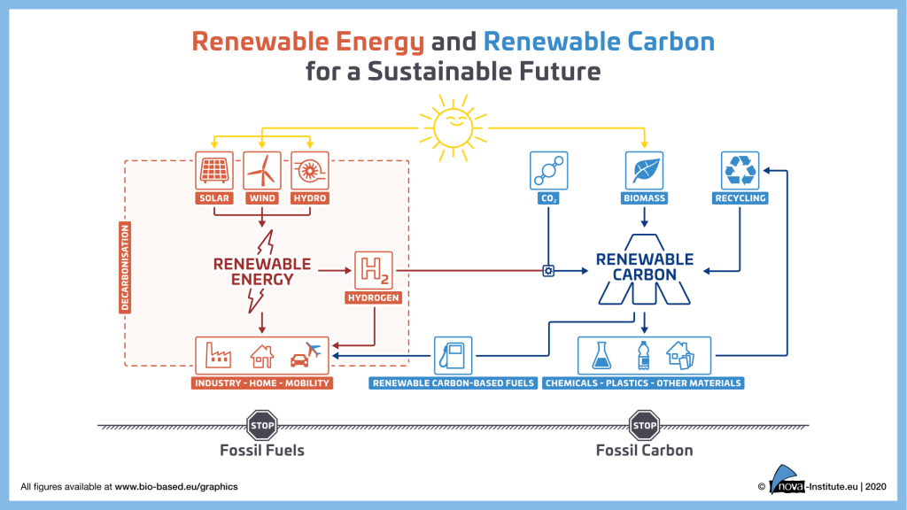
The electricity (and heat) generated by a waste-to-energy (WTE) facility can provide part of the energy needed to produce the “green hydrogen” for the CO2 recycling process. Converting a traditional WTE facility to a “CO2 recycling” facility should arguably raise the facility to the “recycling” level in the plan’s hierarchy.
For future systems, an alternative to typical waste-to-energy facilities is a partial oxidation or “gasification” system that produces “syngas”, a key starting material for many chemical processes. LanzaTech has demonstrated using gasification of municipal solid waste (MSW) to produce ethanol in Japan. This ethanol could provide the starting material for other chemicals or e-fuels. The draft plan only mentions one version of gasification briefly, on page 40.
Proposal to Fund an Engineering and Design Study
I have been working with some local nonprofit organizations and my state representative, Amanda Hemmingsen-Jaeger, to propose legislation that would fund a front-end engineering and design (FEED) study to evaluate a project that would add CO2 capture and recycling to the St. Paul Metropolitan Waste Treatment Plant incinerators (and/or other waste-to-energy facilities). The captured CO2 would then be combined with green hydrogen and converted to valuable hydrocarbons such as sustainable aviation fuel, which may also be eligible for a state tax credit. This could significantly reduce the air pollution and greenhouse gas emissions of the facility, the airport, and the state. Once the system has been demonstrated here, it could be replicated at WTE facilities and incinerators across the state and elsewhere.
Urgent Need to Quickly Reduce Minnesota’s CO2 Greenhouse Gas Emissions
Considering the current record global heat wave, air quality alerts from Canadian wildfires, prolonged drought in the Southwest, record flooding in Vermont, etc., Minnesota needs to quickly demonstrate its commitment to significantly reducing the state’s CO2 greenhouse gas emissions!

