January 12, 2024

Submitted via online portal (https://mpca.commentinput.com/?id=ZPmRDdtNH)
Minnesota Pollution Control Agency
Commissioner Katrina Kessler
520 Lafayette Road
Saint Paul, MN 55155

RE: Minnesota Clean Water Act Section 303(d) Draft 2024 Impaired Waters List

Dear Commissioner Kessler,

Please find below comments regarding the MPCA Draft 2024 Impaired Waters List.

Key Points:
- Mercury methylation and fish contamination: Northern Minnesota lakes are extraordinarily susceptible to mercury methylation and fish contamination resulting from sulfate pollution. Ambient sulfate concentrations are always less than 2 ppm and for clear, deep lakes in the BWCA and Voyageurs Park fish contamination can quadruple when sulfate concentrations approach 5 ppm.

- Failures to protect Minnesota from sulfate pollution: Minnesota water historically has not been well protected from sulfate pollution.

- Effect of ongoing regulatory lapses: Continued relaxed regulation will result in irreparable harm to the environment, especially the BWCA.

- Economic feasibility of treating mining waste to remove sulfate: It is economically feasible to remove sulfate pollution from mining waste water discharges.

Mercury methylation and fish contamination. Data from the USGS published in 2017 [1] shows a strong, highly correlated dependence of mercury contamination in perch on sulfate concentrations for lakes in Voyageurs Park. This data is plotted in Figure 1. MPCA data on mercury contamination in walleyes of Voyageurs Park lakes (source: Fish Contaminant Monitoring Program (FCMP) database) shows the same strong, highly correlated dependence (Figure 2). In the absence of human activity, sulfate levels are always under 2 ppm (as discussed below).
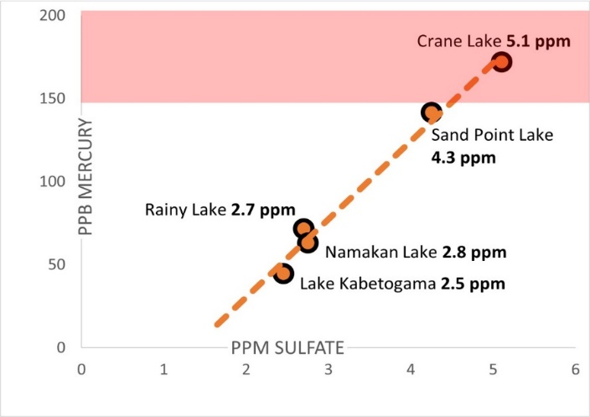 | 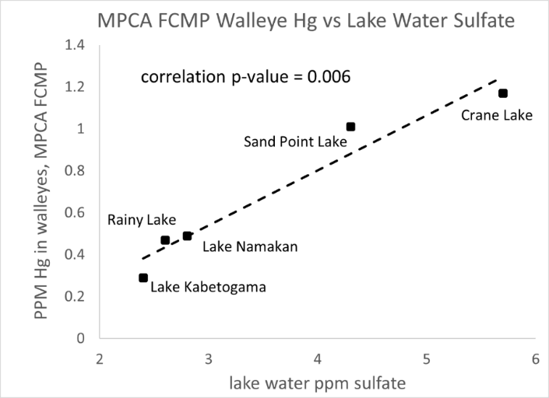
Figure 1: PPB mercury in young of the year yellow perch vs lake sulfate concentration for Voyageurs Park lakes (2014 testing data from Christensen et al (2017)) | Figure 2: PPM mercury in Voyageurs Park walleyes vs lake sulfate concentration data from MPCA Fish Contaminant Monitoring Program database
Ironically, scientific publications that allege that mercury methylation is independent of sulfate concentration exploit the extreme sensitivity of Northern Minnesota waters to sulfate. The way these publications work is to compare mercury methylation at 5 ppm sulfate to mercury methylation at 15 and 50 parts per million. Because mercury methylation peaks at 5 ppm sulfate as indicated in Figures 1 and 2, such comparisons, as would be expected, show no significant difference. The deceptive conclusions are stated, for example, as “chronically impacted wetlands do not appear to continually accumulate or produce MeHg at rates different from wetlands unimpacted by mining” and “Link between mining and mercury in fish less of a factor than previously thought.” One of the most poignant examples of publications lobbying that mercury methylation is not dependent on sulfate concentrations purports to compare a polluted wetland with an unpolluted wetland, however the unpolluted wetland (so called “un-impacted West Two River (WTR) wetland (N 47.465, W 92.77)) is in fact polluted with 5.8 ppm sulfate as a result of being surrounded by mine waste rock dumps [2,3]. An assumption of publications that compare mercury methylation at 5 ppm vs 15 ppm or 50 ppm is that unpolluted water naturally has 5 ppm sulfate. This is absolutely false, as discussed below.
The misconception that sulfate values can naturally exceed 2 ppm is partially based on the fact that measuring sulfate concentrations using turbidity methods does not give accurate results below 5 ppm because of the difficulty of completely filtering out turbidity attributable to other sources (interferences). For example, the sulfate concentration in Sandpit Lake in the BWCA measured 11 times between 1981 and 1991 gave a range of 2 to 3.6 ppm with an average of 2.9 ppm, and Tin Can Mike Lake measured in 1981 was 3.5 ppm. A much better method for measuring sulfate concentrations below 5 ppm is ion chromatography (EPA METHOD 300.0 DETERMINATION OF INORGANIC ANIONS IN DRINKING WATER BY ION CHROMATOGRAPHY [4]). Because the sulfate response by ion chromatography is isolated from interferences from turbidity and other chemical species, and the quantification limit is well below 1 ppm. When sulfate is measured in Sandpit Lake and Tin Can Mike Lake using ion chromatography, the results are 1.0 ppm for both lakes.
The misconception that sulfate values can exceed 2 ppm is also attributable to inaccurate statements that enforcing sulfate water quality standards puts small towns in the situation of financial hardship by requiring the removal of naturally occurring sulfate. For example, in a House Environment and Natural Resources Policy and Finance Committee proceeding regarding the 10 ppm sulfate standard in April 2018, former Representative Jason Metza gives the example of Hoyt Lakes, noting incorrectly that the Partridge River naturally has 25 ppm sulfate [5].
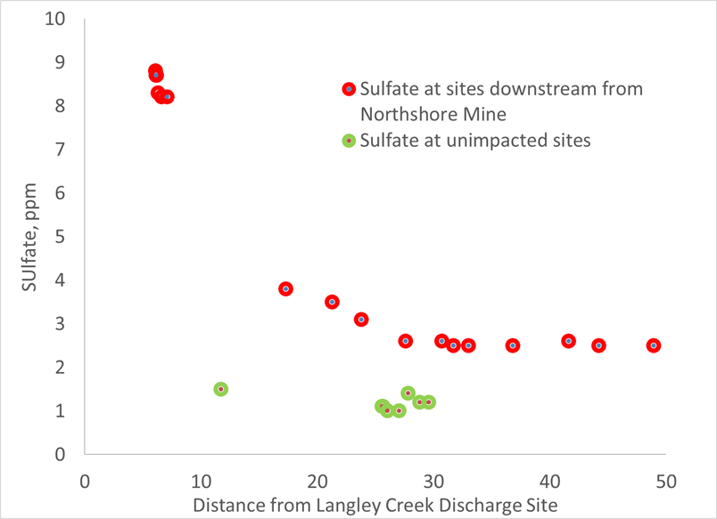
In 2023, the Northern Lakes Scientific Advisory Board measured sulfate concentrations by ion chromatography EPA Method 300.0 in BWCA lakes and rivers not downstream from mining activity (Mudro Lake, Sandpit Lake, Tin Can Mike Lake, Horse Lake and Back Bay of Basswood Lake, Range River and Horse River). Sulfate concentrations ranged from 1.0 to 1.4 ppm. Sulfate concentrations were measured in lakes and rivers downstream of the Northshore Mine in Babbitt including Crooked Lake, Basswood River, Pipestone Bay of Basswood Lake, Newton Lake, Kawishiwi River, Fall Lake, Garden Lake, White Iron Lake, Birch Lake, Dunka River, and Langley Creek. At Crooked Lake, the furthest downstream site 50 river miles from Northshore Mine, the sulfate concentration was 2.5 ppm, clearly showing that the water is polluted. Moving downstream from Langley Creek where sulfate polluted water is discharged, sulfate concentrations drop from 50 ppm to 2.5 ppm at Crooked Lake with dilution from inflow of unimpacted streams. These data show that 2.5 ppm sulfate concentrations are not natural, and to allege that 25 ppm sulfate is naturally occurring is grossly incorrect. Figure 3 is a graphical representation of sulfate concentrations vs distance from Northshore mine, along with sulfate concentrations in water not downstream from the mine.
Figure 3 Sulfate concentrations downstream of Northshore Mine in Babbitt, MN. Not shown (off scale) Langley Creek, 50 ppm sulfate and Dunka River, 15.3 ppm.
Failures to protect Minnesota from sulfate pollution. There are many instances where adherence to the sulfate water quality standard has failed. Four examples are presented here that illustrate governance issues within agencies, disregarding mercury methylation, and lack of resources.
- Cleveland Cliffs Northshore Mine discharge to Langley Creek. In April 2015, the MN DNR issued a Record of Decision In the Matter of the Determination of the Need for an Environmental Impact Statement for the Northshore Mining Company Progression of the Ultimate Pit Limit [6] that allowed Northshore Mine to discharge untreated water with high levels of sulfate into Langley Creek, tributary to the Dunka River, Birch Lake and the BWCA. The order was signed by Barbara Laramore, Assistant Commissioner whose educational background is Public Policy, not technical. In signing the order, Assistant Commissioner Laramore disregarded the fact that wild rice was known to grow in Dunka Bay of Birch Lake and claimed that the MPCA had determined that no downstream waters were used for production of wild rice. The statement that “As the St. Louis watershed is already heavily impacted by mining, the Berndt and Bavin findings indicate that increased sulfate may not be a direct cause of increased mercury methylation in watersheds with elevated sulfate concentrations” means that since because sulfate may not be a direct cause of increased mercury methylation, even though it was well known that sulfate can cause increased methylation, the benefit of the doubt goes to the polluter. Since the Record of Decision was issued, sulfate concentrations in Langley Creek have increased from less than 3 ppm to 50 ppm and by fall of 2021, four tons of sulfate per day were flowing in the Dunka River on the way to Birch Lake and the BWCA. This failure to protect Minnesota water is attributable to the arbitrariness of MPCA administrators and a failure in internal agency governance.

- PolyMet NPDES-SDS Permit MN00701013. In December 2018 PolyMet was issued an NPDES-SDS Permit for what would have been a 30 square mile footprint from which at least 8 streams originate and two rivers flow adjacent to. The heart of the permit is a 321 page table entitled Limits and Monitoring. This table has over 2300 rows, all of which say “monitor only” except for 17 rows with numerical limits on pollution at only two sites. The only site with limits within the 30 square mile permit (site SD001) does not include limits on sulfate, and limits on other pollutants are excessively liberal. For example, the limit on mercury is 1000 nanograms/L compared to the water quality standard of 1.3 nanograms/L. This failure to protect Minnesota water is attributable to the arbitrariness of MPCA administrators and a failure in internal agency governance.

- Spring Mine Creek. Cleveland Cliffs NPDES-SDS Permit MN0042536 Hoyt Lakes Mining Area. Surface discharge site SD 033 discharges to Spring Mine Creek which is a tributary to the Embarrass River, Wynne Lake, and Embarrass Lake, all of which are impaired for sulfate and wild rice. The sulfate concentration requirement for SD 033 is “monitor only” and in spring of 2022, 10 tons of sulfate per day were flowing in Spring Mine Creek to the Embarrass River. The TMDL target completion year for the Embarrass River, Wynne Lake, and Embarrass Lake is 2033. This failure to protect Minnesota water is attributable to limited resources for enforcement.

- Dark Lake. US Steel NPDES-SDS Permit MN0057207 - Minntac Tailings Basin Area. Surface discharge site SD 001 discharges to the Dark River which is a tributary to Dark Lake. The sulfate concentration requirement for SD 001 is “monitor only” and in spring of 2022, 18 tons of sulfate per day were flowing into Dark Lake through the Dark River and the sulfate concentration was 88 ppm. Dark Lake (MN DNR water body number 69-0790-00) is on the 2023 MPCA list of Wild Rice Producing Waters. The Minnesota Court of Appeals reversed MPCA’s National Pollutant Discharge Elimination System (NPDES) permit for the Minntac tailings basin in June 2021 and the facility continues to operate without a valid permit. U.S. Steel had called the groundwater requirements "economically infeasible," unnecessary and impractical, but the Court of Appeals ruled that "U.S. Steel has not argued, much less substantiated with the required information, that it will suffer an 'undue hardship' through application of the standards, as an applicant is required to do when seeking a variance primarily based on economic hardship." As discussed below, the position of US Steel is insupportable. The failure to protect Dark Lake including listing Dark Lake as impaired for wild rice production from sulfate pollution originating at Minntac is attributable to the MPCA yielding to aggressive and litigious behavior from US Steel.
Effect of continuing regulatory lapses. The BWCA is at risk because of sulfate pollution to Birch Lake. It is important that Birch Lake be listed as impaired for sulfate and for all sulfate discharges to Birch Lake to be regulated by TMDL allocation. There is a dire need for sulfate regulation in Birch Lake which is exacerbated by the possibility of non-ferrous mining which targets high sulfur geological formations and generates a much higher proportion of waste to extracted metal than iron mining. As noted above, if PolyMet were to have gone into operation with the NPDES-SDS permit as issued in 2018, they would have been allowed to discharge sulfate without restraint. The prospect of copper nickel mining by Antofogasta / Twin Metals is extremely concerning because of the geography of Birch Lake. Birch Lake is the Birch River swollen by a dam at Minnesota State Highway 1, and the much greater volume of the lake compared to the river means that once sulfate levels become elevated, the damage can’t be undone by stemming present and future discharges and destruction of the BWCA will be a fait accompli. Currently, water in the Kawishiwi River downstream of the Birch Lake dam at Minnesota State Highway 1 has a sulfate concentration 2.3 ppm above ambient resulting in sulfate concentration 1.0 ppm above ambient in Crooked Lake in the BWCA on the Canadian border 32 miles downstream. When sulfate discharges increase by a factor of three, Kawishiwi River water will be 6.9 ppm above ambient and Crooked Lake 3.0 ppm above ambient at 4.5 ppm. Based on data from Voyageurs Park (Figures 1 and 2 above), such an increase will triple or quadruple the concentration of mercury in fish in BWCA lakes from Fall to Crooked. Such an increase is possible from the Northshore mine alone – the expected high for sulfate concentration is 157 ppm [5], about three times higher than that in Langley Creek today. PolyMet and Antofogasta would make such destruction inevitable. The only solution is to get strict about sulfate pollution.
Economic feasibility of treating mining waste to remove sulfate. PolyMet has consistently made the case that removing sulfate by reverse osmosis is tried and true and economical. For example, in the PolyMet Public Hearing Day 2 Session 1 [7], PolyMet testifies they will reduce sulfate loading by over one million kilograms per year by collecting and treating water at the tailings basin, all of the contact water at the mine site, water coming off of the haul roads and anything that's going to be carrying sulfate or constituents of concern to give below 10 milligrams per liter of sulfate before the water is returned to the environment. The MPCA determined that while sulfate treatment costs are unaffordable for municipal, wastewater treatment plants, there is no data to assess whether costs for industrial dischargers will be affordable or not [8].
Summary. This is our legacy – either to make Minnesota recognized as a steward for the abundance of clean water that we are blessed with, or recognized for capitulating to the pressures and devices of polluters intent on increasing their profits. Minnesota has struggled to regulate sulfate pollution, resulting in substantial damage to the environment, and it is time for a change, especially given the possibility of non-ferrous mining. Primary reasons for the difficulty to regulate include poor decisions by MPCA and DNR administrators, for example, decisions about the Northshore mine expansion and the PolyMet NPDES-SDS water discharge permit. Administrators with non-technical backgrounds must consider both sides of issues, for example whether sulfate pollution causes increased mercury methylation and must avoid making consequential, poor and arbitrary appearing decisions. The science of mercury methylation can be reduced to common, non-technical language, and help is available from many technically proficient groups such as the Northern Lakes Scientific Advisory Panel (NLSAP), Water Legacy, Northeastern Minnesotans for Wilderness (NMW) and others. Incentivization of administrators (such as by the prospect of future employment at mining companies, for example in the case of PolyMet’s NPDES-SDS permit) is a problem that must be recognized. While incentivization may make administrators resistant to reason, it should be considered that sensible, supportable permitting that avoids future litigation is beneficial to all stakeholders – mining companies, agencies, and environmental groups. It is important to promote a culture of participation and communication from all sides early in the process – not only will that facilitate progress moving forward, it will also help to reduce the risk of severe, permanent environmental destruction.
Specific requests for the MPCA:
- Create and enforce sulfate NPDES effluent limits (permits with limits, not just “monitor only”) and begin waste load allocations to bring waters impaired by sulfate into compliance with Minnesota’s wild rice standard.

- Do not ignore the problem of mercury methylation by sulfate. This is a topic that needs more examination, not less. Do not limit consideration of sulfate and mercury methylation to information based on already polluted locations such as the St. Louis River and the West Two River wetland. Consider that ambient sulfate levels in water in the absence of human activity are always less than 2 ppm and that the uptick in mercury methylation occurs between 2 and 5 ppm, not between 5 and 50 ppm. Because of mercury methylation, future sulfate emissions need to be more restricted, not less. Failure to uphold the 10 ppm standard for wild rice is going the wrong way.

- Acknowledge that, as promised by PolyMet, sulfate can be practically removed from waste water in an economically feasible way. If the value of metal is insufficient to allow for mining in an environmentally responsible way today, at some future day it will be. So leave it in the ground for now and do not allow destruction of Minnesota’s clean water to be the difference between profitable and unprofitable.

- Address the egregious case of Dark Lake by adding it to Minnesota’s Final 2024 List of wild rice producing waters impaired because of sulfate. Even if enforcement of sulfate discharge limits for Minntac is an unpleasant subject, this is no reason to allow Dark Lake to remain unlisted.

Respectfully,

Eric D. Morrison, PhD (Chemistry)

Volunteer, Northern Lakes Scientific Advisory Panel
info@NLSAP.org
cell 651-334-8399

References

[1] Christensen V, Larson J, Maki R, Sandheinrich M, Brigham M, Kissane C, LeDuc J (2017). Lake levels and water quality in comparison to fish mercury body burdens, Voyageurs National Park, Minnesota, 2013–15. Scientific Investigations Report. https://doi.org/10.3133/SIR20165175

[2] Johnson N, Mitchell C, Engstrom D, Bailey J, Coleman Wasik J, Berndt M. Methylmercury production in a chronically sulfate impacted sub-boreal wetland Environ. Sci.: Processes Impacts, 2016, 18, 725.

[3] Buhl, MN topographical maps showing 47.465, -92.77 (equivalent to 47º27’54”, -92º46’12”) are available at https://livingatlas.arcgis.com/topoexplorer/index.html (enter Buhl, MN in the search box)

[4] method available at https://www.epa.gov/sites/default/files/2015-08/documents/method_300-0_rev_2-1_1993.pdf

[5] Minnesota House of Representative video archive, testimony starts at 1:24,
available at https://www.house.leg.state.mn.us/hjvid/90/890559.

[6] Record of Decision In the Matter of the Determination of the Need for an Environmental Impact Statement for the Northshore Mining Company Progression of the Ultimate Pit Limit available at https://www.dnr.state.mn.us/input/environmentalreview/northshore/index.html

[7] testimony of Christie Kearney and Steve Donahue at The U.S. Army Corps of Engineers, St. Paul District, hybrid in-person and virtual public hearing for the PolyMet/NorthMet Mine project, May 3-5, 2022 video available at https://www.youtube.com/watch?v=x8BqknsJgjU

[8] Kyser, S. Minnesota Pollution Control Agency Sulfate Treatment, November 9, 2018 available at https://www.eqb.state.mn.us/sites/default/files/documents/FINAL_181107%20Sulfate%20Treatment%20Presentation.pdf

