Minnesota Pollution Control Agency  
c/o George Schwint  
12 Civic Center Plz, Ste 2165  
Mankato, MN 56001

On behalf of my constituents and livestock farmers in Minnesota, I am writing to express my concerns with MPCA’s proposed changes to NPDES and SDS General Feedlot Permits. Farmers are already among the best stewards of Minnesota’s land and water, as their livelihoods depend on it. However, these proposed rules offer a one size fits all framework that cannot possibly accommodate the breadth of Minnesota agriculture. Minnesota farms vary widely in size, the crops grown, soil type, topography, and water sources used. It is simply not possible for an office in St. Paul to set rules that meet the unique needs of each farm, that’s why we have individual farmers making these decisions on their own individual farms.

For example, the proposal that all farms who receive their manure from a feedlot must comply with the feedlot’s permitting requirements relating to spreading manure will negatively impact a farm’s willingness to take manure. Such a proposal doesn’t recognize the various best practices or environmental stewardship measures taken on each farm. However, this new regulation will result in less demand for manure due to the regulatory risk and less willingness by neighboring farmers. Instead of efficiently using manure as a natural fertilizer, livestock producers may have to increase their costs by constructing new manure storage, while crop farmers may turn to more synthetic fertilizers rather than utilizing a natural product.

These proposals could have a wide-reaching and chilling impact on Minnesota agriculture. There were no recent statutory changes made to authorize these new rules. Therefore, these rules should not be adopted! At a minimum, it would be prudent to delay implementation of changes until after the conclusion of the 2025 legislative session to allow for greater public input, as well as to allow the legislative committees with authority over agriculture to scrutinize these proposals and the negative effect they may have on livestock producers.

Thank you,

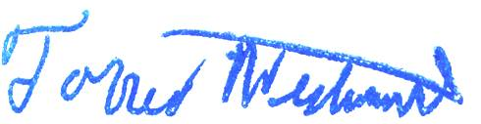

Senator Torrey Westrom

Senate District 12