IZAAK WALTON LEAGUE
WES LIBBEY NORTHERN LAKES CHAPTER
On the web: www.iwla.org/grandrapidsweslibbey

Grand Rapids, Minnesota
----since 1925----

July 24, 2024

Minnesota Pollution Control Agency
c/o George Schwint
12 Civic Center Plz, Ste 2165
Mankato, MN 56001

Minnesota Pollution Control Agency Representative,

Thank you for the chance to comment on this important issue. I am the president of the Wes Libbey Northern Lakes Chapter of the Izaak Walton League of America. Our chapter members live in the Itasca County area in northern Minnesota. The Izaak Walton League of America is a conservation organization whose goal is to protect our nation’s soil, air, woods, waters and wildlife. We care about this issue because we are very concerned about the pollution of our surface and groundwater with nitrogen and phosphorus from synthetic fertilizers and manure applications.

We are glad to see some of the changes and updates that the agency has proposed for the new NPDES (National Pollutant Discharge Elimination System) and SDS (State Disposal System) permits. Many of them are commonsense ways to protect our shared land, water and communities from the harmful effects of CAFOs (Concentrated Animal Feeding Operations), and we want to share our support for these changes including:

- Protecting our shared groundwater by requiring that by 2028, all lands that have manure applied to them in vulnerable groundwater areas must have either a growing crop, a perennial crop planted, or have a cover crop planted with 14 days of manure application if spreading in October and November. We also support phasing out winter application entirely in these areas.

- Protecting surface waters by limiting manure application within a 100-year floodplain to only application that incorporates the manure into the soil.

- Monitoring spreading by requiring the permit holder to do visual inspections of all land application areas. - Helping with cleanup and accountability by requiring the permit holder to do water sampling after a manure discharge event.

- And making our rules consistent by requiring people who buy manure from a permit holding operation, or spread manure for one, follow the permit requirements.

These new changes are a good start to what must be done to keep people and our shared water and land safe, but they also leave quite a bit of room for improvement. Here are some changes to your proposed permit that we think would make it stronger and would bring it closer to what Minnesotans need:

- While protecting water sources in Minnesota's vulnerable groundwater areas is particularly important, all Minnesotans, regardless of where they live, deserve to have access to clean water. The additional requirements to the October, November, and winter applications of manure in vulnerable groundwater areas are good, commonsense management practices, and the requirement that those practices be followed should be extended to all lands where manure is applied.

- While it is good that record-keeping of applications, including water sampling and ensuring that manure buyers are following permit rules, will be required to help make sure that permits are being followed, there needs to be a more robust requirement for permit holders to share this information with the agency so they can ensure permits are being followed. In addition, this information should be made available to the public. Communities that are at risk of CAFO pollution and its effects deserve to know that permits are being followed. Making this information publicly available will also allow community members to help the agency ensure that permit requirements are being met.

- In addition to water sampling and testing being done after a discharge event, this permit should require more proactive water samplings to ensure long-term compliance with the permit and to help ensure accountability. These permits should require water sampling and testing be done regularly around the permit holding site and where liquid manure from the site is being spread so that the agency and the public can know that long-term damage and contamination is not occurring. These permits should also require that new constructions of manure basins and new lands used for spreading must undergo water sampling and testing before construction begins or manure is spread to establish a baseline nutrient load for future testing to be measured against.

We are encouraged by the steps the agency has taken to strengthen Minnesota’s NPDES and SDS permits to help keep us, our communities, and our shared water and land safe. We hope that you can continue these steps and incorporate some of the much-needed changes we have shared here into your new permit. Let’s make these new permits something that will protect all Minnesotans. Thank you.

Sincerely,
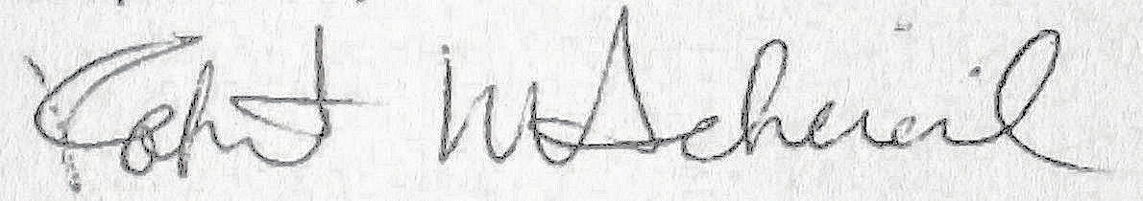
Robert Scheierl, President
Wes Libbey Northern Lakes Chapter
Izaak Walton League of America
1109 NE 5th Avenue
Grand Rapids, MN 55744

