September 22, 2025

Dear Minnesota Pollution Control Agency Staff,

I appreciate the opportunity to submit my observations and comments on the U.S. Steel Keetac Mine and Tailings reservoir permits and U.S. Steel's application for a variance to the sulfate standard.
I stand in opposition to any modification of the 10 mg/l restriction on Keetac's wastewater permit. Here is why I believe relaxation of the current standard would be a grievous error:

Hay Lake was a year-round destination to me, family, and friends since the 1960s. We fished, hunted deer and small game, snowshoed, skied, winter-camped, waded and even carried canoes over four miles round trip to fish the lake in the warm seasons. There are unique features to this lake known to very few people such as the vigorous springs that surface at the foot of the balsam bluff on the East side of the lake. That's also where bootleggers once used the cold spring waters to chill their still condensers. The footings to their shack have now rotted away but the excavation into the hillside remains.

For the past few years I've heard countless false stories regarding the status of the wild rice crop in Hay Lake. I will testify that when I first began visiting Hay Lake in the 1960s launching a canoe or raft at trail's end at the edge of the lake required pushing the craft through standing wild rice 20 yards on good years – a feat complicated by the oozing black muck from the millennia of spring activity on that East side of the lake.

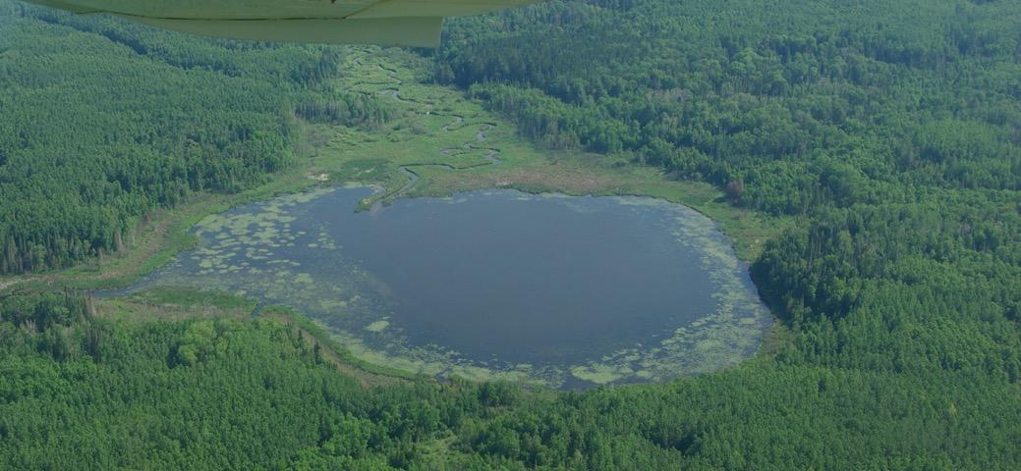

The aerial photo above was taken by Chris Baldwin in July of 2025. It will come in handy for my testimony. The inlet coming from the Keetac Diversion Ditch via Hay Creek is seen at the top of the photo. It is accompanied by a weedy peninsula that has grown since the mine expanded from red ore mining to taconite. That ore conversion amounted to a multi-fold increase in tailings. Red ore had a much higher iron concentration compared to taconite (a low-grade ore). The extraction of iron from taconite left much more coarse and fine tailings to be disposed-of, thus the need for a massive tailings reservoir.

A novice may think July is too early in the year for wild rice plants to be visible from the air. That is not the case. The area circled in red in the photo below shows the location of the wild rice plants we found in coming to Hay Lake on September 7th, 2025. Even from the aircraft photo of July 1st, 2025 it appears sparse and unhealthy, oddly symmetrical, about 70 yards long and 10 to 15 yards wide.

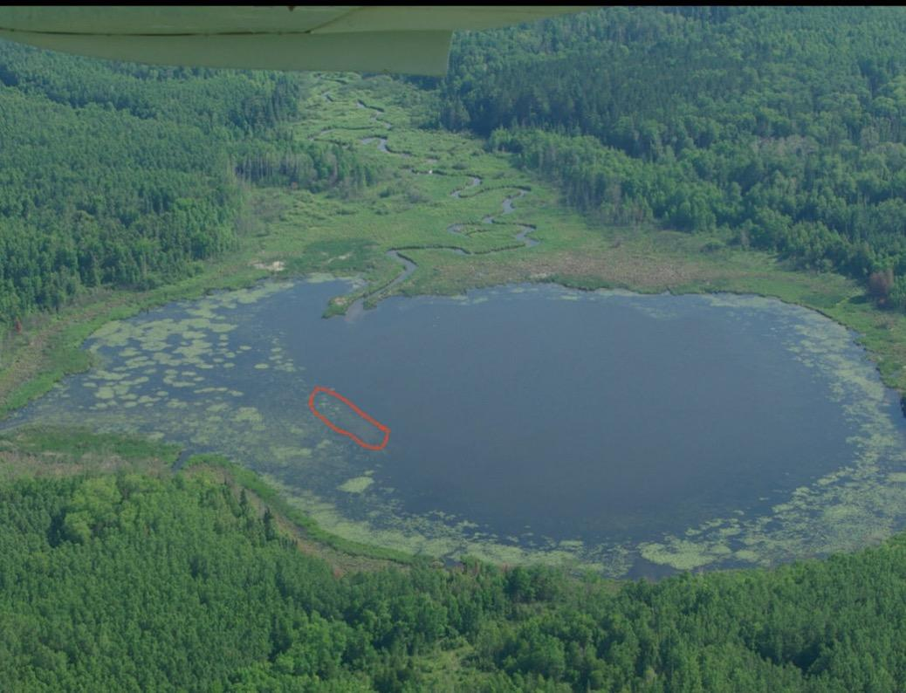

After the September 3, 2025 hearing and public comment meeting in Virginia, I could take no more of the lies. Early on the morning of September 7, 2025 two friends and I hiked out to Hay Lake from Hwy 16 to see for ourselves if some miracle or mischief had taken place. Here is a picture of some trails in the area. The one we used is the solid green line. It is entirely on Blandin Paper Company (UPM) property. The dotted green trail from the Northeast cuts across a small segment of U.S. Steel property. It is a much rougher trail and lands at Hay Lake on a wide swath of swamp too cumbersome to cross.
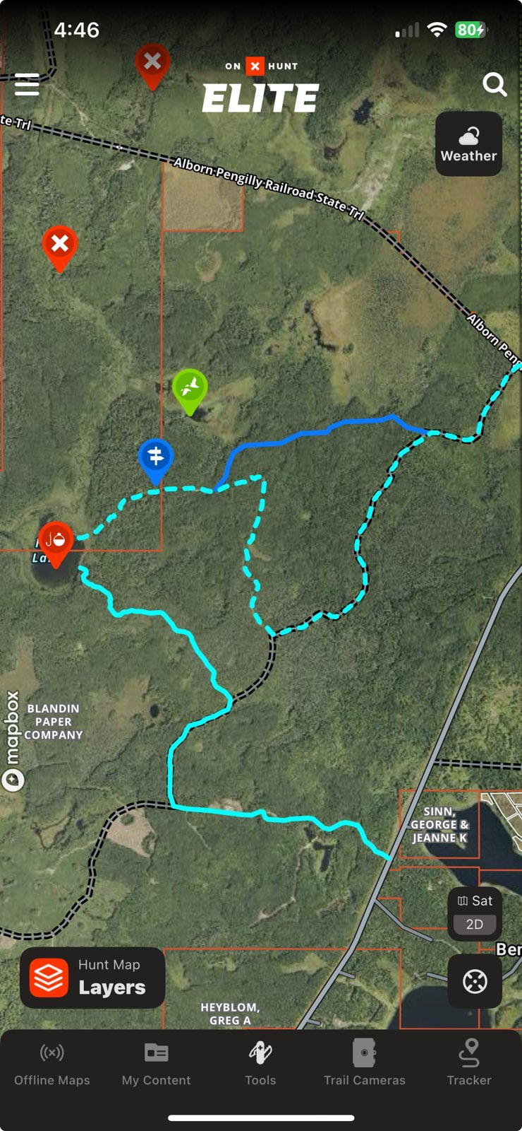

As we waited for the fog to lift we took a few pictures:

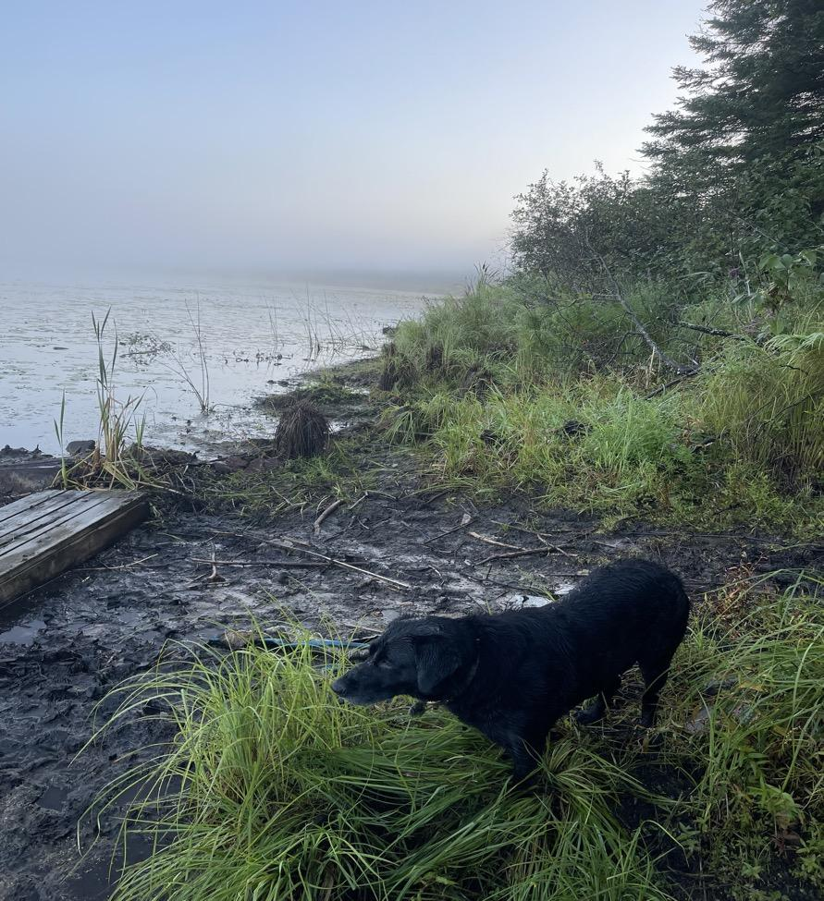

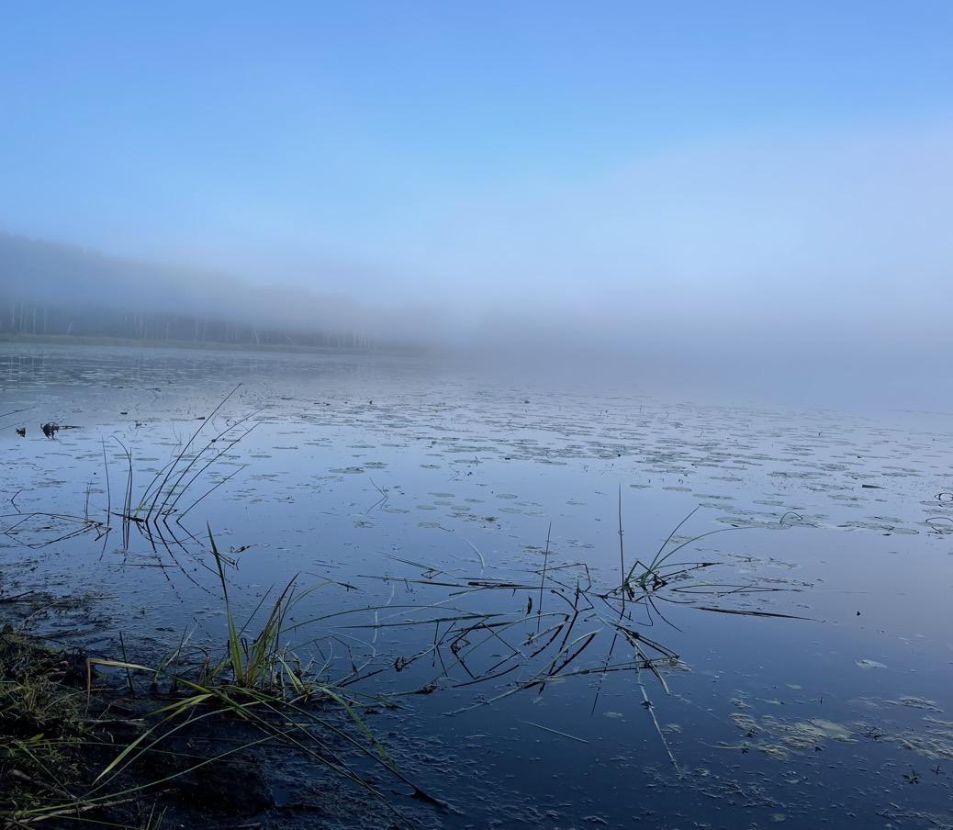

You will see no wild rice beds visible in the two pictures above.

We found a canoe and one paddle stashed nearby. We borrowed it and my friends paddled it across the lake. There they discovered what appeared to be very sickly and broken plants. Neither of them are familiar with wild rice, but they took some photos which we verified are very unhealthy wild rice. Here are some of their photos:

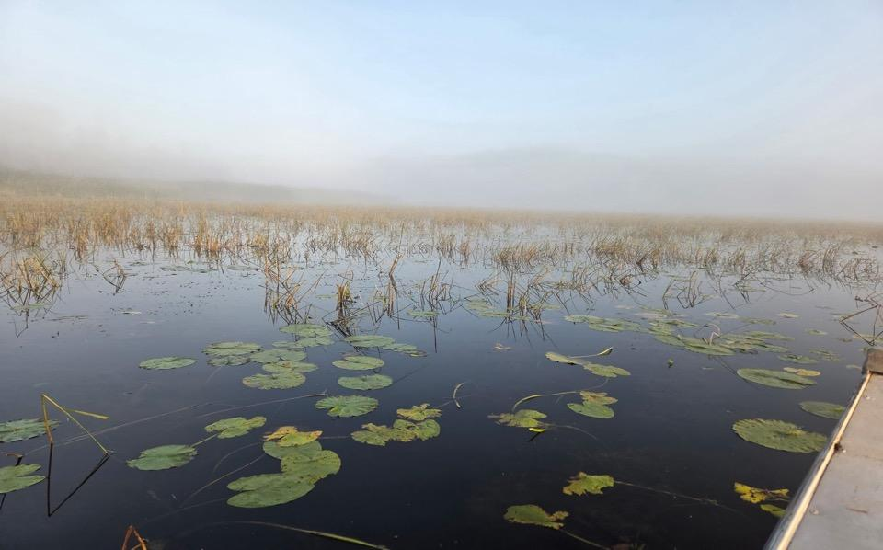
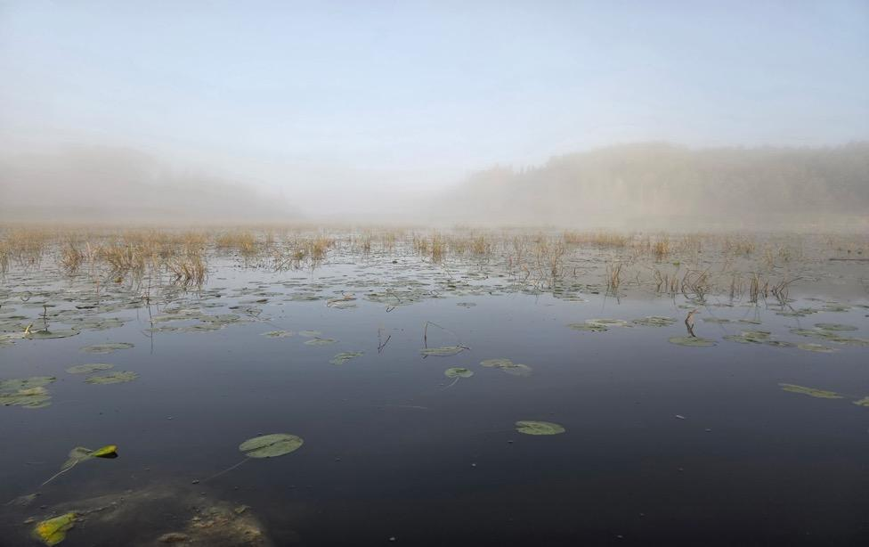

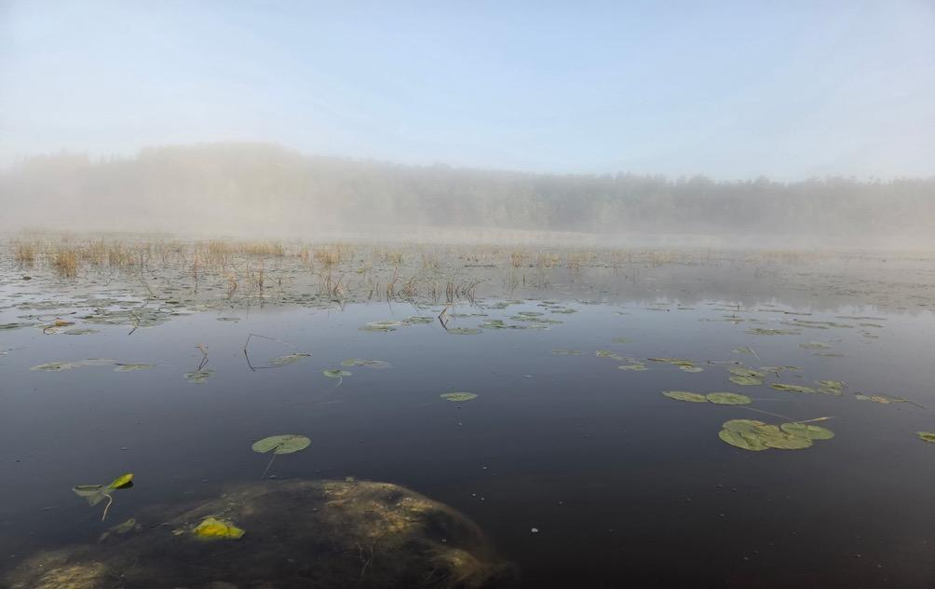
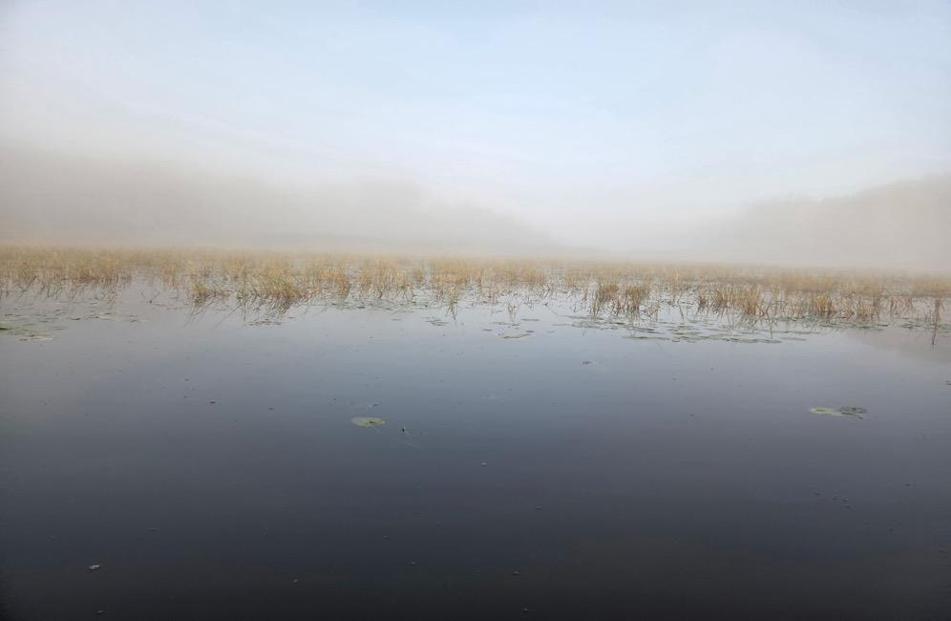

This next picture is my recollection of the extent and layout of the wild rice beds in the 1970s.

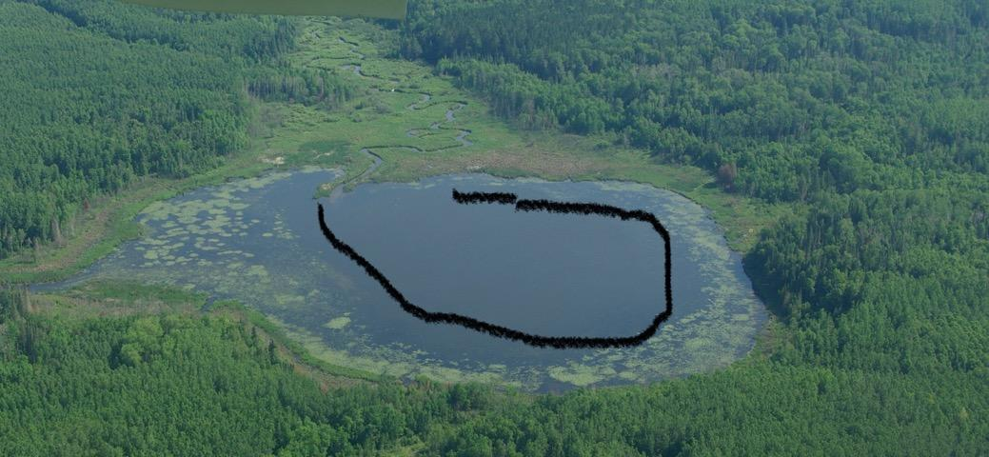
The rice grew from just offshore to the black line. Obviously this is an approximation, but I do recall the wild rice bed also extended Westward down the outlet some distance.

My family and I harvested wild rice from the Big Sandy & Round Lake area, to Ball Club and Mississippi Rivers, Shannon Lake and Vermilion River. We also harvested wild rice at Big Rice Lake North of Virginia and other locations in northeastern Minnesota that I don't specifically recall now.

I know that from year to year wild rice has wildly varying productivity. Wind, heavy rains, drought, poor seed head production, fungus on the seed head – all affecting abundance. But in all the years of hunting ducks, fishing NE MN waters and harvesting wild rice I have never known a body of water to persistently fail to experience a rebound in crop quantity and quality as Hay Lake has. That failure took place slowly at first, then more dramatically as decades passed.

I am not taking a political stance with respect to the 10 mg/l standard. Mining advocates cry out about 'shutting down these mines', job loss, and communities becoming ghost towns. I believe their comments, though worthy and endlessly expressed, must be taken into consideration seriously. What they are asking for is that the MPCA set aside its mission and contemplate an exchange of our most fundamental resource––water and the plants, fish, wildlife and people that depend on it––for money. Time, science, and computers have brought a trove of priceless information to the issue of sulfate mining vs wild rice. Science continues to develop as hypotheses are tested and fact emerges. However, at this time there is no quibbling.... sulfates in wild rice waters eventually kill the wild rice plants. When the plants can no longer produce seed heads the next years' production is in jeopardy.

We have done enormous deeds as a mining community in Northeastern MN. The infrastructure alone – locks & dams on the St. Lawrence Seaway, many hundreds of miles of rail, and two World Wars were won with the iron that came out of these holes. In the 1960s we ran out of the softer, rich red ore. We discovered that a much harder, low-grade taconite ore had a “mine-able” quantity of iron in it. But the machinery to crush and grind red ore wasn't up to the task of grinding the taconite so we gutted some processing plants, retro-fitted them with new equipment, and built several other taconite processing facilities from SCRATCH! This cost billions of dollars. No mining executives dug into their pockets to make this happen. Taxpayers did, using tax breaks, investments, and even an amendment putting the tax breaks into Minnesota’s constitution. And no jobs were lost.

In the 1970s and 1980s the processing plant smokestacks were found to be spewing sulfur dioxide creating acid rain and mercury contamination of fish. The EPA said they had to be fixed. Were the mines shut down? Of course not.

In the 1980s & 1990s steel markets went global and foreign subsidized producers dumped millions of tons of steel in the U.S. markets at prices lower than what they paid to produce it. It was an effort to destroy the American steel market and thus, our national security. I was a union officer at the time. United Steelworkers of America union miners and mining company executives sought relief in the form of tariffs, unemployment benefits, and other governmental aids to allow mining companies to rebuild, refit, continue to pay retirement benefits and keep the industry alive. I was one of them. Did any mining executives reach into their pockets to make this happen? No. The taxpayers did. Jobs and an industry were saved. As recently as this year, taxpayers reached in to provide more unemployment benefits to taconite workers.

Miners in Northeastern MN have historically found solutions to the most daunting of tasks. We have the finest trades craftsmen in the world right here. They want to build stuff and they're the best at it. They need blueprints. Blueprints come from draftsmen collaborating with engineers. Engineers collaborate with scientists, chemists, the medical community, unions, colleges, lawyers, financial institutions, and the list goes on and on. Our taconite mining industry can race to the top and create jobs building treatment plants and cleaning up leaky tailings storage reservoirs, rather than racing to the bottom and leaving pollution behind when they run out of ore.

The absolute wrong thing to do in this matter of Keetac permitting is to knock down the sulfate standard. Do not do that. You are the Minnesota Pollution Control Agency. Let's pay attention to what is actually going on in Hay Lake and other downstream waters and control some pollution.

Thank you,
Mike Maleska
Hibbing, MN

The Keetac Diversion Ditch is a re-route of the original Welcome Creek to allow room for the immense tailings storage reservoir Keetac needed to expand from red ore mining to taconite. A ditch was constructed in the 1960s on the East side of the proposed tailings storage reservoir to 'divert' the stream from its original path, with the tailings stockpiled deep and wide next to it to the West. Welcome Creek became Hay Creek.

