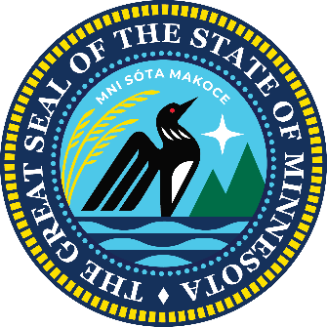

Minnesota Pollution Control Agency
By Electronic Mail: stephanie.handeland@state.mn.us
c/o Stephanie Handeland
Minnesota Pollution Control Agency
520 Lafayette Road North
St. Paul, MN 55155

Re: Comment on NPDES Permits MN0055948 and MN0031879 for U.S. Steel Keetac
Dear Ms. Handeland,
We submit this letter as elected members of the Minnesota State Legislature representing the people, communities, schools, and businesses of Minnesota’s Iron Range. We write collectively to comment on the MPCA’s proposed permits for the U.S. Steel Keetac facility, and on the agency’s denial of a request for variance. We do so to express our united resolve to find a reasonable, balanced solution to the problems created by the MPCA’s failure to update Minnesota’s outdated sulfate wild rice standard, coupled with its recent proposal to enforce it.
This is not a new problem, but the lack of action to update the standard—and the current proposal to enforce it—makes the matter urgent. State laws passed in 2011, 2015, and 2016 directed the MPCA to update the standard. The MPCA made one attempt, but that effort stalled in 2018, and nothing has been done since to revise it.
Despite this, the MPCA now proposes to enforce the old standard with an unreasonably short compliance schedule. Are our concerns with the standard and its enforcement reasonable? Consider what the MPCA itself said in 2015, when it began the failed rulemaking process:
“Because the cost of treating wastewater to remove sulfate is extremely high, it is reasonable and very important to minimize the possibility of applying a standard that is more stringent than necessary to protect the wild rice beneficial use.”
Governor Mark Dayton echoed that same concern in 2015, stating:
“If you have an impossibly low standard that doesn't correlate to the problem that you're trying to solve anyway ... you put the whole industry out of business. We don't even know if it's going to improve wild rice conditions, and it's going to be catastrophic for life up in northeastern Minnesota.”
At the MPCA’s public meeting on September 3, a United Steelworkers leader testified that he had asked the last three MPCA Commissioners whether forcing mining companies to comply by installing extraordinarily expensive technology would cause wild rice to flourish. Each commissioner gave the same answer: “We don’t know.”
The MPCA standard is outdated, unproven, and the agency is under a legal obligation to update it. Since the MPCA has failed to act, it must use every tool available to avoid the potentially devastating consequences of strictly enforcing it.
Testimony at the September 3 meeting painted a sobering picture. Union leaders, local elected officials, and citizens described the potential devastation if the MPCA proceeds with strict enforcement. We already have 620 steelworkers laid off. Global steel competition has never been stronger. This is the worst possible time to enforce a rule written in the 1970s—outdated, unproven, and uncertain even according to the MPCA’s own statements.
During the meeting, the MPCA asked for more information on economic impacts. One of the experts who prepared the economic analysis for Keetac’s variance provided clear answers. He testified that the net present value of constructing and operating a compliant system for 20 years is $1.3 billion. Most strikingly, he warned that “using techniques allowed by the EPA, it shows that Keetac will operate at a net loss if and when this technology is implemented.”
Others testified that the costs would add $17.50 to each ton of taconite pellets produced. The consequences of imposing that burden on a product that must compete in a global market are obvious: the permit cannot be issued as written.
Imagine that cost multiplied across every mine and potentially hundreds of Minnesota cities. Billions of dollars drained from our communities, industries, and mines to comply with a standard that even the MPCA cannot confirm will improve wild rice. This is unacceptable.
We want Minnesota and the United States to remain not just competitive, but leaders in mining. The MPCA’s proposal would do the opposite, putting our industry, our workers, and our communities at risk. As the director of the Iron Mining Association—herself a fourth-generation Iron Ranger—testified: “If we don’t mine it here, we don’t have an American steel industry.”
We urge the MPCA to stop its proposed permit action and work toward a solution that protects both wild rice and the mining industry that sustains our region. Specifically, we request that the MPCA withdraw its proposal to strictly enforce the outdated standard and the unreasonably short compliance timeline. Any regulatory action must recognize that the current standard is outdated, that enforcement cannot be shown to benefit wild rice, and that no economically feasible technology exists today to meet the standard.
We look forward to working with the MPCA and all stakeholders to find a reasonable, balanced path forward.

Respectfully submitted,

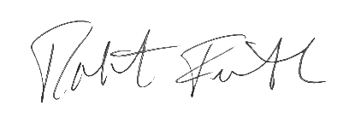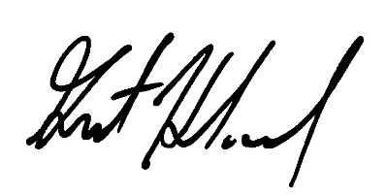

Senator Farnsworth Senator Hauschild

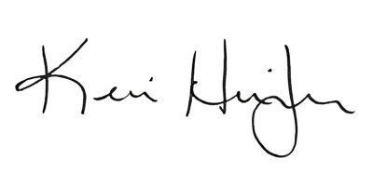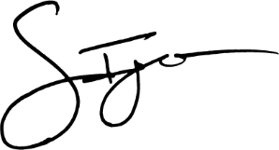
Senator Heintzeman Representative Igo
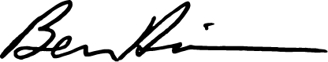
Representative Warwas Representative Davis

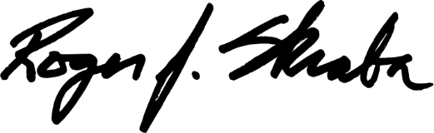

Representative Skraba

