Keri Heintzeman

State Senator
District 06


January 30, 2026

Stephanie Handeland,

As a member of Minnesota’s Iron Range legislative delegation, I'm writing to strongly support the permit applications currently under review for Mesabi Metallics. This project represents an incredible opportunity for northern Minnesota and for our state as a whole.

Mesabi Metallics will be Minnesota's first new mine and pellet plant in nearly 50 years. They have already invested more than $2 billion into this project and have planned another $400 million, which will create hundreds of great jobs for families across the Range and northern Minnesota. There are already 80 full-time employees on staff, and 600 more union construction workers on site. Beyond direct employment, the project will generate tremendous economic activity that will help fund schools, roads, and essential services throughout the area.

I've consistently been impressed by Mesabi Metallics' commitment to engaging with our community. They've held town halls and open houses to keep people informed, and they've invested directly in more than 25 community projects over the past year. That kind of partnership is vital, especially in northern Minnesota where mining is so deeply woven into our history and our communities.

The Iron Range has a long history of powering Minnesota's economy and meeting the America’s industrial needs. The Mesabi Metallics project continues that great tradition. I urge swift approval of all permits necessary to move this project forward.

Sincerely,
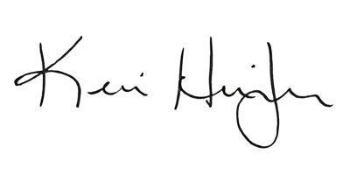
Keri Heintzeman
State Senator
District 06
651-296-7079
MN Senate Building, 95 University Avenue West, St. Paul, MN 55155-1606
Sen.Keri.Heintzeman@mnsenate.gov

