Cal Warwas  State Representative  District 07B | 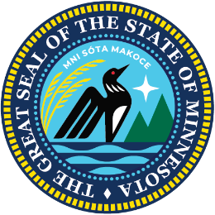 | Minnesota  House of  Representatives

January 26, 2026

Minnesota Pollution Control Agency
520 Lafayette Rd
St Paul, MN 55155

As a member of Minnesota’s Iron Range delegation, and as a lifelong Iron Ranger and union miner, I write to urge your continued support for Mesabi Metallics and the swift approval of its permit amendments.
I am a third-generation miner and a second-generation Minntac employee in the Steelworkers Local 1938, where I will soon have completed 30 years of sevice. My entire family literally represents how important these jobs are to our community. Mining has put food on my table and clothes on my back all the days of my life; the Mesabi project can do the same for scores of other Minnesotans too.
In my role as a state representative, my number one priority has been to use my office to advocate for the Iron Range and its working families - like my own - who depend on this industry. Supporting responsible mining and long-term economic development is central to why I serve.
Mesabi Metallics is a direct investment in the future of Minnesota’s economy and workforce, and will generate hundreds of high-quality, family-sustaining jobs, contribute over $30 million in annual tax benefits and provide long-term economic security to a region that has powered this state for generations. This project is more than a regional development; Mesabi Metallics is a direct investment in the future of Minnesota’s economy, workforce and also every public school student in the state.
I ask for your leadership in supporting the final steps to move this project forward.

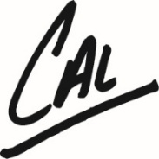
Respectfully,

Representative Cal Warwas- District 07B

