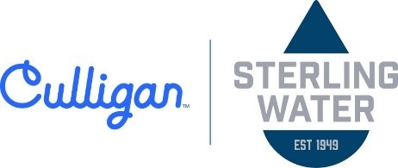
4/6/2026
TO:
Minnesota Pollution Control Agency
ATTN: Charles Peterson 520 Lafayette Road St. Paul, MN 55155

My name is Kris Mielnik, and I am with Sterling Water Inc. in Sauk Centre, Minnesota. Through my work, I collaborate closely with Riverview LLP, providing service and support for their dairy water treatment systems and assisting in maintaining high standards of water quality and efficiency across multiple operations. I am writing to express my support for Riverview’s proposed West River Dairy expansion in Stevens County.

From my direct, hands-on experience, Riverview has consistently demonstrated a high level of professionalism, accountability, and commitment to doing things the right way. Their operations reflect a strong focus on cleanliness, organization, and environmental responsibility. They invest in proper systems, maintenance, and oversight to ensure their facilities operate efficiently and in compliance with regulatory expectations.
Riverview also prioritizes providing a quality environment for their livestock. Their attention to water quality, system performance, and overall facility management contributes to animal health and productivity, which are critical components of responsible agricultural practices. This level of care is not only good for their operation but also supports broader environmental and sustainability goals.

Beyond their operational standards, Riverview is a dependable partner to those of us who work alongside them. They are proactive, responsive, and committed to continuous improvement. This reliability creates confidence for vendors, service providers, and regulators alike, knowing that they take their responsibilities seriously and follow through on their commitments.
The proposed expansion represents a positive step for rural Minnesota. It will support local economies through job creation, increased demand for services, and continued investment in agricultural infrastructure. Businesses like ours depend on stable, well-managed operations like Riverview’s to sustain growth and continue serving communities across the region.

Based on my experience working with Riverview, I am confident in their ability to continue operating in a professional, clean, and environmentally responsible manner.

Thank you for your time and consideration. I respectfully encourage the MPCA to support and approve this project.

Sincerely,
Kris Mielnik
Sterling Water Inc.
Cell: 715-450-5309

