April 7, 2026

Minnesota Pollution Control Agency ATTN: Charles Peterson 520 Lafayette Road St. Paul, MN 55155

My name is Sean Gallant, and I am one of the owners of Industrial Environmental Concepts, a Geomembrane Cover/Liner Business serving agricultural operations in Minnesota like Riverview. I am writing in support of their proposed West River Dairy expansion in Stevens County.

Through our work in the agricultural sector, we depend on a strong and stable livestock industry. Operations like Riverview’s create consistent economic activity that supports local jobs, drives investment, and allows businesses like ours to grow and reinvest in our communities.

The proposed expansion represents a meaningful economic benefit to the region. It will generate demand for local vendors, support both construction and long-term employment, and contribute to the vitality of rural communities that rely on agriculture.

From our direct experience, Riverview is a professional and reliable partner that contributes positively to the communities where it operates. Their presence strengthens the local economy and supports a broad network of agricultural and service-related businesses.

Projects like this are essential to maintaining a competitive and sustainable rural economy in Minnesota. Continued investment in agriculture ensures that local businesses can continue to provide jobs, services, and economic stability close to home.

No EIS is needed as the state environmental review process is rigorous and very sufficient. I respectfully encourage your support and approval of this important project.

Sincerely,
Sincerely,
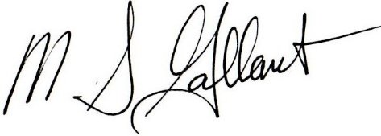

M. Sean Gallant
Director of Operations

