Dear Secretary Kenney:

I urge you to deny the pending Air Quality Permit (9295) for a concrete batch plant (CBP) on a pristine section of Billy the Kid State and National Scenic Byway, which lies in the midst of seven long-time residential neighborhoods:

Alto Lakes Golf and Country Club
Enchanted Forest
Legacy Estates
Ranches of Sonterra
Rancho Ruidoso Valley Estates
Sun Valley
Vista Rio Bonito

My property is less than 100 yards from the proposed plant. Should you decide to approve this air quality permit, your decision will destroy my peaceful life of hiking, gardening and spending hours every day and evening outdoors---enjoying the fresh air, stunning views and night skies that brought me to Alto, NM. It will likely require that I sell my home (for hopefully only a 50% loss in value) and move.

Numbers on an application do not adequately describe the health damage that will accrue to the more than 140 property owners within a half-mile radius of this site.

The effects of this proposed CBP, with its toxic air, extreme water usage, loud industrial noise, proposed long operating hours, and heavy truck traffic would reach far beyond its borders, harming the health and welfare of residents, disturbing habitats of native NM wildlife, birds, plants, polluting the pristine White Mountain Wilderness, disturbing the Mescalero Apache Reservation and outlying areas such as the Snowy River Cave Conservation Area, depleting natural resources, and contaminating the scarce surface water and perhaps irreparably harming the subsurface water we all share. The benefits of this CBP will accrue to Roper Constructions, leaving taxpayers of Lincoln County, the state of New Mexico, the federal Government---and local property owners--to pay for the increased health care costs, road repairs, management of road dust and water quality, damage to local wells, loss of property value---in short, to subsidize the profits of Roper Construction.

NMED has deemed this application administratively complete, and writes that “if conducted in accordance with the Department’s draft permit conditions” emission rates will “comply with applicable requirements” and “not cause or contribute to an exceedance of federal and state ambient air quality standards.” Roper Construction has been running the Carrizozo Concrete Plant since 2016, he already knew the application requirements and yet disregarded important details to the extent that he needed to revise his original AQP application more than ten times—often in response discrepancies discovered by those of us trying to make sense of the information in his AQP application. Mr. Roper did not defend his original data/information but merely changed it to fit the requirements. This does not bode well for his conducting this CBP in accordance with the Department’s draft permit conditions, and his lack of attention to details does not augur favorably for his attention to the many details needed to prevent dust and particulate matter from escaping this plant site.

My own experience bears out these concerns. When I spoke with Mr. Roper and voiced my opposition to a CBP plant so close to my neighborhood, he seemed genuinely surprised, and told me that I was “only the second person” to have phoned him that. The next day I discovered that five of my friends were also “only the second person.” He also told me that he lets his children play around his other CBP. If so, he is either a party to child endangerment or he is lying.

NMED states that it monitors such plants to ensure they comply with regulations, but since his Carrizozo plant has been in operation for over five years and has yet to be monitored, that is not a sufficient option to protecting the health and welfare of our communities.

NMED staff have told me that measures will be taken—including “wet dust suppression”---to prevent “visible dust” from crossing the property line. It is not the “VISIBLE” we fear, but the “INVISIBLE.” Respirable silica dust is 1/100 the size of a grain of beach sand. This invisible silica dust, when inhaled, bypasses our body’s defenses and goes straight to our lungs, creating scars in the delicate lung fibers that can never be repaired and may eventually lead to terminal silicosis. It also exacerbates asthma, heart and lung diseases and so starkly limits our outdoor activities---thus damaging not only our physical health, but our mental health as well.

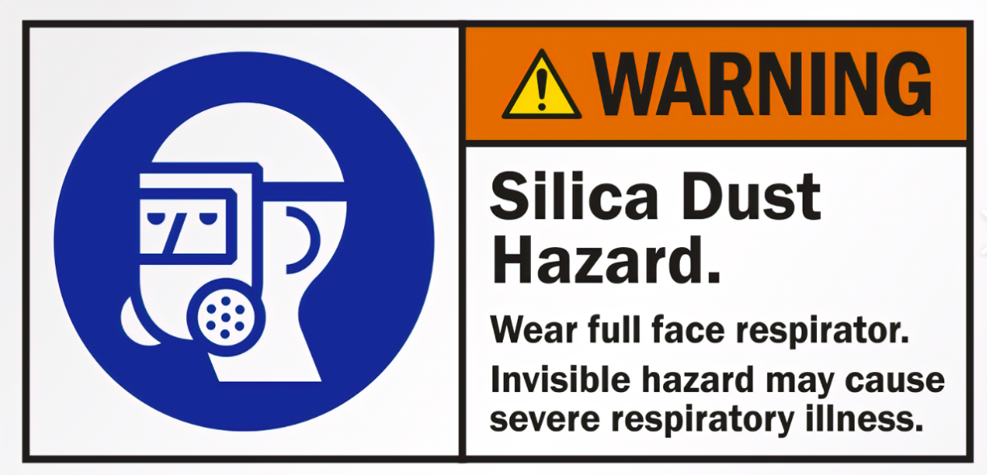

NO COMPANY HAS THE RIGHT TO SUBSIDISE ITS PROFITS WITH OUR PHYSICAL AND MENTAL HEALTH.

Concrete batch plants are a necessary part of 21st century current construction. But this concrete batch plant at this location is wrong---and an imminent health danger to the community.

As a 78-year-old “little old lady” with health issues, including heart disease, allergies and a compromised immune system, I implore you to deny this permit.

On other related matters:

One of the four excellent tenets of your Environment Department is Collaboration—Engaging communities and interested stakeholders in environmental decision-making outcomes.

As an interested stakeholder, I have found it difficult to engage with your department. Although most employees in your Environment Department were approachable and helpful, that was not universal.

Those of us trying to prevent our neighborhood from being destroyed are just ordinary people, living in a normal world and trying to survive. Here are some issues that I found troubling:

1. Locating up to date information on AQ Construction Permit (9295)

Although updates to the Original Application may have been received by NMED on the date of the new version, that version was not made available to the public for as much as 100 days. It was a shock to discover that the AQP version I was relying on was outdated. When a revised version posted, there was no indication of which information had been updated, although I was able to identify the updates by way of a word for word comparison. After this discovery, I called in to inquire if yet another version had been received, but not yet posted and was told that everything that NMED had received was available on the public site. Perhaps this complies with your Department’s PIP (Public Involvement Plan), but to me it does not equate to “adequate public access to information about this permit application.”

Please remember, we are just elderly people searching for reasons that the State of New Mexico’s Environment Department is preparing to grant a permanent permit to poison our air, water and ruin our neighborhoods—and trying to deter such a move.
Original Application
Revisions to the original application:
- Section 1 (version 8/10/2021) (posted 11/18/21)
- Section 1 (version 12/21/2021) (posted 12/28/2021)
- Section 1 (version 12/30/2021) (posted 12/30/2021)
- Section 2:
  - Table 2A (version 9/22/21) (posted 11/18/21)
  - Table 2D (version 9/22/21) (posted 11/18/21)
  - Table 2E (version 9/22/21) (posted 11/18/21)
  - Table 2H (version 9/22/21) (posted 11/18/21)
  - Table 2I (version 9/22/21) (posted 11/18/21)
  - Table 2J (version 9/22/21) (posted 11/18/21)
- Section 3 (version 11/17/21) (posted 11/18/21)
- Section 4 (version 11/17/21) (posted 11/18/21)
- Section 5 (version 9/22/21) (posted 11/18/21)
- Section 6 (version 11/17/21) (posted 11/18/21)
- Section 6 (version 1/13/22) (posted 1/14/22)
- Section 6 (version 1/28/22) (posted 1/28/22)
- Section 7 (version 8/10/21) (posted 11/18/21)
- Section 7 PDF (version 1/13/22) (posted 1/14/2022)
- Section 7 Excel Calculations (version 1/13/22) (posted (1/14/22)
- Section 9 (version 1/4/22) (posted 1/14/22, reposted 1/19/22)
- Section 11 (version 11/5/21) (posted 11/18/21)
- Section 14 (version 1/28/22) (posted 1/28/22
- Section 16 (version 8/10/21) (posted 11/18/21)
- Section 16 (version 12/29/21) (posted 12/29/21)

2. Regulatory Requirement: Posting of Public Notice at Site

Public notices are to be posted in “accessible and conspicuous” places at the site of the proposed facility. Perhaps it appears so from this photo in the AQP:

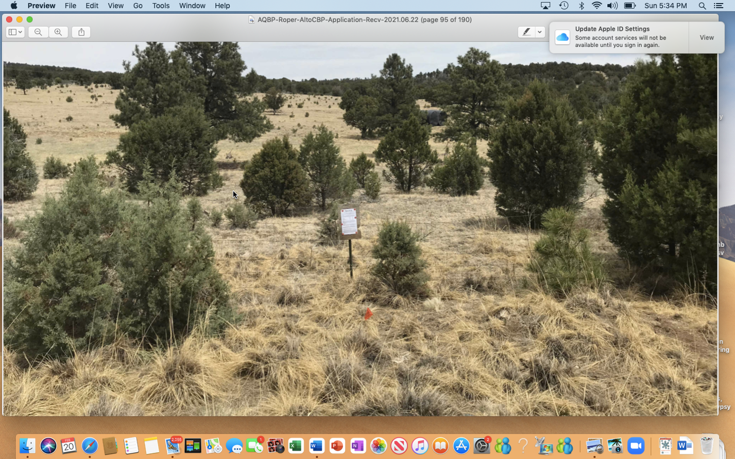

However, this 8.5x14” poster, printed in 10 or 12 point type, some 20 feet closer than a driver on the Scenic Byway could be, looks quite different from the shoulder of the highway:

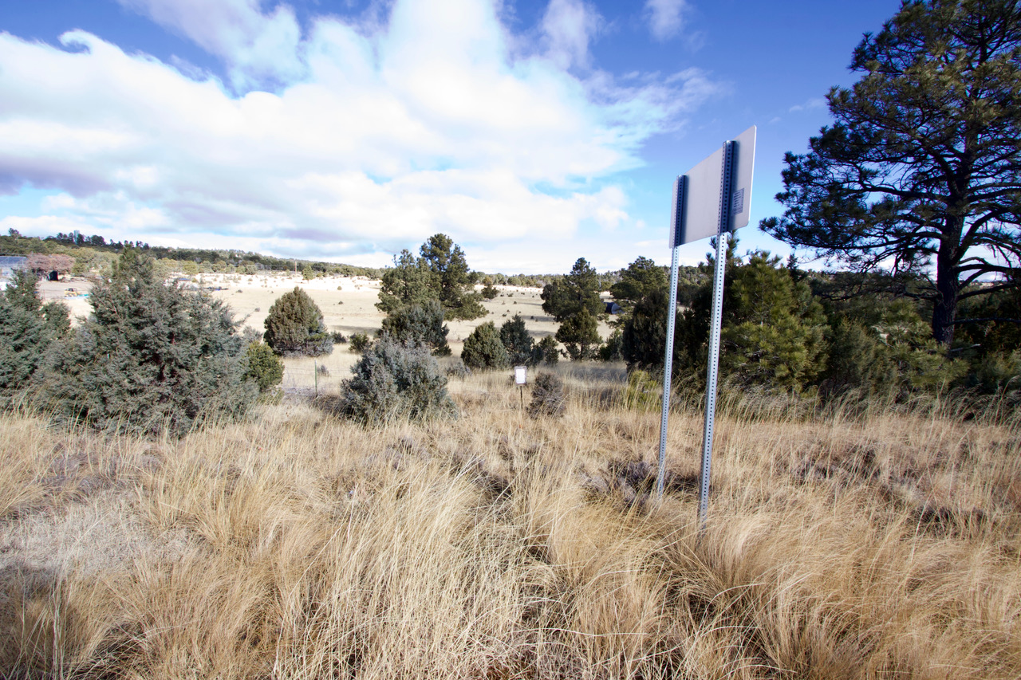

Compound that with the 50 MPH speed limit on this stretch and the designation of such signage as “accessible and conspicuous” becomes truly ludicrous.

Yet, the Hearing Officer deemed it in compliance with the regulations.

3. Notification of Property Owners per New Mexico Administrative Code

Although NMAC states that notification should be provided by certified mail, to owners of record, as shown in the most recent property tax schedule of all properties within one-half (1/2) mile of the property on which the facility is located or proposed to be located, the applicant (9295) failed to do so. I have personally used the Lincoln County Assessor’s website and it’s not difficult to locate property owners. Of the 143 to be notified, 13 failed to receive the legally required certified mail in a timely and appropriate manner.

That delinquency alone should have caused this permit to be denied and the permit process restarted, but in response to the Motion to Dismiss hearing on November 19, 2021, when only one property owner had been identified, the hearing officer wrote the “allegation that one household did not receive the notice does not void the Permittee’s efforts, nor does it require dismissal” and that the proper venue is a public hearing. Why was the hearing officer defending the applicant rather than protecting us vulnerable homeowners?

In response to the Renewed Motion to Dismiss, by which time thirteen non-notified property owners had been identified, the hearing officer cited from another case “this rule is tempered somewhat by the fact that New Mexico does not take a strict view regarding compliance with statutory notice requirements. Instead, substantial compliance with the statutory notice provisions would satisfy the purpose of the statue.” Whoa… Why does New Mexico even have an administrative code if it isn’t followed? What is the meaning of “not a strict view” or “substantial”? There is no definition of either term---so the operative question is who defines those terms….and for whose benefit? Not the benefit of the citizens of Lincoln County, New Mexico it seems.

Even more disturbing is the reasoning given by the hearing officer as to the importance of these thirteen property owners: “The property owners who did not receive notice by certified mail made up approximately 6% of the 190 total parcels (143 distinct owners) within one-half mile of the proposed site.” “Seen another way, 94% of the property owners within one-half mile did receive notice.” The requirements were for property owners, not parcels. It is quite a contortion to turn 13/143=9.09% into 13/190=6.84%---rounded off in direct contradiction to NMED’s rules on rounding---AQP Application Section 6, page 1 to “approximately 6%.” Why would an impartial Hearing Officer do such a thing?

I have read your qualifications and your experience—and am quite impressed. I would be genuinely surprised if this is the way you want members of your Department to treat to their employers--the citizens of New Mexico.

4. “The proper venue for a factual determination of the adequacy of the posting of public notice is a public hearing.” “The proper venue for weighing the possibility that one household did not receive notice is a public hearing…”

However, when these issues were raised at the February 9, 2022 public hearing, Mr. Vigil objected, and the Hearing Officer sustained the objections, ruling that these matters had already been adjudicated. What? Didn’t both Mr. Vigil and Mr. Chakalian defer these issues to the public hearing? And then both refused to hear the issues….at the public hearing?? What is happening here?

5. Public Hearing 2.9.22: “IN THE MATTER OF THE PERMIT APPLICATION OF ROPER CONSTRUCTION, INC FOR AIR QUALITY PERMIT NO. 9295 ALTO CONCRETE BATCH PLANT AQB 21-57 (P)”

It reads as though this would be an evenhanded hearing, with two sides presenting positions, with witnesses, technical experts and public comments, leading toward a decision on the AQP that included all relevant facts and considerations necessary to award a permanent AQP.

Unfortunately, the hearing turned out to be something else. NMED’s WebEx platform was not ready to go at 9:00 AM, even though NMED had set the date at least 30 days before February 9th, and there was adequate time to test and be prepared to begin the hearing as advertised. The start was delayed some thirty minutes while technical issues were resolved, so that participants and citizens could join the hearing remotely.

Several of those attempting to join remotely were never allowed in by NMED’s host. No information about revised start time was broadcast and some concerned citizens simply gave up, as they had no idea when the hearing would begin.

Also unfortunately, the physical location chosen by NMED for those without access to internet was Traylor Gym in Capitan---10 miles from the proposed plant site and especially inconvenient for those working in Ruidoso---rather than a more accessible location---i.e. Ruidoso Convention Center, 4.4 miles distant.

Before the hearing, Roper filed to exclude evidence on water issues at the February 9 hearing. I was shocked and appalled that NMED originally concurred with Roper’s motion to prohibit any mention of water or water issues at this public hearing—even though the application of water is a major part of required dust suppression and the permit requires water usage.

Fortunately, someone at your department recognized the integral role that water plays in this particular AQP application and water testimony was allowed, although NMED’s initial concurrence with Roper’s motion was chilling.

As mentioned above in 4), although earlier hearing officers had postponed evidence for both posting of notice and notification of nearby residents until this hearing, inexplicably such testimony was denied.
Other issues, such as insisting that the meteorological data from Holloman AFB in the Chihuahuan desert on the western side of the Sacramento Mountains was similar to that at the mountainous terrain of the proposed site because “The similar elevation, topography, terrain, vegetation, and climate of both sites make this meteorological data representative of the model area” (UA4 12 of 17, Meteorological Data, p.178) and equating an average 11 mph wind speed with the dramatic variations of calm to frequent 70 mph gusts that we experience at the proposed site were bizarre, but happened—despite NMED’s own recommendation that using similar terrains—i.e. canyons, etc.—was appropriate.
Throughout the hearing, NMED appeared to be a part of the Roper legal team, questioning Sonterra’s witnesses and cross-examining such witnesses when one would have thought that was the role of the Roper legal team.

This conflict of interest was reinforced when one of your employees, a Mr. Vigil prefaced his calling of NMED’s witnesses by opining that Sonterra will give emotional testimony and do something to “muddy the waters.” Such a comment seemed to me to be out of place in an impartial public hearing---but apparently, not to the hearing officer.

At the times reserved for public comment (12:00 noon and 5:00 PM), many concerned citizens came forward to give their oral comments either in person or via WebEx. The Notice of Public Hearing stated that “Members of the public will have up to five (5) minutes to offer general comment.” However, for the 5:00 PM public comment period, the Hearing Officer decreased that time to three (3) minutes---“in the interest of time.” In the interest of whose time? Those of us who had been waiting over eight hours to have our five minutes were quite willing to stay a bit longer and allow everyone to give their prepared comments.

But that is not what NMED wanted, and that is not what happened.

As the hearing was adjourned, I and others realized that your Department’s impartial hearing on the AQP application was more akin to a defense of the determination that had already been made, and that holding the hearing seemed to have been a necessary and inconvenient formality.

The New Mexico Environment Department is the regulatory agency that enforces state regulations and federal laws relating to protection of the environment, resources, and public health and safety. Somehow, protecting public health and safety seem to have diminished in importance.

Please reassert the prominence of environmental protection of the public health and safety of the citizens of New Mexico by denying this Air Quality Permit.

If you wish to discuss this matter, please call me at 214.499.5081.

The favor of a response is appreciated.

Dr. Barbara Yount
214.499.5081

