EIB 22034: In The Matter of the Petition for Hearing on Air Quality Permit No. 9295, Roper Construction Inc.’s Alto Concrete Batch Plant

I am Dr. Barbara Yount. I wish to submit written comments urging you, the members of the Environmental Improvement Board, to uphold the FINAL ORDER of the NMED to deny the Air Quality Permit application for a concrete batch plant (CBP) on Billy the Kid State and National Scenic Byway, which is situated in the midst of seven long-time residential neighborhoods:

Alto Lakes Golf and Country Club
Enchanted Forest
Legacy Estates
Ranches of Sonterra
Rancho Ruidoso Valley Estates
Sun Valley
Vista Rio Bonito

The AQP application is designed for an industrial site—not for a residential site. OSHA has studied the health effects of a CBP on the workplace and issued regulations. No agency has studied the health effects of a CBP on residential sites, because no agency ever expected a CBP to be built in the midst of multiple residential neighborhoods.

My property lies less than 100 yards from the proposed plant. Should you decide to reverse the NMED denial and approve this air quality permit, your decision will destroy my peaceful life of hiking, gardening and spending hours every day and evening outdoors---enjoying the fresh air, stunning views and night skies that brought me to Alto, NM. Such a decision will make my health worse.

Numbers on an application do not adequately describe the health damage that will accrue to the more than 140 property owners within a half-mile radius of this site.

This proposed CBP, with its toxic air, extreme water usage, loud industrial noise, proposed long operating hours, and heavy truck traffic would reach far beyond its borders, harming the health and welfare of residents, disturbing habitats of native NM wildlife, birds, plants, depleting natural resources and contaminating the scarce surface water and perhaps irreparably harming the subsurface water we all share. The benefits of this CBP will accrue to Roper Constructions, leaving taxpayers of Lincoln County, New Mexico, the federal Government---and local property owners--to pay for the increased health care costs, road repairs, management of road dust and water quality, damage to local wells, loss of property value---in short, to subsidize the profits of Roper Construction.

Earlier, NMED deemed this application administratively complete, and wrote that “if conducted in accordance with the Department’s draft permit conditions” emission rates will “comply with applicable requirements” and “not cause or contribute to an exceedance of federal and state ambient air quality standards.” Roper Construction has been operating the Carrizozo Concrete Plant since 2016, he already knew the application requirements, and yet disregarded important details to the extent that he needed to revise his original AQP application more than ten times—often in response to discrepancies discovered by those of us trying to make sense of the information in his AQP application. Mr. Roper did not defend his original data/information but merely changed it to fit the requirements. This does not bode well for his conducting this CBP in accordance with the Department’s draft permit conditions.

My own experience bears out these concerns. When I spoke with Mr. Roper and voiced my opposition to a CBP plant so close to my neighborhood, he seemed genuinely surprised, and told me that I was “only the second person” to have phoned him that. The next day I discovered that five of my friends were also “only the second person.” He also told me that he lets his children play around his other CBP. If so, he is either a party to child endangerment or he is lying.

NMED states that it monitors such plants to ensure they comply with regulations, but since the Carrizozo plant has been in operation for over five years and has yet to be monitored, that is not a sufficient option to protect the health of New Mexico citizens in our communities.

NMED staff have told me that measures will be taken—including “wet dust suppression”-to prevent “visible dust” from crossing the property line. It is not the “VISIBLE” we fear, but the “INVISIBLE.” Respirable silica dust is 1/100 the size of a grain of beach sand. This invisible silica dust, when inhaled, bypasses our body’s defenses and goes straight to our lungs, creating scars in the delicate lung fibers that can never be repaired and may eventually lead to terminal silicosis. It also exacerbates asthma, heart and lung diseases and thus starkly limits our outdoor activities---thus damaging not only our physical health, but our mental health as well.

NO COMPANY HAS THE RIGHT TO SUBSIDISE ITS PROFITS WITH OUR PHYSIAL AND MENTAL HEALTH.

The stated mission of the New Mexico Environment Department is “to protect and restore the environment and to foster a healthy and prosperous New Mexico for present and future generations.” This CBP plant will not protect and restore the environment and foster a healthy and prosperous New Mexico for present and future generations.
Concrete batch plants are a necessary part of 21st century current construction. But this concrete batch plant at this location is wrong---and an imminent health danger to the community.

This CBP at this site will make my health WORSE. As a 79-year-old “little old lady” with health issues, including heart disease, allergies and a compromised immune system, I implore you to uphold the denial of this permit.

Thank you for your attention to this life threatening proposed intrusion.

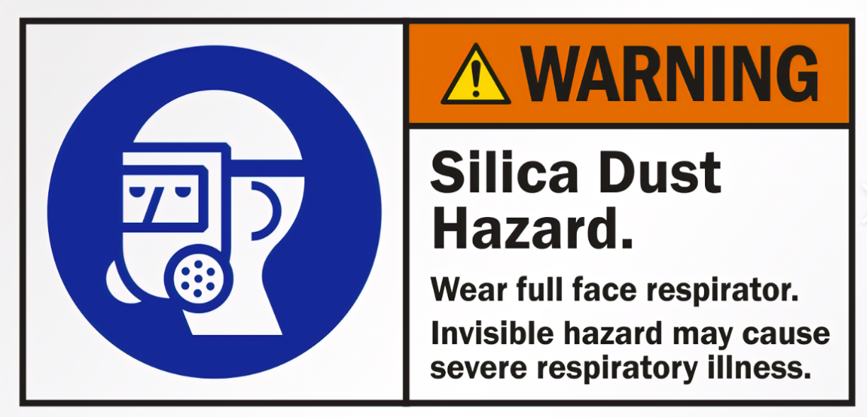

Dr. Barbara Yount

