Roper Construction Concrete Batch Plant Permit Request
Alto, New Mexico
10-18-22

To Whom It May Concern:

The picture on the left was taken March 8 on a clear breezy day. The picture on the right was taken on March 5 with afternoon wind gusts of around 24 mph. This area in Lincoln County is known for high spring wind gusts that can reach speeds of 80 mph. The air quality that you see is a result of sand being blown over from White Sands Missile Base. We also had the McBride fire this Spring. The McBride fire was strongly encouraged by hurricane force winds. Data for these winds must be available. The NMED needs to consider wind data from the McBride Fire.

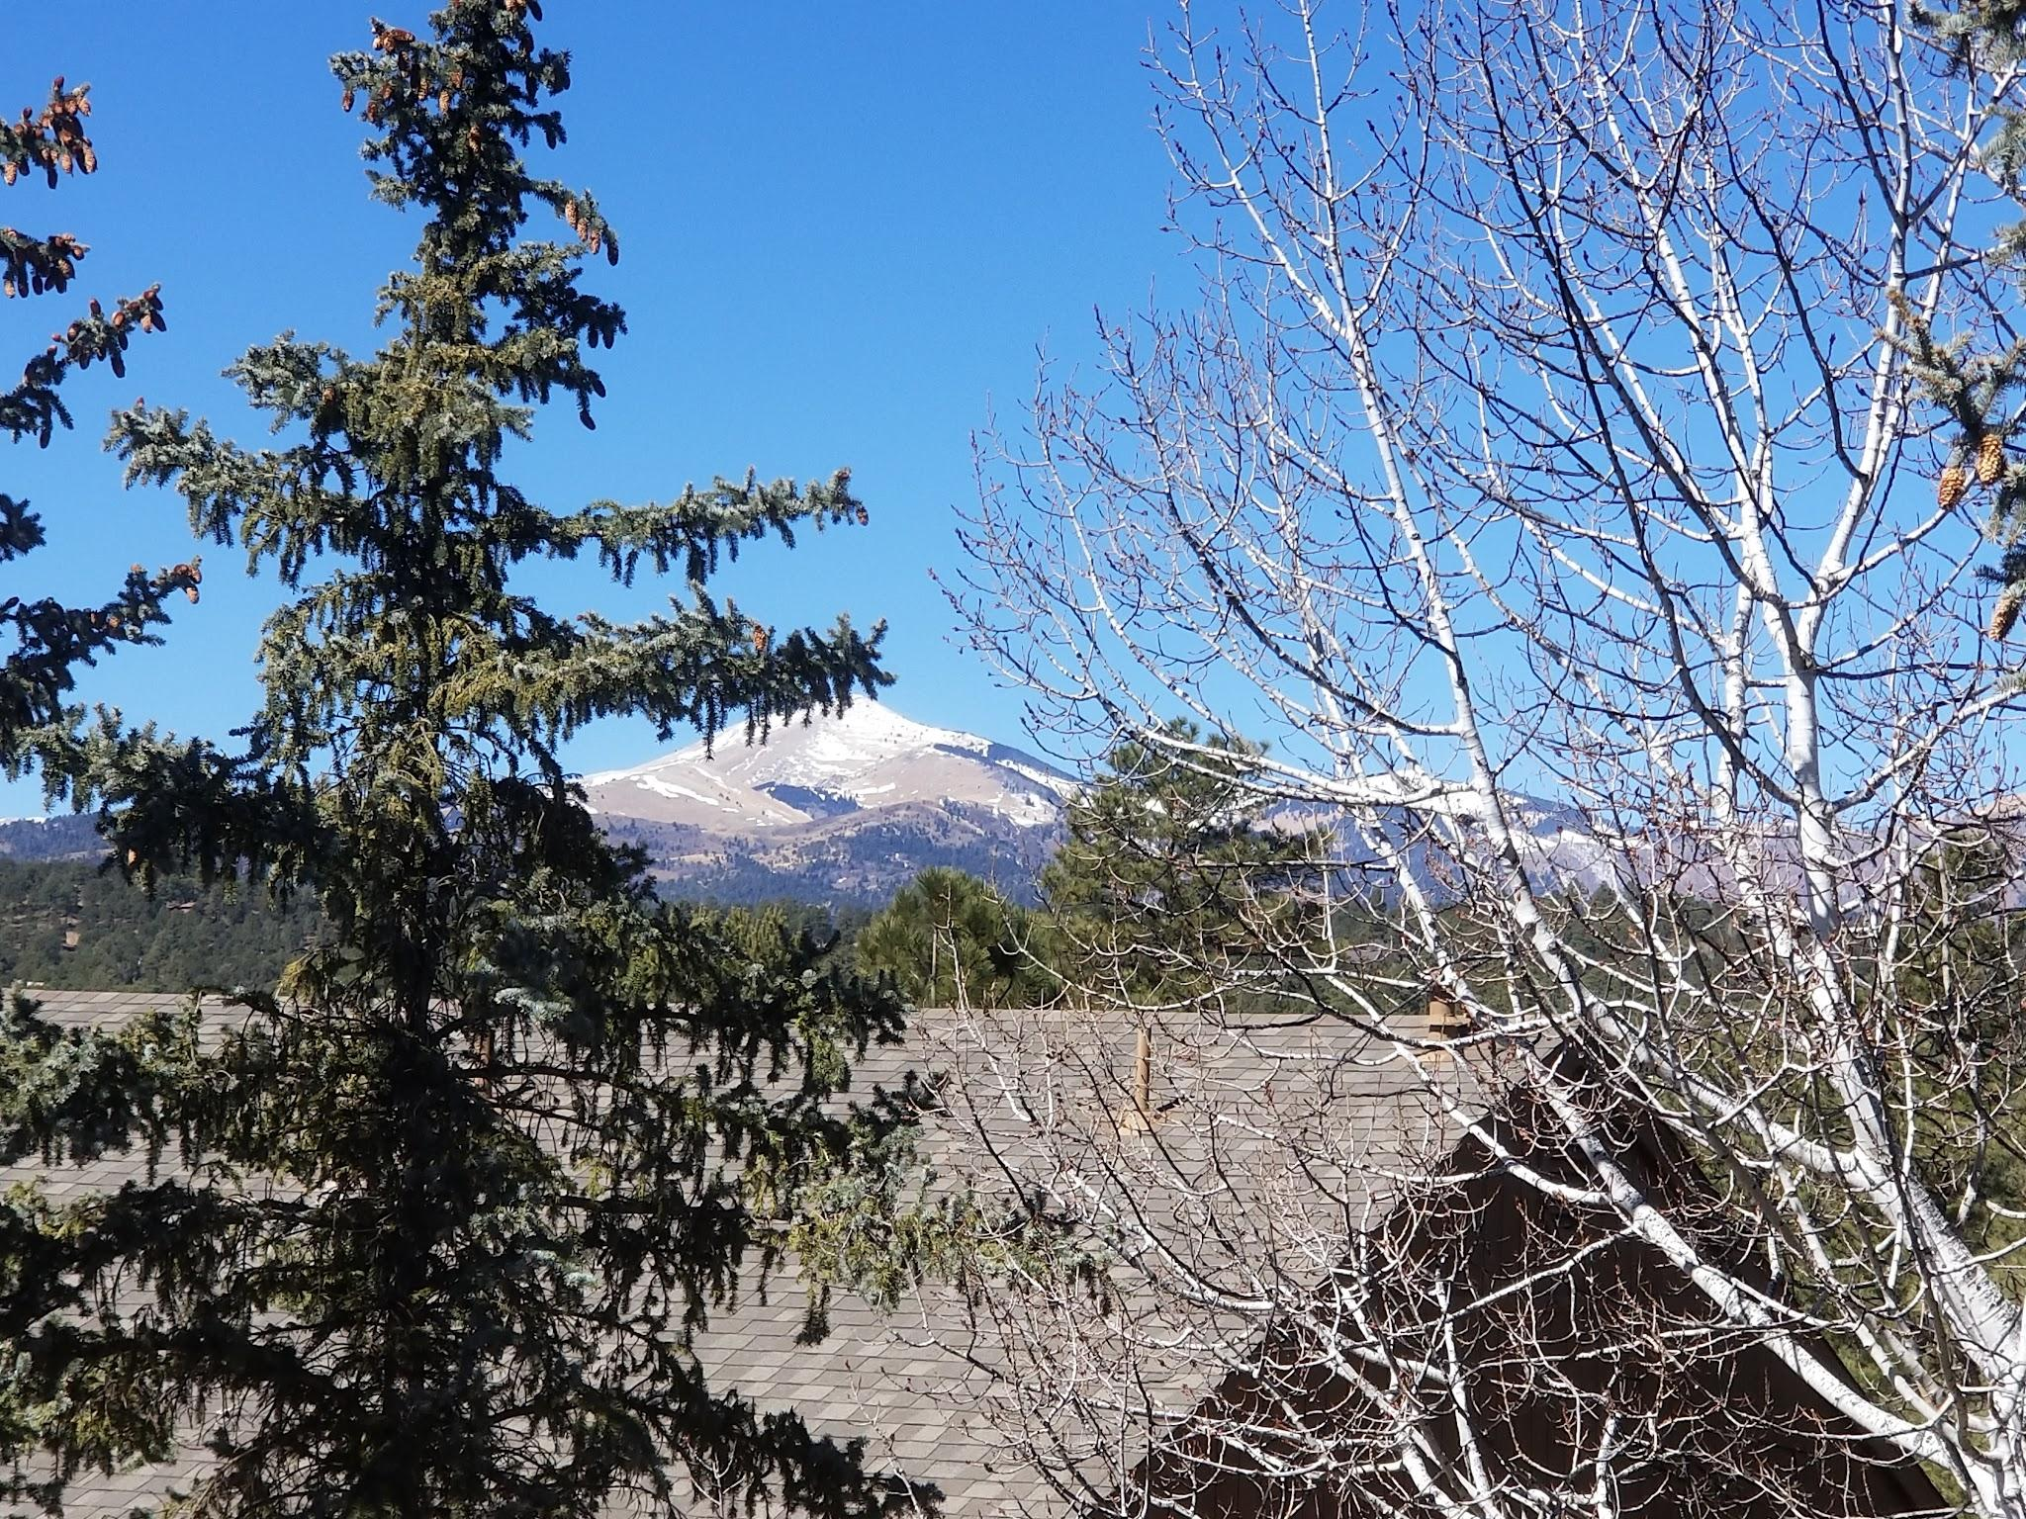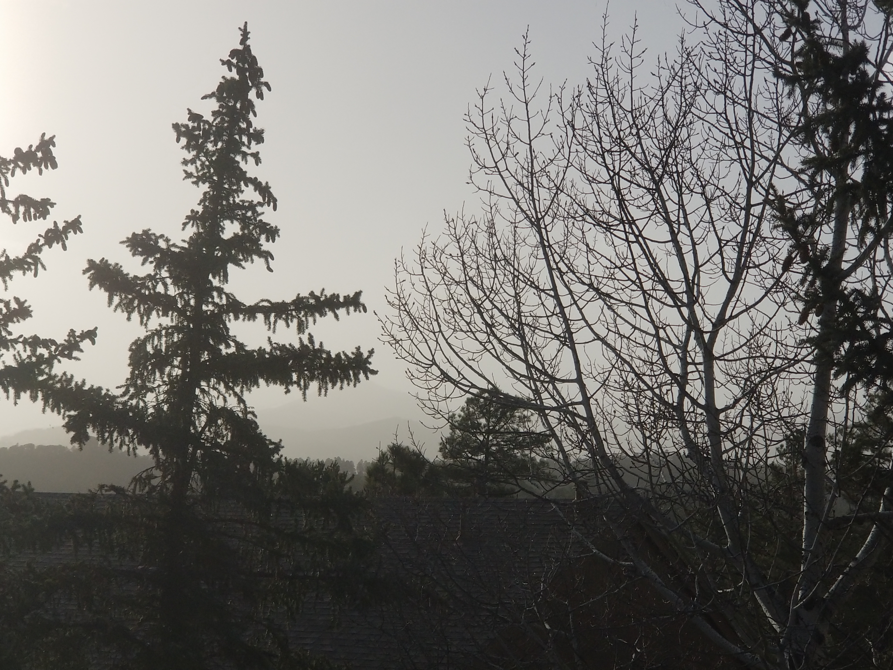

If you have ever visited this area or have any familiarity with it, you would understand how inappropriate a proposed concrete batch plant would be at the general confluence of NM-48 and Airport Road 220. Airport Road (220) is en route to historic Fort Stanton as coming from Ruidoso or historic Lincoln. The famous Spencer Theater is on Road 220 as is the Fort Stanton-Snowy River Cave National Conservation Area. Highway NM-48 is a route to the well-respected Capitan 4th of July rodeo and Smokey Bear Museum. This is a wildlife area. This is a tourist area. This is a residential area. The turn-off for Ski Apache is also near this junction. Alto Lake with its fish and fowl is nearby. Bonito Lake with its fish and fowl is nearby. This is not an industrial area. Many, many seniors, and other residents will suffer financial loss from their home values if this plant is approved. Others would suffer health consequences from fugitive dust emissions being dispersed from the plant. The roads were not built and planned for this type of industrial activity.

Water is a precious resource. Oil is a precious resource. Rubber for tires is a precious resource. An unutilized /underutilized already approved concrete plant in Capitan which is only miles down the road is a precious resource, yet Roper did not purchase this plant or make plans to upgrade it. The permit request and suppression of “fugitive” dust is dependent on the business filling the roads with water trucks (40? of them) from 3 am to 9 pm to fetch water approximately 28 miles away. Roads will be less safe as industrial trucks run up and down them to fetch water and deliver concrete. Accidents and fatalities could be a likely outcome of the increased industrial traffic in a residential and tourist area.

In 1999, New Mexico enacted the Night Sky Protection Act [74-12-1 to 74-12-10 NMSA 1978]; its purpose is to regulate outdoor night lighting fixtures to preserve and enhance the state’s dark sky while promoting safety, conserving energy and preserving the environment for astronomy. One of the first of its kind in the U.S, The Night Sky Protection Act makes dark skies a priority in New Mexico for the health of its people, wildlife, and economy. This plant will require safety lights that negatively impact this residential area abundant with wildlife.

The elevation at the confluence of NM- 48 and Road 220 is at approximately 7000 feet. How can one justify the noise of water and cement trucks coming and going from 3 am to 9 pm in a residential and tourist area? Herds of elk, deer, wild horses, wild turkey, bobcats, bears, red foxes, coyotes and even a mountain lion are in the area. I have personally witnessed young bull elk's sparring at the proposed location. Exactly what will be covering the grasses these animals graze on if they attempt to remain in the area. Where will they go if they leave the area? Or, will the animals be silently eliminated by this plant? The Snowy River Cave in Fort Stanton and the bats suffering from White Nose Syndrome are downwind and downstream from the proposed plant.

Another unique element of this area is high wind. We were supposed to believe that low wind is the concern. Why? Because the fugitive emissions stay in the area, and in the grass and in the soil and seep into the water table when the fugitive emissions are not blown away by the high winds. When the winds are high the fugitive dust emissions will be blown off the industrial lot and onto residential lots and important area features and will have the exact same effect.

Was the land sold with deed restrictions? What do these deed restrictions say? Why are primarily vulnerable seniors having to spend their financial resources to protect themselves from a concrete batch plant when two already exist within a reasonable proximity? Where are the monitoring reports that the other two nearby plants were monitored for compliance after approval by the EPA? Concerned local citizens have been unable to locate these reports if they exist.

We all depend on capitalism. However, common sense would preclude this grievous exploitation of an entire community, eco-system, and tax base. The job of the environmental protection agency is to protect the environment, as the agency name indicates. How does the EPA protect the misuse of fossil fuels? How does the EPA protect lungs from fugitive dust emissions? How does the EPA protect the area's water resources? How does the EPA protect the air? How does the EPA observe the Dark Skies Act? How is the EPA stopping noise pollution? How does the EPA protect lives? How does the EPA protect wildlife? I see no protection from the EPA if the plant is approved. Obviously, Lincoln County has some serious work at hand if it is to protect its unique and highly valuable identity while building an economically viable community.

The plant is an unscrupulous idea proposed by an unscrupulous businessman. NMED and the government of New Mexico needs to make a decision within a comprehensive framework. The plant is hardly a self-contained business – the negative impacts of its approval would benumerous. Please help the residents of Alto, NM put the tentative EPA approval of the Alto Concrete Batch plant in the rear-view mirror

Respectfully,

Lisa French

NOTES

The New Mexico Environment Department (NMED) Public Hearing on the air quality permit application for the proposed Alto concrete batch plant was held virtually on February 9, 2022. Concerned residents attended on-line via WebEx, and at two public participation sites, Traylor Gym in Capitan and the Ruidoso Convention Center.

Approximately 85 people registered at the two sites and around 30 gave oral comments voicing their objections and concerns before the hearing concluded. Additionally, a large number of written comments were submitted prior to, during and immediately after the hearing. All written and oral comments are now a part of the NMED’s administrative record of the application.

The timeline for the NMED’s decision on the air quality permit application is:
14 days for the NMED Court Reporter to generate a transcript of the hearing 30 days for “facts and filings” review from the NMED’s, plaintiff’s and defendant’s legal counsel regarding the hearing as documented in the court reporter transcript. (essentially a review and submission of corrections to the record, if required) 14 days for generation of Hearing Officer’s report and recommendation for approval or disapproval of the application 7 days for review and comment on the Hearing Officer’s report and recommendation by the NMED’s, plaintiff’s and defendant’s legal counsel Deputy Environment Secretary for Operations Stephanie Stringer then reviews the Hearing Officer’s report, comments from the legal counsel of all parties, and makes the final approval/disapproval decision.
The Alto Coalition for Environmental Preservation (AltoCEP) encourages everyone to convey their opinions and concerns to the New Mexico state leadership.
Specifically:
New Mexico Governor Michelle Lujan-Grishamthrough her comment portal at:
https://www.governor.state.nm.us/contact-the-governor/
or via postal mail:
490 Old Santa Fe Trail Room 400
Santa Fe, NM 87501
New Mexico Environment Secretary James Kenney
via email: James.Kenney@state.nm.us
via telephone: (505) 470-6161
or via postal mail sent to:
PO Box 5469
Santa Fe, NM 87502-5469
The NMED public hearing did receive media coverage.
AltoCEP Assistant Chair Kevin Fleharty was interviewed live during the hearing on KRQE for their 4pm newscast. KRQE aired an additional story regarding the concrete batch plant here which can be viewed here:
https://www.krqe.com/news/new-mexico/concerns-over-cement-plant-proposal-sparks-pubic-hearing-trial-in-alto/
Additional news coverage is being planned by KWES radio, the Ruidoso News and the Lincoln County Leader. Updates will also be provided on https://altocep.org/

