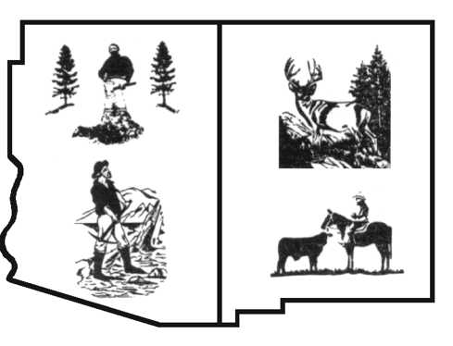

*Coalition Of Arizona/*

*New Mexico Counties*

*For Stable Economic*

*Growth*

*“Working together for responsible management.”*

November 7, 2023

New Mexico Environmental Improvement Board

Attn: Pamela Jones, Board Administrator

P.O. Box 5469

Santa Fe, NM 87502

Albuquerque/Bernalillo County Air Quality Control Board

P.O. Box 1293

Albuquerque, NM 87103

**Re: EIB 23-56 (R) Advanced Car and Truck Rules** (Rules)

Dear Respective Board Members,

These comments are being submitted by the New Mexico Counties, Catron, Chaves, Eddy, Lea, McKinley, Otero, Roosevelt, Sierra and Socorro along with strong support from the timber, farming, livestock, mining, small business, sportsman and outfitter industries as members of the Coalition of Arizona/ New Mexico Counties (Coalition). Our representation currently exceeds 396,634 in combined New Mexico county populations.

The Coalition respectfully requests that the Environmental Improvement Board (EIB) vote **NO** on Docket Number EIB 23-56 (R).

The Coalition is opposed to the Advanced Car and Truck Rules for the following reasons.

The Rules:

1. do not provide any new funding for counties to performing the mandated activities in violation of the New Mexico Constitution, Article X Section 8[1];
2. will impair interstate commerce in violation of the U.S. Constitution[2];
3. will require the purchase and installation of expensive charging equipment;
4. will require the purchase of cars, trucks and heavy equipment that have not demonstrated the capacity to do the work reliably;
5. will create the need to reeducate and train county work forces to operate, service and repair vehicles and equipment they are totally unfamiliar with;
6. will impose an unnecessary burden on Counties and the people of New Mexico;
7. will be directly impacte consumers when their ability to purchase gas/diesel powered vehicles and equipment is eliminated;
8. will have a disproportional impact on low-income citizens of the state who depend on the availability of used cars, trucks and equipment;
9. will negatively impact the Coalition’s member counties revenue from oil & gas production, timber harvesting, mining, ranching, farming, guiding, hunting, fishing, and recreation;
10. will outpace NM’s grid capacity. This rule is trying to accomplish extreme goals faster than the state will be able to comply;
11. will tax infrastructure statewide that is ill-prepared to handle the expected demand caused by the conversion of thousands of vehicles. Additionally, there continues to be a lack of infrastructure available (charging stations) to support and serve rural communities;
12. will increase demand on the electrical and will have significant impacts on the cost of energy statewide. New Mexicans cannot afford higher electricity bills and should not have to foot the costs associated with the proposed rules;
13. will add additional financial pressure to NM’s low-income residents and agricultural producers who are already operating at razor-thin margins;
14. will further exacerbate the competitive advantage that NM’s producers face today, especially with producers across the border in Mexico;
15. will dramatically reduce consumer choice not only for producers but for consumers as well. The cost of compliance for timber harvesters, mining, oil and gas and agricultural producers will be much higher than for the public;
16. will require electric trucks and semis with high capacity that are currently limited in the marketplace and will be extremely costly when they become available;
17. will force producers and consumers to travel out of state to make the vehicle purchase of their choice;
18. EV trucks and semis carrying a full load will have to take additional, longer stops along their route to charge. Additional stops, especially during extremely hot and cold times of the year, can compromise perishable agricultural products and overall animal health;
19. entirely disregard the long distances perishable agricultural products are required to travel to market; and
20. will further stress an already shorthanded transportation and trucking sector.

The Coalition requests that you to vote no on EIB 23-56 (R), also known as the Advanced Car and Truck Rules. We wholeheartedly disagree with the extreme approach and tight timelines. We encourage the board to look at a more reasonable approach developed with input and feedback from New Mexicans in a timeframe that is achievable and through policies that are affordable.

1. Article X, Section 8 New Mexico Constitution “A state rule or regulation mandating any county or city to engage in any new activity, to provide any new service or to increase any current level of activity or to provide any service beyond that required by existing law, shall not have the force of law, unless, or until, the state provides sufficient new funding or a means of new funding to the county or city to pay the cost of performing the mandated activity or service for the period of time during which the activity or service is required to be performed. (As added November 6, 1984.)”
2. U.S. Constitution, Article I, Section 8, Clause 3 The Congress shall have Power…To regulate Commerce with foreign Nations, and among the several States, and with the Indian Tribes.