
Los Jardines Institute * 803 La Vega Dr. SW* Albuquerque, NM 87105 * (505) 573-1904

On behalf of the Los Jardines Institute I am writing to formally submit our opposition to the permit for the Broadway Transfer Station (Application No. SWB 24-08 (P)). This facility will add to the cumulative impacts of pollution that affect this community negatively poisoning the environment and health. It is the responsibility of government to protect our environment, health and well-being.
The state Solid Waste Regulations specifically (20.9.3.8) and the Health Equity & Environmental Impacts (HEEI) passed by the Bernalillo Albuquerque Air Quality Board (2003) govern the county and state and require proposed facilities to first identify if the facility will be in a vulnerable area. Clearly Mountain View is an overburdened and vulnerable community.
The rules also state that:
1. the Best Available Control Technology (BACT) be put in place. This was not clearly evident in the hearings. The large number of trucks and hours and days of operation add to the poor air quality and increased traffic will increase accidents. There was no effort in real time to actually buy one or two electric vehicles or to share a plan for this.
2. Both State regulations and the HEEI require a proposed facility to take into account the number of facilities in the area. This is already an overburdened community; there was not an accurate accounting of facilities. A new facility approved by the county, unknow to the community, was not taken into consideration which would add to negative cumulative impacts in air and the increased large truck traffic.
3. Distance to residential areas continues to be an issue specifically the distance from the school. The state regulations specify four (4) miles.
4. The number of polluting facilities in the area demand objective and ethical government decisions. The number of counties whose trash would be brought to the community is an undue burden and again adds to the cumulative impacts on this community which must be rigorously addressed.
5. The Rhino Decision directs hearing officers and the NMED to take into account the concerns and wellbeing of the community. It is the State that will continue to either protect or sacrifice the environment and its people. Specifically in Mountain View. The residents of the community have voiced & testified against this permit.
6. Notice was problematic and the venue in May itself was a poor arrangement.

We would hope that the Hearing Officer and the Secretary equitably consider the number of commentaries that also represent those that were not there to speak for themselves.
The community has fought polluting initiative after initiative each approved permit has added to our exposure. As a vulnerable community that is also overburdened with industrial pollution, including being host to a problematic sewer system that serves Albuquerque and Rio Rancho and which may be emitting formaldehyde into the air. The American Lung Association has, year after year, given Albuquerque an F or D- on air quality, it is time the NMED complied with its mission.
My family and I have personally suffered the reality of overexposure. My three children attended Mountain View Elementary and drank the water that almost killed a child in the 1980s who had been brought to the community to visit grandparents. The parents had prepared a bottle of formula with the well water that all the Mountain View community residents drank. The child almost died as a result of the high level of nitrates in the water. After much community organizing, we created the MAC (Mountain View Advisory Committee) and worked to pressure politicians to bring municipal water and garbage pickup to the community. However, not all the community was hooked up to city water and sewer. My youngest was the same age as the child impacted by the nitrates in the water, I must have acclimated him to nitrates in my womb and later with the formula I gave him. The impact in my children continues to be a concern for our family.
Mountain View has two superfund sites, over 30 EPA regulated sites, the sewer system, countless auto junk yards leaking mercury, oil, and gas into the ground, large oil and gas storage tanks, and countless industry. It is up to you, Mr. Secretary to decide on the whether this community will continue to suffer this pollution and threat to their lives.

Sincerely,
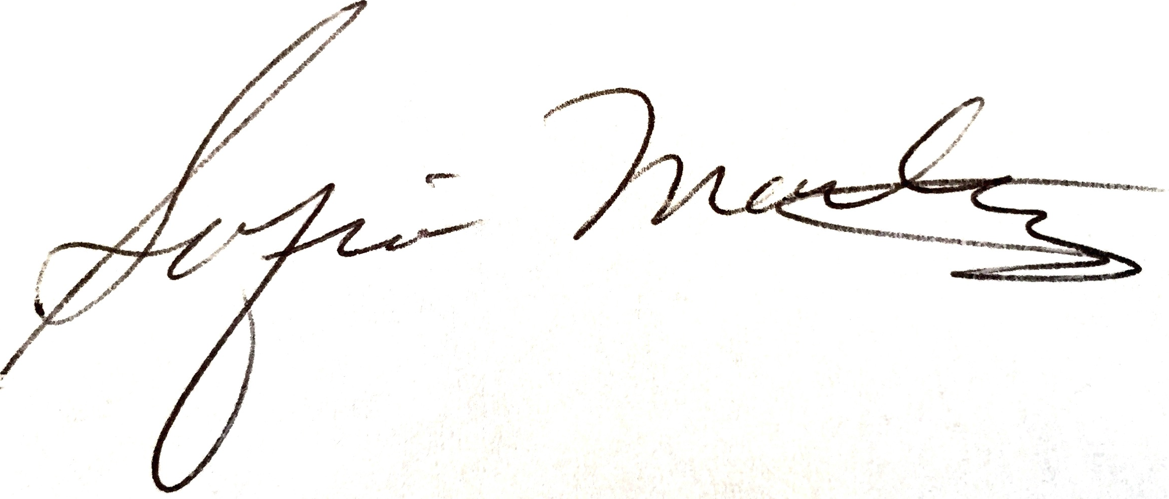
Sofia Martinez, Co-Coordinator
Los Jardines Institute
803 La Vega Dr. SW
Albuquerque, NM 87105
(505) 573-1904

