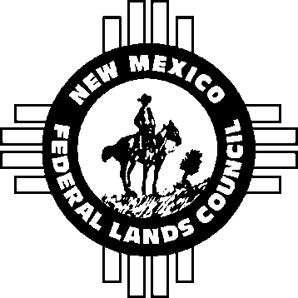

New Mexico Federal Lands Council

3417 Avenida Charada NW / Albuquerque NM 87107

Phone: 575.590.7587

Email: [newmexicofederallandscouncil@gmail.com](mailto:newmexicofederallandscouncil@gmail.com)

May 16, 2025

New Mexico Environment Department

Occupational Health and Safety Bureau

1190 St. Francis Drive, Suite N4050

Santa Fe, New Mexico 87505 **RE:  Proposed Heat Illness and Injury Prevention Rule**

On behalf of the membership of the New Mexico Federal Lands Council, representing federal lands allotment owners and State Trust Lands leases, thank you for the opportunity to comment on the “Proposed Heat Illness and Injury Prevention Rule” by the New Mexico Environment Department (NMED), Occupational Health and Safety Bureau (OHSB).

We respectfully request that this proposed rule be withdrawn. It is a solution in search of a problem and government interference in private enterprise.

Our members are part of the agricultural community that feeds the U.S. and some of the rest of the world. Many have worked on their family ranches for three or more generations with no significant impacts from the heat.

However, common sense is something we are known for. Adaptability is another trait of ranchers and farms. We know how to get up before daylight and get our work finished before it gets hot. We are also acutely aware of water requirements for both man and beast during heat.

New Mexico has a high rate of food insecurity, with 15.2 percent of residents experiencing it. This is above the national average of 13.5 percent. A significant portion of these food-insecure individuals are children, with 26 percent of children facing food insecurity in 2020, according to [New Mexico Voices for Children](https://www.nmvoices.org/wp-content/uploads/2021/03/Food-Insecurity-Rpt-Sept-2021-update.pdf).

In 2023, New Mexico had the third-highest poverty rate in the US, at 17.8 percent. This translates to approximately 368,669 people living in poverty. The state's poverty rate has been consistently high, with New Mexico frequently ranking among the poorest states in the country.

Why would the State propose a rule that has a strong possibility of increasing these rates? Putting agriculture out of business will only increase food insecurity and poverty in New Mexico by increasing food prices and reducing supply.

Where is there research and data to support such over-reach? Perhaps there is no federal rule on this subject because it is unsupportable. How prevalent is heat-stroke in New Mexico?

For these reasons and many more, the NMFLC respectfully request that NMED withdraw the Proposed Heat Illness and Injury Prevention Rule.

Thank you in advance for your time and attention. Should we be of further service, please let us know.

Sincerely,

**Ty Bays**

President