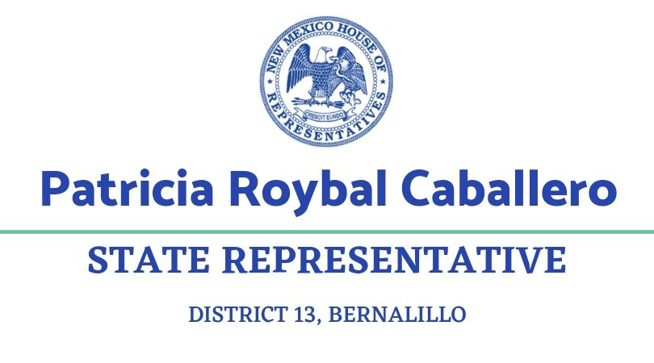May 30, 2025
NM Environmental Improvement Board
c/o NM Environment Department
1190 St. Francis Drive, Suite N4050
Santa Fe, NM 87505

Dear Chair Suina and Bureau Chief Peck:
I write to support the petition to the Environmental Improvement Board to adopt a proposed rule, NMAC 11.5.7 Heat Illness and Injury Prevention Regulation, on occupational heat illness and injury prevention, as proposed by the New Mexico Environment Department (NMED), Occupational Health and Safety Bureau (OHSB).
The need to protect employees from more frequent and more intense excess heat illnesses and injuries grows with our changing weather. In addition, the proposed rule can benefit employers by mitigating the productivity losses seen when workers are exposed to occupational heat stress.
I understand your process allows for the consideration of potential changes to the proposed Rule. As a Representative I acknowledge the many concerns expressed to date in public comment to the EIB, and urge the Board to seriously consider reasonable adjustments to the Rule.

Public comments opposed to the Rule include a great deal of unscientific claims as well as important information which may lead you to consider amending the Rule prior to adoption
The NMED proposed Rule does incorporate best practices and science-based solutions to keep workers safe from exposure to heat at the workplace, including: coverage of both indoor and outdoor workers; calling for written Heat Injury and Illness Prevention Plans; providing for comprehensive worker training; implementing common sense preventive strategies including water, shade/cooling rooms, paid rest breaks, and acclimatization; and using trigger temperatures that are based on physiological science and years of experience from other states with heat standards. This standard will save lives, so we support the proposal in general while not endorsing every provision per se.

Evidence shows OSHA and voluntary employer action is not sufficiently protective, and the situation is rapidly deteriorating as Emergency Department visits due to heat stress in New Mexico doubled between early 2010s and 2023. Deaths due to heat stress more than tripled between early 2010s and 2023. The southeast and southwest regions experience the highest rate of heat stress ED visits and deaths. Heat waves are becoming more frequent, last longer and are more intense than in the past.
The federal requirements are insufficient to address heat-related illnesses and safety –and so too is a reliance solely on the good will of employers who are in business to maximize their profits.
- Federal OSHA did a literature review to determine its temperature triggers and concluded that a heat trigger of 80 degrees would capture 96-100 percent of heat-related fatalities and virtually all non-fatal illnesses. (starting on page 70745). They cited studies that showed that even acclimatized workers exceeded the exposure limits for safety in heat at 90 degrees and needed preventive work breaks, and that unacclimated ones hit the exposure limits at 80 degrees.
- A CalOSHA (state of California) investigation in 2006 (right after their outdoor rule went into effect) found that heat illnesses occurred in temperatures as low as 80 degrees. https://www.dir.ca.gov/dosh/heatillnessinvestigations-2006.pdf
Maintaining the status quo in the face of our increasing temperatures leads to a loss of productivity, and increased accidents. It is true some employers provide shade, cooling gear, and work rotation, but this is not the case across the entire state economy. If all employers provided preventative measures, costs would equalize among employers. Compliance with these rules will not only protect workers but will also level the playing field between businesses.
Productivity losses that businesses experience now are due to workers suffering the effects of heat-related illnesses. A systematic review of studies on work and heat published in the Lancet (The highly regarding medical profession publication) found that at the end of a work shift under heat stress 30 percent of workers reported lost productivity. A meta study of heat and productivity loss among construction workers found that 60 percent of those workers exposed to high heat lost productivity. The Rule will lead to lower staff turnover; reduced absenteeism; reduced accidents; and reduced hospital care costs.
A study of Washington State workers compensation claims found that the median number of lost working days for time loss claims was 6 days. In the U.S. as a whole, in 2021 agriculture, construction, manufacturing, and service sectors lost 2.5 billion hours of labor to worker exposure to heat, and in 2020 the costs to the economy may have been roughly $100 billion.
It has wrongly been suggested employers should be able to substitute PPE like cooling vests or other controls like misters for preventive work breaks: this will leave workers unprotected from heat-related illnesses and does not adhere to the best practice of following the hierarchy of controls.
PPE is the least effective tool for health and safety goals and places an undue burden on the worker to protect themselves, while isolation (or removing people from the hazard) ranks more highly. A study conducted by UT Houston found that cooling vests were initially effective in lowering worker temperature, but rapidly lost effectiveness as gel packs warmed.
I urge the Environmental Improvement Board to adopt, perhaps with reasonable modifications, the proposed Occupational Heat Illness and Injury Prevention rule currently under consideration.
Thank you for your consideration of my concern and perspective.
Respectfully yours,
Patricia Roybal Caballero
pat.roybalcaballero@nmlegis.gov
patriciafornm@gmail.com

