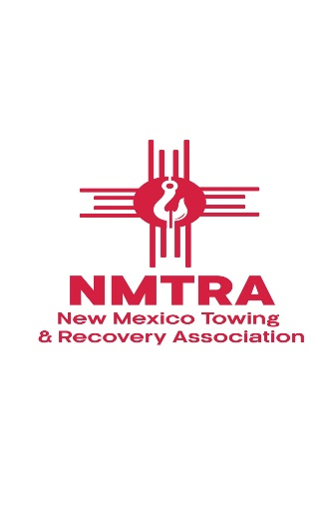
1111 10th St Box 506 Alamogordo, NM 88310 nmtrapresident@gmail.com
RE: Docket No. OSHA-2021-0009 – Heat Injury and Illness Prevention in Outdoor and Indoor Work Settings
To Whom It May Concern:
As the President of the New Mexico Towing and Recovery Association (NMTRA), I am writing in strong opposition to the proposed rule on Heat Injury and Illness Prevention in Outdoor and Indoor Work Settings (Docket No. OSHA-2021-0009), published on August 30, 2024.
While we agree that heat stroke and heat-related illness are serious concerns and that safety measures must always be taken seriously, this proposed rule imposes unrealistic and unworkable mandates on industries such as ours, whose operations are inherently and unavoidably conducted outdoors.
The towing and recovery industry is 100% outdoor-based, except for the limited time operators are driving between calls. Our teams respond to accidents, breakdowns, and emergencies in extreme conditions—often under intense heat, at night, or during inclement weather. In New Mexico, the summer months are the busiest time of year, due in part to the increased number of overheated vehicles and tire failures. Quick response is critical not just for the success of our businesses but for public safety. We do not have the luxury of delaying highway recoveries or emergency tows so that workers can wait out the heat. Doing so would endanger stranded motorists, worsen traffic conditions, and delay law enforcement or emergency medical services access to scenes.
Further, NMTRA members already take the necessary steps to protect our workers. We provide unlimited access to water, encourage cool-down periods as needed, and support every employee's right to stop if they feel unwell. These practices are common-sense and already in place—not because of a federal mandate, but because we care about our people.
This proposed rule does not reflect the reality of our work and would render many small and medium-sized towing companies across New Mexico—and nationwide—unoperable. The towing industry cannot stop operations every time the temperature exceeds an arbitrary threshold. The economic and safety consequences of such a requirement would be devastating.
We urge OSHA to reconsider and revise this rule to reflect the diversity of working environments across the country and to recognize that industries like ours cannot function under rigid, one-size-fits-all standards. Solutions must be flexible, adaptable, and based on realistic conditions—not blanket policies that ignore industry-specific needs.
Respectfully submitted,
Amy Barela
President
New Mexico Towing and Recovery Association (NMTRA)

