






O: (505) 476-3700
400 Tijeras Avenue NW, Suite 100
Albuquerque, NM, 87102
GREATERABQ .COM



June 26, 2026

Secretary James Kenney
New Mexico Environment Department
1190 St. Francis Drive
Santa Fe, NM 87505

RE: Support for Project Jupiter

Dear Secretary Kenney:

On behalf of the Greater Albuquerque Chamber of Commerce, we write in support of Project Jupiter and the significant opportunity it represents for economic development, job creation, infrastructure investment, and long-term growth in New Mexico.

The Greater Albuquerque Chamber of Commerce works with government, business, and community partners to promote and develop a welcoming business environment and a thriving, diverse economy in New Mexico. Through our Plan of Action, the Chamber has placed a clear emphasis on the business of economic growth, including efforts to help diversify and grow our private sector, strengthen key industries, and support pro-business policies that allow New Mexico to better compete for jobs, investment, and opportunity.

Project Jupiter aligns directly with those goals. As proposed, the project would bring substantial private investment to New Mexico, support thousands of construction jobs, create long-term employment opportunities, and expand the tax base needed to support schools, public services, infrastructure, and local communities. At a time when states across the country are competing aggressively for major economic development projects, New Mexico should be prepared to welcome responsible investments that create jobs, strengthen communities, and help diversify our economy. The Chamber’s economic development work is organized around the understanding that major opportunities often affect multiple sectors at once, including construction, real estate, utilities, technology, professional services, education, workforce development, and local government. Project Jupiter is exactly that kind of opportunity. Its potential impact extends beyond a single site or single employer. It has the ability to support a broader ecosystem of New Mexico workers, contractors, suppliers, small businesses, community partners, and public institutions.

We also appreciate that Project Jupiter includes commitments related to workforce development, education, local infrastructure, water system improvements, and community organizations. Those commitments matter. Economic development is strongest when it produces both immediate job opportunities and lasting community benefits. Investments in training, upskilling, education, water infrastructure, and nonprofit partners can help ensure that local residents and businesses share in the benefits of growth.

For the Chamber, this project also reflects a broader vision for New Mexico’s future. Our state must continue to build an economy that is more competitive, more diverse, and more capable of retaining and attracting talent.

That means supporting opportunities in technology, advanced infrastructure, logistics, energy, construction, and other sectors that can create meaningful career pathways for New Mexicans. Project Jupiter has the potential to contribute to that effort in a significant way.

We also believe the project’s proposed use of fuel cell technology to power the facility is an important element of the proposal and one that is directly relevant to the Department’s review. For a project of this scale, the method of power generation matters. A commitment to fuel cells reflects an effort to use innovative energy infrastructure that can provide reliable power while offering meaningful environmental advantages compared to many conventional alternatives. That approach is consistent with the broader principle that major economic development projects should be evaluated not only for their job creation and investment potential, but also for the steps they take to reduce environmental impacts, improve infrastructure, and support responsible long-term growth.

We recognize and respect the important role of the New Mexico Environment Department in reviewing projects carefully and ensuring compliance with applicable environmental and public health standards. Responsible growth and regulatory accountability should go hand in hand. At the same time, we believe it is appropriate for the Department to consider the substantial economic, workforce, infrastructure, and community benefits associated with Project Jupiter as part of its review.

New Mexico has an opportunity to demonstrate that it can compete for transformative private investment while also expecting serious commitments to community benefit, infrastructure, and responsible development. Project Jupiter represents such an opportunity. For these reasons, the Greater Albuquerque Chamber of Commerce supports Project Jupiter and encourages the New Mexico Environment Department to give full and fair consideration to the project and the benefits it can provide to New Mexico workers, businesses, and communities.

Thank you for your consideration.

Sincerely,

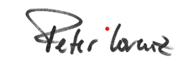

Peter Lorenz Terri Cole
Chairman of the Board President and CEO
Greater Albuquerque Chamber of Commerce Greater Albuquerque Chamber of Commerce

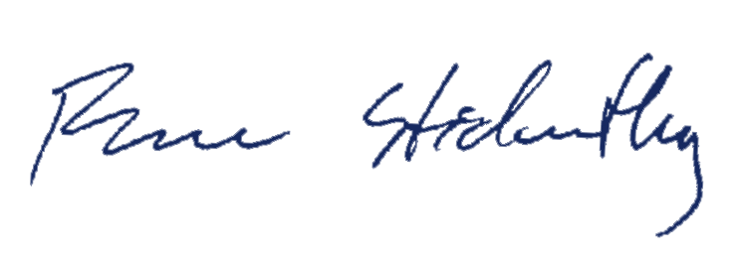
Bruce Stidworthy
Local Government Chairman
Greater Albuquerque Chamber of Commerce

