
June 18, 2026

New Mexico Environmental Improvement Board c/o New Mexico Environment Department
1190 St. Francis Drive, Suite N4050 Santa Fe, NM 87505

Re: Support for Project Jupiter and Its Air Quality Permit Application

Dear Members of the Board,

On behalf of the Associated Builders and Contractors of New Mexico (ABC NM), representing merit shop contractors, specialty trades, suppliers, and construction professionals across our state, we write in support of the air quality permit applications for Project Jupiter (Yucca Growth Infrastructure).

From a construction and infrastructure standpoint, Project Jupiter represents a historic opportunity for New Mexico’s building industry and workforce. As the largest private investment in our state’s history, this project will activate thousands of skilled craft professionals and contractors while setting a new standard for large-scale, technologically advanced development in southern New Mexico.
During the construction phase alone, Project Jupiter is expected to generate over 4,000 construction jobs. These are not temporary economic ripples — they represent sustained, multi-year opportunities for general contractors, subcontractors, specialty trades, suppliers, and local small businesses. This level of activity strengthens the entire construction ecosystem, from apprentices entering the trades to established firms expanding their capacity and workforce.

ABC NM is particularly encouraged by the project’s “Doña Ana First” hiring commitment and its $1.5 million investment in workforce training partnerships with local schools and colleges. Workforce development is central to our mission. Investments like these help ensure that residents are equipped with the technical skills necessary to succeed not only on this project, but on future infrastructure and industrial developments across the region.

Beyond jobsite impact, Project Jupiter will deliver long-term economic stability to Doña Ana County. The projected $360 million in direct payments to the county will strengthen public education, public safety, and essential services — the very systems that support a healthy construction workforce and thriving communities. Additionally, the $6.9 million commitment to community investment reinforces a broader vision of responsible growth.

It is notable that the new fuel-cell design runs without combustion and reduces emissions about 92% compared to the original gas-turbine plan; this change was made after listening and responding to citizen concerns about emissions.

For ABC New Mexico, Project Jupiter is not simply a data center project — it is a generational
infrastructure investment that strengthens our skilled workforce, expands opportunity for New Mexico contractors, and positions our state as a leader in advanced construction and innovation.
We respectfully urge the Board to approve the air quality permit applications and allow this transformative project to move forward. Thank you for your leadership and commitment to responsible economic growth in New Mexico.

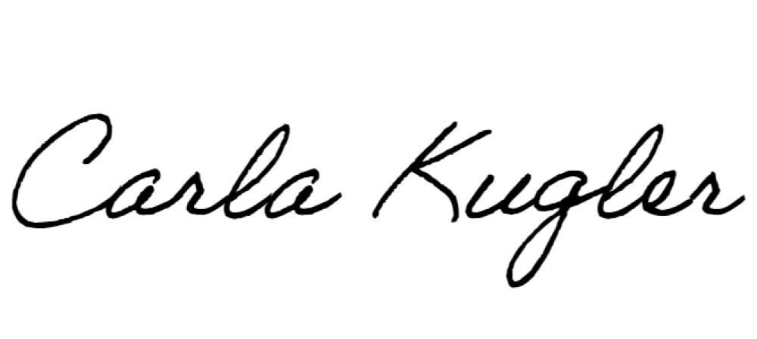
Sincerely,

Carla Kugler President & CEO
Associated Builders and Contractors of New Mexico

