June 5, 2024

Abiy Berehe, Rule Project Manager
Water Availability Division
Texas Commission on Environmental Quality

Sent via: TCEQ Public Comments system

Re: Rule Project Number 2024-006-230-OW

Dear Mr. Berehe,

Texas Groundwater Association (TGWA) is a non-profit organization with over 2,000 members representing water well drillers, pump installers, manufacturers, suppliers, and groundwater science professionals working together to support the water well industry and improve the education and science of groundwater resources within the state.

With the passage of SB 2440 (88th Regular Session), the Texas Commission on Environmental Quality is required to adopt rules in accordance with changes in law. Given that these rules have the potential to impact TGWA's membership, it is important to share our thoughts and expertise concerning the rule changes currently under consideration by the Commission.

TGWA would like to enter the following statement for consideration:

TGWA recognizes that groundwater and its availability have significant ramifications with regard to private property rights in this state. As such, we believe access to that resource should be treated fairly and with minimal government intervention. At the same time, we also recognize the need for appropriate groundwater management to ensure a stable supply for future generations of Texans.
Given these guardrails, TGWA recommends that any statements of “credible evidence” regarding the assurance of current and future groundwater availability as required when seeking a waiver to the requirements of Local Government Code §212.0101 and §232.0032 be addressed by the local Groundwater Conservation District (GCD) or the Texas Water Development Board in jurisdictions which do not have GCD.

Thank you for considering these recommendations. TGWA very much appreciates the efforts of TCEQ staff on these essential issues.

Please let me know if you have any questions or if I can be of any assistance.

Sincerely,

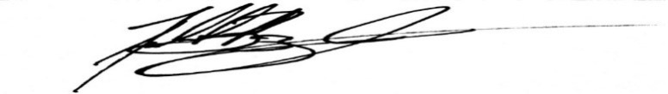
Bobby Bazan
Executive Director, TGWA

