June 20, 2024

Gwen Rico, MC 205

Office of Legal Services

Texas Commission on Environmental Quality

P.O. Box 13087

Austin, Texas 78711-3087

Re: Commissioners court waiver of groundwater availability certifications pursuant to Tex. Local Gov’t Code §232.0032

Dear Ms. Rico,

The Parker County Commissioners Court (“Court”) has concerns regarding what would constitute “credible evidence” of groundwater availability in situations where a proposed subdivision divides a tract into ten parts or less. The Commissioners Court seeks your guidance in this regard.

Where a land owner desires to subdivide a tract into ten parts or less, a full groundwater availability certificate (“GAC”) may be cost prohibitive. While the Court does not wish to inhibit these types of subdivisions, we want to make sure that sufficient groundwater is available. Several options have been raised. One option is a single-well test pump, measuring flow rate, drawdown, and recovery for a twenty-four hour period. While this option is not as costly as a full GAC, it also may be cost prohibitive.

Another option is using information from well logs in the vicinity of the proposed subdivision. Would this well-log information adequately determine groundwater availability for a small number of homes and be sufficient to substantiate waiving a full GAC?

Thank you for any guidance you may give in this matter.

Sincerely,

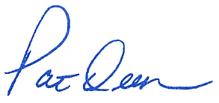

Pat Deen

Parker County Judge