§ 230.1. Purpose and Applicability
(a) Purpose and Applicability. The purpose of this chapter is to implement Texas Local Government Code, § 212.0101 and § 232.0032, relating to certifying groundwater availability in the platting of certain subdivisions utilizing groundwater as the source of water supply. Subdivisions utilizing groundwater as the source of water supply. Except as provided by Subsection (a-1), Iin the plat application and approval process, municipal and county authorities may shall require certification that adequate groundwater is available for a proposed subdivision if groundwater under that land is to be the source of water supply, and . The municipal or county authority may waive the required certification that adequate The municipal or county authority is not required to exercise their authority under Texas Local Government Code, § 212.0101 or § 232.0032. However, if they do exercise their authority, the form and content of this chapter must be used. A municipal or county authority responsible for approving plats is encouraged to consult with any applicable groundwater conservation district throughout the plat application and approval process in complying with this Chapter.

(a-1) Waiver. A municipal or county authority responsible for approving plats may waive the groundwater availability certification requirement prescribed by Subsection (a) and this chapter if:

(1) based on credible evidence, which shall include at a minimum the results of an aquifer test demonstrating sufficient groundwater availability that was completed no more than 3 years before the date of the plat application within a ¼-mile radius of the proposed subdivision and was conducted in compliance with any applicable rules of any groundwater conservation district in which the proposed subdivision will be located, and any other information required under the rules of such groundwater conservation district and the municipal or county authority, the municipal or county authority determines that sufficient groundwater is available and will continue to be available to the subdivision tract of land; and

(2) either:

(A) the entire tract proposed to be subdivided by the plat will be supplied with groundwater from the Gulf Coast Aquifer or the Carrizo-Wilcox Aquifer as those aquifers are delineated by the Texas Water Development Board; or

(B) the proposed subdivision divides the tract into not more than 10 parts.

(a-2) Exception to Waiver. A person subject to a waiver authorized by Subsection (a-1)(2)(b) regarding a subdivided tract of land must comply with the requirements of Subsection (a) and this chapter if:

(1) the tract is subsequently divided in a manner that results in the original tract being subdivided into more than 10 parts; or

(2) the municipal or county authority determines that the proposed subdivision is part of a series of proposed subdivision from an original tract that collectively includes more than 10 parts.
(b) Use of this chapter. If required by the municipal or county authority, the The plat applicant and the Texas licensed professional engineer or the Texas licensed professional geoscientist shall use this chapter and the attached form to certify that adequate groundwater is available under the land of a subdivision subject to platting under Texas Local Government Code, § 212.004 and § 232.001. These rules do not replace other state and federal requirements applicable to public drinking water supply systems. These rules do not replace the authority of counties within designated priority groundwater management areas under Texas Water Code, § 35.019, or the authority of groundwater conservation districts under Texas Water Code, Chapter 36, which may include, among other things, production limitations and well spacing requirements.

(c) Verification and Transmittal of data. If use of this chapter is required by the municipal or county authority, the The plat applicant shall:

(1) provide copies of the information, estimates, data, calculations, determinations, statements, and certification required by § 230.8 of this title (relating to Obtaining Site-Specific Groundwater Data), § 230.9 of this title (relating to Determination of Groundwater Quality), § 230.10 of this title (relating to Determination of Groundwater Availability), and § 230.11 of this title (relating to Groundwater Availability and Usability Statements and Certification) to the executive administrator of the Texas Water Development Board and to the applicable groundwater conservation district or districts; and

(2) using the attached form, attest that the information provided to meet the requirements of this chapter is accurate and copies of all information, estimates, data, calculations, determinations, statements, and submit proof that the certification and all supporting information required under subsection (1) as required under this chapter has have been provided to the executive administrator of the Texas Water Development Board and the applicable groundwater conservation district or districts. A completed copy of this form shall be included as part of an applicant’s plat application and must be submitted to the municipal or county authority prior to approval of the plat application. The executive director may make minor changes to this form that do not conflict with the requirements of these rules.

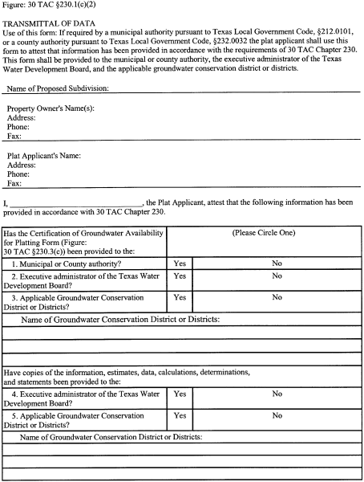​
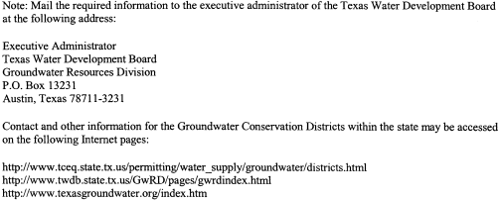​

§ 230.2. Definitions

The following words and terms, when used in this chapter, shall have the following meanings, unless the context clearly indicates otherwise. If a word or term used in this chapter is not contained in this section, it shall have the same definition and meaning as used in the practices applicable to hydrology and aquifer testing.

(1) Applicable groundwater conservation district or districts--Any district or authority created under Texas Constitution, Article III, Section 52, or Article XVI, Section 59, that:

(A) has the authority to regulate the spacing of water wells, the production from water wells, or both, and

(B) which includes within its boundary any part of the plat applicant’s proposed subdivision.

(2) Aquifer--A geologic formation, group of formations, or part of a formation that contains water in its voids or pores and may be used as a source of water supply.

(3) Aquifer test--A test involving the withdrawal of measured quantities of water from or addition of water to a well and the measurement of resulting changes in water level in the aquifer both during and after the period of discharge or addition for the purpose of determining the characteristics of the aquifer. For the purposes of this chapter, bail and slug tests are not considered to be aquifer tests. All aquifer tests required under this chapter, including the drilling, construction, operation and conversion or closure of any wells used to conduct such aquifer test, must be completed in accordance with the rules of the Texas Department of Licensing and Regulation and the applicable groundwater conservation district or districts.

(4) Certification--A written statement of best professional judgement or opinion as attested to on the Certification of Groundwater Availability for Platting Form contained under § 230.3(c) of this title (relating to Certification of Groundwater Availability for Platting).

(5) Drinking water standards--As defined in commission rules covering drinking water standards contained in Chapter 290, Subchapter F of this title (relating to Drinking Water Standards Governing Drinking Water Quality and Reporting Requirements for Public Water Systems).

(6) Executive administrator--The executive administrator of the Texas Water Development Board.

(7) Full build out--The final expected number of residences, businesses, or other dwellings in the proposed subdivision.

(8) Licensed professional engineer--An engineer who maintains a current license through the Texas Board of Professional Engineers in accordance with its requirements for professional practice.

(9) Licensed professional geoscientist--A geoscientist who maintains a current license through the Texas Board of Professional Geoscientists in accordance with its requirements for professional practice.

(10) Plat applicant--The owner or the authorized representative or agent seeking approval of a proposed subdivision plat application pursuant to municipal or county authority.

(11) Requirements applicable to public drinking water supply systems--The requirements contained in commission rules covering public drinking water supply systems in Chapter 290, Subchapter D of this title (relating to Rules and Regulations for Public Water Systems).

§ 230.3. Certification of Groundwater Availability for Platting
(a) Certification. The certification required by this chapter must be prepared by a Texas licensed professional engineer or a Texas licensed professional geoscientist.

(b) Submission of information. The plat applicant shall provide to the municipal or county authority, the executive administrator of the Texas Water Development Board, and the applicable groundwater conservation district or districts the certification of adequacy of groundwater under the subdivision required by this chapter.

(c) Form required. This chapter and the following form shall be used and completed if plat applicants are required by the municipal or county authority to certify that adequate groundwater is available under the land to be subdivided. The executive director may make minor changes to this form that do not conflict with the requirements of these rules.

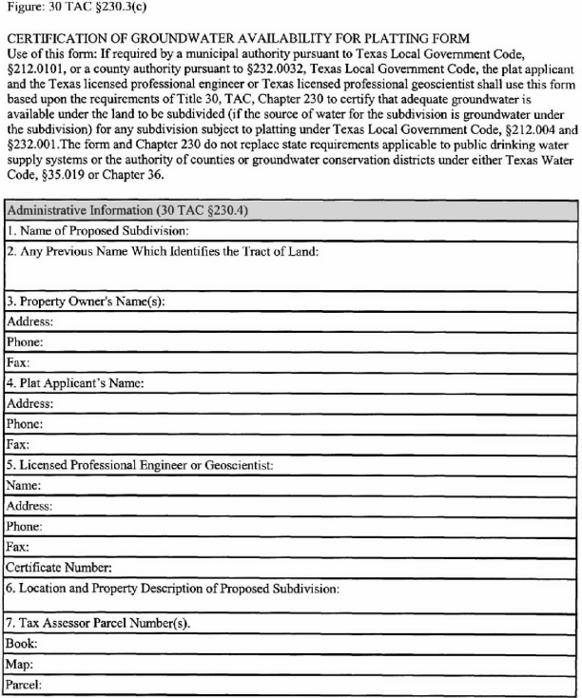​
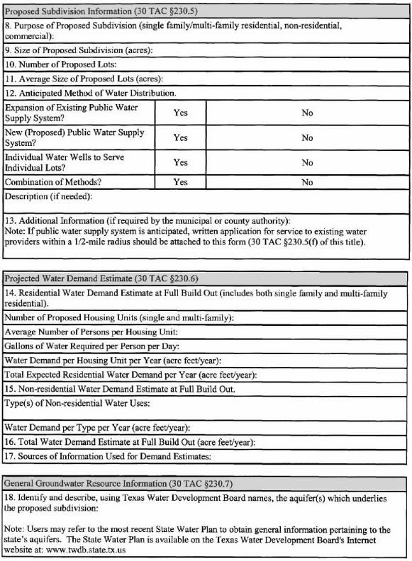​
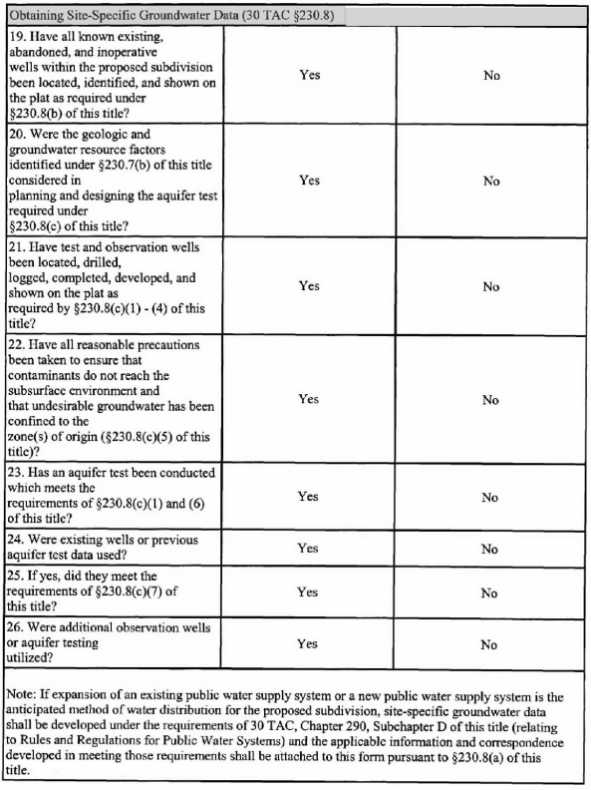​
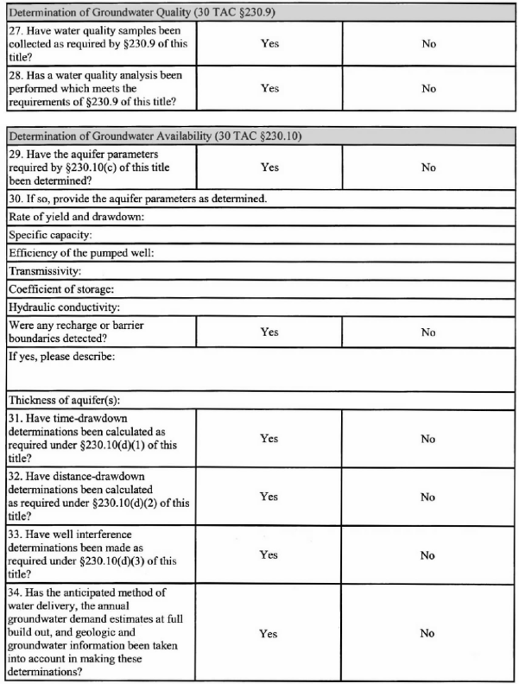​
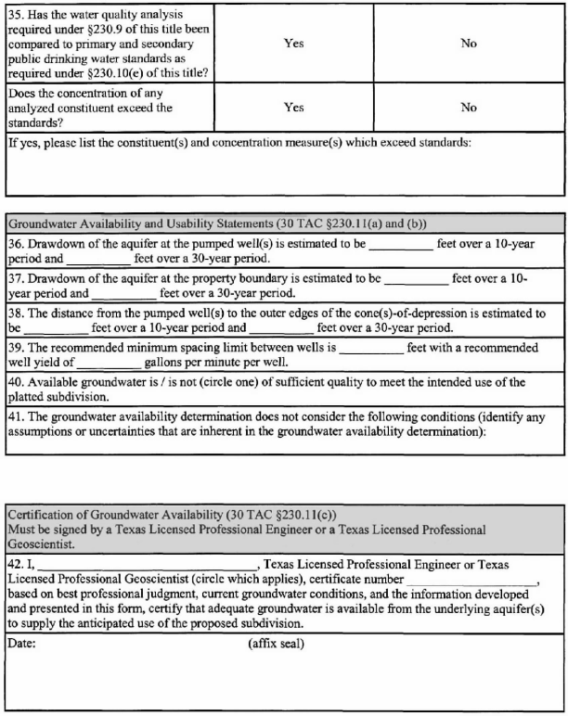​

§ 230.4. Administrative Information
At a minimum, the following general administrative information as specified in § 230.3(c) of this title (relating to Certification of Groundwater Availability for Platting), shall be provided for a proposed subdivision for which groundwater under the land will be the source of water supply:

(1) the name of the proposed subdivision;

(2) any previous or other name(s) which identifies the tract of land;

(3) the name, address, phone number, email address, and facsimile number of the property owner or owners;

(4) the name, address, phone number, email address, and facsimile number of the person submitting the plat application;

(5) the name, address, phone number, email address, facsimile number, and registration number of the licensed professional engineer or the licensed professional geoscientist preparing the certification as required in this chapter;

(6) the location and property description of the proposed subdivision; and

(7) the tax assessor parcel number(s) by book, map, and parcel; and
(8) the name, address, phone number, and facsimile number of the applicable groundwater conservation district or districts and the name and email address of the General Manager(s) of the district(s).

§ 230.5. Proposed Subdivision Information
At a minimum, the following information pertaining to the proposed subdivision shall be provided as specified in § 230.3(c) of this title (relating to Certification of Groundwater Availability for Platting):

(1) the purpose of the proposed subdivision, for example, single family residential, multi-family residential, non-residential, commercial, or industrial;

(2) the size of the proposed subdivision in acres;

(3) the number of proposed lots within the proposed subdivision;

(4) the average size (in acres) of the proposed lots in the proposed subdivision;

(5) the anticipated method of water distribution to the proposed lots in the proposed subdivision including, but not limited to:

(A) an expansion of an existing public water supply system to serve the proposed subdivision (if groundwater under the subdivision is to be the source of water supply);

(B) a new public water supply system for the proposed subdivision;

(C) individual water wells to serve individual lots; or

(D) a combination of methods;

(6) if the anticipated method of water distribution for the proposed subdivision is from an expansion of an existing public water supply system or from a proposed public water supply system, evidence required under § 290.39(c)(1) of this title (relating to Rules and Regulations for Public Water Systems) which shall be provided demonstrating that written application for service was made to the existing water providers within a 1/2-mile radius of the subdivision;
(7) if the anticipated method of water distribution for the proposed subdivision requires a permit or permit amendment under the rules of the applicable groundwater conservation district, a description of how the proposed water supply and method of water distribution complies with Chapter 36, Texas Water Code, and the rules of the applicable groundwater conservation district or districts; and

(7)(8) any additional information required by the municipal or county authority as part of the plat application.

§ 230.6. Projected Water Demand Estimate
(a) Residential water demand estimate. Residential water demand estimates at full build out shall be provided as specified in § 230.3(c) of this title (relating to Certification of Groundwater Availability for Platting). Residential demand estimates shall, at a minimum, be based on the current demand of any existing residential well including those identified under § 230.8(b) of this title (relating to Obtaining Site-Specific Groundwater Data), or § 290.41(c) of this title (relating to Rules and Regulations for Public Water Systems), and:

(1) the number of proposed housing units at full build out;

(2) the average number of persons per housing unit;

(3) the gallons of water required per person per day;

(4) the water demand per housing unit per year (acre feet per year); and

(5) the total expected residential water demand per year for the proposed subdivision (acre feet per year).

(b) Non-residential water demand estimate. Water demand estimates at full build out shall be provided for all non-residential uses as specified in § 230.3(c) of this title. Non-residential uses shall be specified by type of use and groundwater demand per year (acre feet per year) for each type of use. The estimate shall also include the existing non-residential demand of any well including those identified under § 230.8(b) of this title or § 290.41(c) of this title.

(c) Total annual water demand estimate. An estimate of the total expected annual groundwater demand, including residential and non-residential estimates at full build out (acre feet per year), shall be provided as specified in § 230.3(c) of this title.

(d) Submission of information. The sources of information used and calculations performed to determine the groundwater demand estimates as required by this section shall be provided made available to the municipal or county authority if requested. The plat applicant shall provide any additional groundwater demand information required by the municipal or county authority as part of the plat application.

§ 230.7. General Groundwater Resource Information
(a) Aquifer identification. Using Texas Water Development Board aquifer names, the aquifer(s) underlying the proposed subdivision which is planned to be used as the source of water for the subdivision shall be identified and generally described as specified in § 230.3(c) of this title (relating to Certification of Groundwater Availability for Platting).

(b) Geologic and groundwater information. The current groundwater availability model approved by the Texas Water Development Board provides baseline geologic and groundwater information and shall be included, as supplemented by site-specific data, for consideration. To meet the requirements of this chapter, the following geologic and groundwater information shall be considered in planning and designing the aquifer test under § 230.8(c) of this title (relating to Obtaining Site-Specific Groundwater Data):

(1) the stratigraphy of the geologic formations underlying the subdivision;

(2) the lithology of the geologic strata;

(3) the geologic structure;

(4) the characteristics of the aquifer(s) and their hydraulic relationships;

(5) the recharge to the aquifer(s), and movement and discharge of groundwater from the aquifer(s); and

(6) the ambient quality of water in the aquifer(s).

§ 230.8. Obtaining Site-Specific Groundwater Data
(a) Applicability of section. This section is applicable only if the proposed method of water distribution for the proposed subdivision is individual water wells on individual lots. If expansion of an existing public water supply system or installation of a new public water supply system is the proposed method of water distribution for the proposed subdivision, site-specific groundwater data shall be developed under the requirements of Chapter 290, Subchapter D of this title (relating to Rules and Regulations for Public Water Systems), rules of any applicable groundwater conservation district, and the information developed in meeting these requirements shall be attached to the form required under § 230.3 of this title (relating to Certification of Groundwater Availability for Platting).

(b) Location of existing wells. All known existing, abandoned, and inoperative wells within the proposed subdivision shall be identified, located, and mapped by on-site surveys. Existing well locations shall be illustrated on the plat required by the municipal or county authority. Such wells shall be identified with applicable well permit numbers from the applicable groundwater conservation district shall be provided. Any abandoned or inoperative wells must be reported to TDLR.

(c) Aquifer testing. Utilizing the information considered under § 230.7(b) of this title (relating to General Groundwater Resource Information), an aquifer test shall be conducted to characterize the aquifer(s) underlying the proposed subdivision. The aquifer test must provide sufficient information to allow evaluation of each aquifer that is being considered as a source of residential and non-residential water supply for the proposed subdivision. Appropriate aquifer testing shall be based on typical well completions. A municipal or county authority responsible for approving plats is encouraged to consult with any applicable groundwater conservation district in establishing any site-specific aquifer test requirements. An aquifer test conducted under this section utilizing established methods shall be conducted in accordance with the rules of any applicable groundwater conservation district and be reported as specified in § 230.3(c) of this title and shall include, but not be limited to, the following items.

(1) Test well and observation well(s). At a minimum, one test well (i.e., pumping well) and one observation well, shall be required to conduct an adequate aquifer test under this section. Additional observation wells shall be used for the aquifer test if it is practical or necessary to confirm the results of the test. The observation well(s) shall be completed in the same aquifer or aquifer production zone as the test well. The locations of the test and observation well(s) shall be shown on the plat required by the municipal or county authority. Test and observation well(s) must be constructed, operated, and subsequently closed or converted in accordance with applicable rules of TDLR and any applicable groundwater conservation district.

(2) Location of wells. The test and observation well(s) must be placed within the proposed subdivision and shall be located by latitude and longitude. The observation well(s) shall be located at a radial distance such that the time-drawdown data collected during the planned pumping period fall on a type curve of unique curvature. In general, observation wells in unconfined aquifers should be placed no farther than 300 feet from the test well, and no farther than 700 feet in thick, confined aquifers. The observation well should also be placed no closer to the test well than two times the thickness of the aquifer’s production zone. The optimal location for the observation well(s) can be determined by best professional judgement after completion and evaluation of the test well as provided in paragraph (4) of this subsection.

(3) Lithologic and geophysical logs. The test and observation wells shall be lithologically and geophysically logged to map and characterize the geologic formation(s) and the aquifer(s) in which the aquifer test(s) is to be performed.

(A) A lithologic log shall be prepared showing the depth of the strata, their thickness and lithology (including size, range, and shape of constituent particles as well as smoothness), occurrence of water bearing strata, and any other special notes that are relevant to the drilling process and to the understanding of subsurface conditions.

(B) Geophysical logs shall be prepared which provide qualitative information on aquifer characteristics and groundwater quality. At a minimum, the geophysical logs shall include an electrical log with shallow and deep-investigative curves (e.g., 16-inch short normal/64-inch long normal resistivity curves or induction log) with a spontaneous potential curve. The municipal or county authority may require additional log types to characterize the aquifer(s) for testing purposes.

(C) The municipal or county authority may, on a case-by-case basis, waive the requirement of geophysical logs as required under this section if it can be adequately demonstrated that the logs are not necessary to characterize the aquifer(s) for testing purposes.

(4) Well development and performance. The test and observation well(s) shall be developed prior to conducting the aquifer test to repair damage done to the aquifer(s) during the drilling operation. Development shall iensure that the hydraulic properties of the aquifer(s) are restored as much as practical to their natural state. Test and observation well(s) must be constructed, operated, and subsequently closed or converted in accordance with the applicable rules of TDLR and any applicable groundwater conservation district.

(A) Well development procedures applied to the well(s) may vary depending on the drilling method used and the extent of the damage done to the aquifer(s).

(B) During well development, the test well shall be pumped for several hours to determine the specific capacity of the well, the maximum anticipated drawdown, the volume of water produced at certain pump speeds and drawdown, and to determine if the observation well(s) are suitably located to provide useful data.

(C) Water pumped out of the well during well development shall not be allowed to influence initial well performance results.

(D) Aquifer testing required by this section shall be performed before any acidization or other flow-capacity enhancement procedures are applied to the test well.

(5) Protection of groundwater. All reasonably necessary precautions shall be taken during construction of test and observation wells to ensure that surface contaminants do not reach the subsurface environment and that undesirable groundwater (water that is injurious to human health and the environment or water that can cause pollution to land or other waters) if encountered, is sealed off and confined to the zone(s) of origin.

(6) Duration of aquifer test and recovery. The duration of the aquifer test depends entirely on local and geologic conditions. However, the test shall be of sufficient duration to observe a straight-line trend on a plot of water level versus the logarithm of time pumped. Water pumped during the test shall not be allowed to influence the test results. Aquifer tests shall be prohibited while nearby wells are pumping and during significant rain or recharge events. To ensure water levels are static, pre-test water-level measurements shall be conducted for at least 7 days prior to commencing an aquifer test under this section. Aquifer testing shall not commence until water levels (after well development) have completely recovered to their pre-development level or at least to 90% of that level.

(A) Unless expressly provided otherwise by rules of the applicable groundwater conservation district, Aat a minimum, a 24-hour uniform rate aquifer test shall be conducted. Testing shall continue long enough to observe a straight-line trend on a plot of water level versus the logarithm of time pumped. If necessary, the duration of the test should be extended beyond the 24-hour minimum limit until the straight-line trend is observed.

(i) If it is impractical to continue the test until a straight-line trend of water level versus the logarithm of time pumped is observed within the 24-hour limit, the test shall continue at least until a consistent pumping-level trend is observed. In such instances, failure to observe the straight-line trend shall be recorded.

(ii) If the pumping rates remain constant for a period of at least four hours and a straight-line trend is observed on a plot of water level versus the logarithm of time pumped before the 24-hour limit has been reached, the pumping portion of the test may be terminated.

(iii) The frequency of water level measurements during the aquifer test shall be such that adequate definition of the time-drawdown curve is made available. As much information as possible shall be obtained in the first ten minutes of testing (i.e., pumping).

(B) Water-level recovery data shall be obtained to verify the accuracy of the data obtained during the pumping portion of the test. Recovery measurements shall be initiated immediately at the conclusion of the pumping portion of the aquifer test and shall be recorded with the same frequency as those taken during the pumping portion of the aquifer test. Time-recovery measurements shall continue until the water levels have recovered to pre-pumping levels or at least to 90% of that level. If such recovery is not possible, time-recovery measurements should continue until a consistent trend of recovery is observed.

(7) Use of existing wells and aquifer test data.

(A) Unless expressly prohibited by the rules of the applicable groundwater conservation district, An an existing well may be utilized as an observation well under this section if sufficient information is available for that well to demonstrate that it meets the requirements of this section.

(B) Unless expressly prohibited by the rules of the applicable groundwater conservation district, The the municipal or county authority may accept the results of a previous aquifer test in lieu of a new test if:

(i) the previous test was performed on a well located within a 1/4-mile radius of the subdivision;
(ii) the previous test was performed no more than 3 years before the date of the plat application;

(ii) (iii) the previous test fully meets all the requirements of this section;

(iii) (iv) the previous test was conducted on an aquifer which is being considered as a source of water supply for the proposed subdivision; and

(iv) (v) aquifer conditions (e.g., water levels, gradients, etc.) during the previous test were approximately the same as they are presently; and
(vi) aquifer test data from the pumping well and observation well(s) from the previous test are available and calculations of hydraulic properties can be repeated and verified, which data and calculations shall be provided with the submission in accordance with 230.1(c).
A municipal or county authority responsible for approving plats is encouraged to consult with any applicable groundwater conservation district, or the TWDB if there is no groundwater conservation district, to determine the suitability of accepting the results of a previous aquifer test in lieu of a new test.

(8) Need for additional aquifer testing and observation wells. Best professional judgement shall be used to determine if additional observation wells or aquifer tests are needed to adequately demonstrate groundwater availability. The Theis and Cooper-Jacob nonequilibrium equations, and acceptable modifications thereof, are based on well documented assumptions. To determine if additional information is needed, in coordination with the applicable groundwater conservation district or districts, best professional judgement shall be used to consider these assumptions, the site-specific information derived from the aquifer test required by this section, the size of the proposed subdivision, and the proposed method of water delivery.

(d) Submission of information. The information, data, and calculations required by this section shall be provided made available to the municipal or county authority, if requested, to document the requirements of this section as part of the plat application.

§ 230.9. Determination of Groundwater Quality
(a) Water quality analysis. Water samples shall be collected near the end of the aquifer test for chemical analysis. Samples shall be collected from each aquifer being considered for water supply for the proposed subdivision and reported as specified in § 230.3(c) of this title (relating to Certification of Groundwater Availability for Platting).

(1) For proposed subdivisions where the anticipated method of water delivery is from an expansion of an existing public water supply system or a new public water supply system, the samples shall be submitted for bacterial and chemical analysis as required by Chapter 290, Subchapter F of this title (relating to Drinking Water Standards Governing Drinking Water Quality and Reporting Requirements For Public Water Systems).

(2) For proposed subdivisions where the anticipated method of water delivery is from individual water supply wells on individual lots, samples shall be analyzed for the following:

(A) chloride;

(B) conductivity;

(C) fluoride;

(D) iron;

(E) nitrate (as nitrogen);

(F) manganese;

(G) pH;

(H) sulfate;

(I) total hardness;

(J) total dissolved solids; and

(K) presence/absence of total coliform bacteria;
(L) volatile organic compounds; and
(M) radionuclides in counties where testing for naturally occurring radionuclides is required under the requirements of Chapter 290, Subchapter F of this title (relating Drinking Water Standards Governing Drinking Water Quality and Reporting Requirements for Public Water Systems).

(3) Conductivity and pH values may be measured in the field, and the other constituents shall be analyzed in a laboratory accredited by the agency according to Chapter 25, Subchapters A and B of this title (relating to General Provisions and Environmental Testing Laboratory Accreditation, respectively) or certified by the agency according to Chapter 25, Subchapters A and C of this title (relating to General Provisions and Environmental Testing Laboratory Certification, respectively).
(4) Water samples collected in accordance with this section shall include the following information in spreadsheet or table format:
(A) sample date;
(B) collection entity;
(C) statement of reliability; and
(D) name of the testing laboratory, if applicable, pursuant to Subsection (a)(3) of this section.

(b) Submission of information. The information, data, and calculations required by this section shall be provided made available to the municipal or county authority, if requested, to document the requirements of this section as part of the plat application.

§ 230.10. Determination of Groundwater Availability
(a) Time frame for determination of groundwater availability. At a minimum, both a short- and long-term determination of groundwater availability shall be made, each considering the estimated total water demand at full build out of the proposed subdivision. Groundwater availability shall be determined for ten years, 30 years, the joint planning period for the current adopted desired future conditions for aquifers under Section 36.108 of the Texas Water Code, and for any other time frame(s) required by the municipal or county authority.

(b) Other considerations in groundwater availability determination. Groundwater availability determinations shall take into account the anticipated method of water delivery as identified under § 230.5 of this title (relating to Proposed Subdivision Information) and will be compared to annual demand estimates at full build out as determined under § 230.6 of this title (relating to Projected Water Demand Estimate).

(c) Determination of aquifer parameters. The parameters of the aquifer(s) being considered to supply water to the proposed subdivision shall be determined utilizing the information considered under § 230.7 of this title (relating to General Groundwater Resource Information) and data obtained during the aquifer test required under § 230.8 of this title (relating to Obtaining Site-Specific Groundwater Data) for individual water wells or under Chapter 290, Subchapter D of this title (relating to Rules and Regulations for Public Water Systems) and reported as specified in § 230.3(c) of this title (relating to Certification of Groundwater Availability for Platting). The time-drawdown and time-recovery data obtained during the aquifer test shall be used to determine aquifer parameters utilizing the nonequilibrium equations developed by Theis or Cooper-Jacob, or acceptable modifications thereof. The following aquifer parameters shall be determined and provided in a spreadsheet format:

(1) rate of yield and drawdown;

(2) specific capacity;

(3) efficiency of the pumped (test) well;

(4) transmissivity;

(5) coefficient of storage;

(6) hydraulic conductivity;

(7) recharge or barrier boundaries, if any are present; and

(8) thickness of the aquifer(s).
(d) Determination of groundwater availability. Using the information and data identified and determined in subsections (b) and (c) of this section, the following calculations shall be made.

(1) Time--drawdown. The amount of drawdown at the pumped well(s) and at the boundaries of the proposed subdivision shall be determined for the time frames identified under subsection (a) of this section.

(2) Distance--drawdown. The distance(s) from the pumped well(s) to the outer edges of the cone(s)-of-depression shall be determined for the time frames identified under subsection (a) of this section.

(3) Well interference. For multiple wells in a proposed subdivision, calculations shall be made to:

(A) determine how pumpage from multiple wells will affect drawdown in individual wells for the time frames identified under subsection (a) of this section; and

(B) determine a recommended minimum spacing limit between individual wells, minimum well depth, and minimum well yields from the wells that will allow for the continued use of the wells for the time frames identified under subsection (a) of this section.

(e) Determination of groundwater quality. The water quality analysis required under § 230.9 of this title (relating to Determination of Groundwater Quality) shall be compared to primary and secondary public drinking water standards and the findings documented as specified in § 230.3(c) of this title.

(f) Determination of regulatory parameters. Groundwater availability determinations shall take into account the rules of the applicable groundwater conservation district or districts, including but not limited to rules regulating certain aquifer formations, well depth, well spacing, and well permitting to reliably determine whether the available groundwater is in fact accessible under the rules of the applicable groundwater conservation district or districts. If the proposed subdivision is to be located within a designated priority groundwater management area under Chapter 35 of the Texas Water Code, then groundwater availability determinations shall take into account any water availability requirements adopted by the county to prevent current or projected water use in the county from exceeding the safe sustainable yield of the county’s water supply pursuant to § 35.019 of the Texas Water Code (Water Availability).

(g) Submission of information. The information, data, and calculations required by this section shall be submitted to the municipal or county authority, if required, to document the requirements of this section as part of the plat application.

§ 230.11. Groundwater Availability and Usability Statements and Certification
(a) Groundwater availability and usability statements. Based on and citing to the information developed under § 230.10 of this title (relating to Determination of Groundwater Availability), the following information shall be provided as specified in § 230.3(c) of this title (relating to Certification of Groundwater Availability for Platting):

(1) the estimated drawdown of the aquifer at the pumped well(s) over a ten-year period and over a 30-year period;

(2) the estimated drawdown of the aquifer at the subdivision boundary over a ten-year period and over a 30-year period;

(3) the estimated distance from the pumped well(s) to the outer edges of the cone(s)-of-depression over a ten-year period and over a 30-year period;

(4) the recommended minimum spacing limit between wells, recommended well depth, and the recommended well yield; and

(5) the sufficiency of available groundwater quality to meet the intended use of the platted subdivision; and
(6) other parameters necessary to ensure compliance with the rules of the applicable groundwater conservation district(s) or groundwater availability rules adopted by a county in a designated priority groundwater management area.

(b) Groundwater availability determination conditions. The assumptions and uncertainties that are inherent in the determination of groundwater availability should be clearly identified as specified in § 230.3(c) of this title. These conditions must be identified to adequately define the bases for the availability and usability statements. These bases may include, but are not limited to, uncontrollable and unknown factors such as:

(1) future pumpage from the aquifer or from interconnected aquifers from area wells outside of the subdivision or any other factor that cannot be predicted that will affect the storage of water in the aquifer;

(2) long-term impacts to the aquifer based on climatic variations; and

(3) future impacts to usable groundwater due to unforeseen or unpredictable contamination.

(c) Certification. Based on best professional judgement, current groundwater conditions, applicable groundwater conservation district regulations, and the information developed and presented in the form specified by § 230.3(c) of this title, the licensed professional engineer or licensed professional geoscientist certifies by signature, seal, and date that adequate groundwater is available from the underlying aquifer(s) and accessible under the rules of the groundwater conservation district(s), if applicable, to supply the estimated demand of the proposed subdivision.

