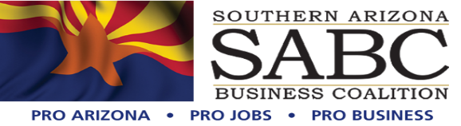

PO Box 57608 Tucson, AZ. 85732

520.247.3268

[www.soazbc.com](http://www.soazbc.com/)

January 12, 2024

Arizona Department of Environmental Quality

Water Quality Division, Surface Water Protection

Attn: Rachel Heinz

1110 W. Washington St.

Phoenix, AZ 85007

Re: Comment in support of renewal of AZPDES Permit No. AZ0026387 for January Mine Hermosa Project; LTF No. 95353

Dear Ms. Heinz:

On behalf of the over 10,000 employees directly and indirectly impacted by the mining industry here in Southern Arizona thank you for your efforts with respect to this project. The Southern Arizona Business Coalition (SABC), formed in 2012 stands for the responsible development of our human and natural resources.

This comment is provided in support of the proposal by the Arizona Department of Environmental Quality to renew the AZPDES permit for the January Mine Hermosa Project owned by South32 Hermosa Inc.

The mine proposed by South32 Hermosa will be a source of two critical minerals, manganese and zinc, that will aid in the country’s transition to clean energy sources. Partly for this reason, We understand that the project is the first mining project to be accepted into the federal FAST-41 program that attempts to streamline permitting without sacrificing environmental protection or opportunities for public input.

The project also will provide significant economic benefits to the local and regional economy in the form of hundreds of jobs during construction and operation, local/regional/state direct spending, and tax revenue. These benefits are critically important for Santa Cruz County, which has a very high unemployment rate. South32 Hermosa has displayed its commitment to the local community by already making significant investments in local infrastructure and education. The company has also acted in a transparent fashion, for example by sharing information with, and seeking input from, community members and its community advisory panel which includes several environmental organizations.

As explained by ADEQ, this would be a renewal of an existing permit. As We understand it, the treatment plants at the mine have been designed to meet all applicable federal and state legal requirements. The discharges are regulated not only by the permit currently under consideration, but also by another permit issued by ADEQ (a groundwater protection permit). Moreover, based on the ADEQ fact sheet, it appears that the changes being proposed to the existing permit would serve to make the renewal permit even more stringent and environmentally protective.

For these reasons, we support ADEQ’s proposal to issue the renewal permit.

Thank you for the opportunity to comment.

Sincerely,

 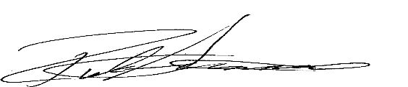

Co-Founder Co-Founder