January 12, 2024

Hello, and I hope I can thank you for listening to us, the people you serve. I appreciate the opportunity to make a fuller presentation of a web of thought about the current water permit proposal than can be fitted into the three minute public hearing slot.

My name is Robert Gay and I live in Patagonia

about 400 ft from the junction of Harshaw and Sonoita Creeks. I’m an amateur cartographer who has been mapping various aspects of the Patagonia area for the decade I’ve lived here. These maps have been for the town and three of the area’s conservation groups. They’ve included trails, parcels, ownership types, mining claims, watercourse and watersheds.

1. I’d like to speak about the upper part of Harshaw Creek, what’s upstream of the proposed Hermosa Project water discharge point. Because of the drama of massive downstream flows and the complexity of aquifers and surface conditions, the human impacts in the town and to the aquifer that supplies our drinking water, have been the focus of the attention and comments thus far.
2. The company’s stance has been that if they deliver OK water to the edge of their property, that’s all they’re responsible for. But watersheds do not work that way: they are a branched tree throughout the whole watershed, and THAT is what your department is charged to protect. It is not just the humans that are at risk, it is about three levels of the critically biodiverse Sky Island range.
3. Fenceline thinking applies also to the air discharges, so I’m commenting on the air discharge permit as well, and by point no. 13 will return to water.
4. At the Jan 11 hearing, a sophisticated air flow model was presented, showing a plume heading downwind and away from Patagonia. Manganese levels have apparently been tested in several areas around the Hermosa Project, and found to be at very low levels, suggesting that the town is probably going to be in the clear.
5. The flaws of this plume modeling are 1) it neglects other residents, such as those along Apache Road and Harshaw Creek Road, a few of whom I’m friends with; 2) It suggests that if toxic levels of a given pollutant flow in an area not populated, that’s OK. That’s clearly an anthropocentric position that neglects the importance of all other species in the ecosystem your department is charged to protect; it’s a reductionist model that does not consider the cumulative effects over time.
6. I am personally sensitive to the plume effect because my home is about 170 ft (downwind from the predominant SW winds) from the site of a former smelter which has left lead and arsenic in the soil around the intersection of Duquesne and School Streets. A badly communicated and skimpy remediation project was done by your agency about 5 years ago but didn’t change anything in our yard, so we only grow edible food in containers and don’t do other landscaping projects involving digging in the toxic dirt.
7. Coming back to South32, the plume effect for manganese because manganese dust is black. As an ardent Google Earth user, I offer this picture of the grounds around the Gemco shipping terminal on Groot Eyelandt, the biggest manganese mine in the world, majority owned by, and operated by South32 in the Northern Territory of Australia:

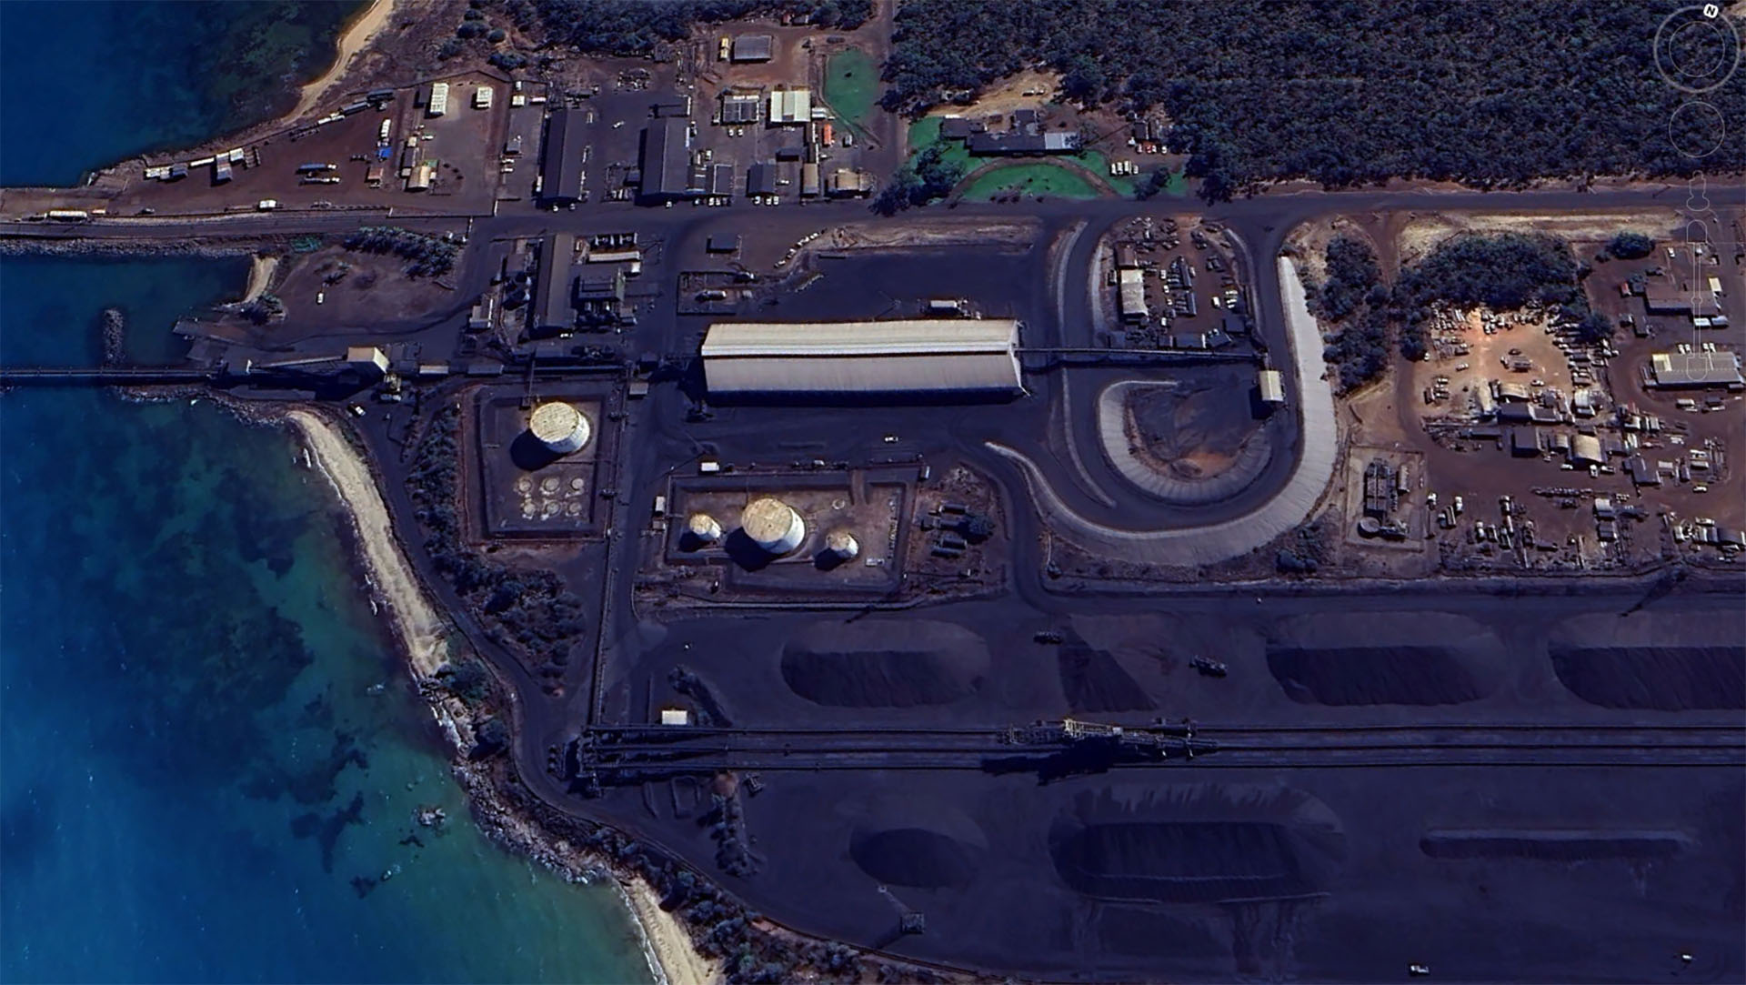 The facility is called the Ayangula loading port, northwest side of the

island and the date of the image is July 5 2023.

You can see sizable open piles of manganese ore in the bottom half of the photo, and that it migrates around the site. Note that manganese oxides, the likely result of airborne manganese interacting with oxygen, are brown not black.

1. For about two years, ABCNews of Australia has published a series of articles on the manganese problems of the islanders, and one includes includes this picture of the local travel of dust to nearby vehicles, roads and yards. This one’s from [a December 6 2021 article by Jane Bardon](https://www.abc.net.au/news/2021-12-07/manganese-mine-indigenous-community/100676998)

1. Past studies of manganese levels on Groote Eyelandt, a December 12, 2021 ABC News article reports, give guidelines for how far away from a source manganese dust must be monitored: *"Fine manganese dust within the respirable size range is found at levels exceeding international recommendations even 20km from manganese extraction, processing and storage facilities on Groote Eylandt," the researchers reported.*
2. There is a side story that gives insight into the political aspect of the operating methodology of South32. Digging into a Dec 18 2024 piece in this series, it turns out that the Northern Territory’s chief minister, Natasha Fyles, was recently forced to resign over an ethics scandal, one of several she’s experienced. *The Labor leader announced she was stepping down at a press conference this afternoon, saying she had failed to declare 754 shares, worth just under $2,500 in South32, a company which owns a manganese mine on Groote Eylandt.*

*Community members have* [*for years called for government testing*](https://www.abc.net.au/news/2021-12-07/manganese-mine-indigenous-community/100676998) *on the Groote Eylandt mine's health impact.*

*Earlier this year, Ms Fyles said the government would not investigate air pollution levels or health impacts following those requests, saying there was adequate monitoring already in place. Ms Fyles was also the territory’s health minister.*

[ABC’s Jan 7 2024 article](https://www.msn.com/en-us/money/markets/nt-government-still-won-t-investigate-health-concerns-of-mine-implicated-in-natasha-fyles-s-resignation/ar-AA1mAXTk) revealed that *The uncovering of the shareholding raised serious conflict of interest concerns for Ms Fyles due to her decision earlier in 2023, as both chief minister and health minister, not to look into the* [*health impacts*](https://www.abc.net.au/news/2021-12-07/manganese-mine-indigenous-community/100676998) *of the mine's dust particles.*

The importance of these revelations to Arizonans is that it points to the likelihood that South32 receives benefits from powerful shareholders, with whom it likely has backroom conversations. Why else would Ms. Fyles block a health investigation long called for by the affected locals near the mine and its shipping terminal?

Locally the ethics issue of possible influence of ADEQ CEO Karen Peters’ possible inflluence from South32 via her husband, South32 attorney Chris Thomas. Informally I’ve heard she recused herself from PARA’s legal actions against the Department. When, at a December Santa Cruz County Supervisors South32 Update presentation by President Pat Risner, he was asked about this seeming conflict of interest, Risner replied that they’d had their legal teem look into and were satisfied that there was no ethical issue. People I talked with afterwards were not remotely satisfied by the response, finding it to be quite consistent with Risner’s frequent use of phrases like “we’ve had our consultants look into it, and there’s no problem.”

1. Coming back to the behavior of plumes, an observant Australian watchdog looked at the particulate scans for 2.5 micron level now assessable from satellite views, and published this density map around Groote Eyelandt from Windy.com.

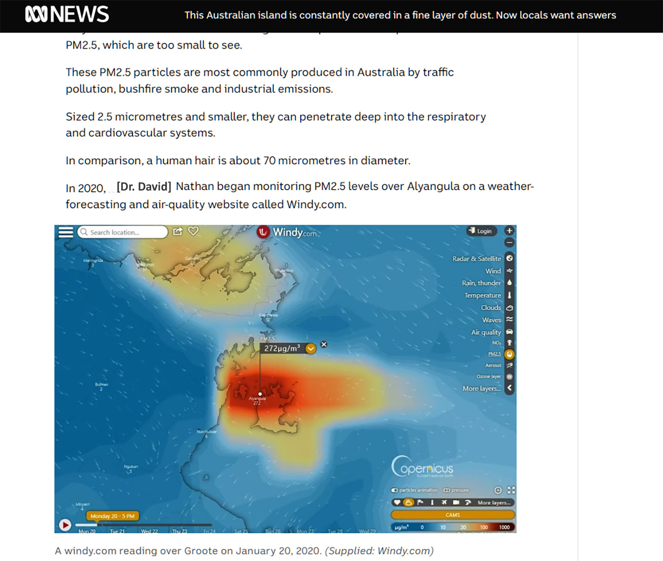

1. The center clearly is at the mine & transport part of the island, and the plume then heads eastward across the entire island, the end which is home to most of the 3,000 mostly Aboriginal residents. This points to the need for the Hermosa Project air quality permit, to the need for major monitoring systems well beyond the fenceline. To do otherwise is to do bad science. Emissions from South32’s private patented parcels can cause effects well beyond the fenceline, which is an arbitrary human construct having nothing to do with the living systems involved.
2. The possibilities of ecological and hydrological consequences downstream (disruption to wildlife, aquifers, residences and town infrastructure) have been well commented on, but the “cone of depression” has not received much attention in the community’s, and apparently the Department’s review of the dewatering proposal. My study of the Cone model scared the pants off me, and I concluded the horrors of 37 square miles of eventual dessication and plant death mean we are considering a Cone of Devastation. That’s the title of an article I wrote this summer for the August-September issue of the Patagonia Regional times, which you can find [here](https://patagoniaregionaltimes.org/cone-of-devastation/), or on the next page.

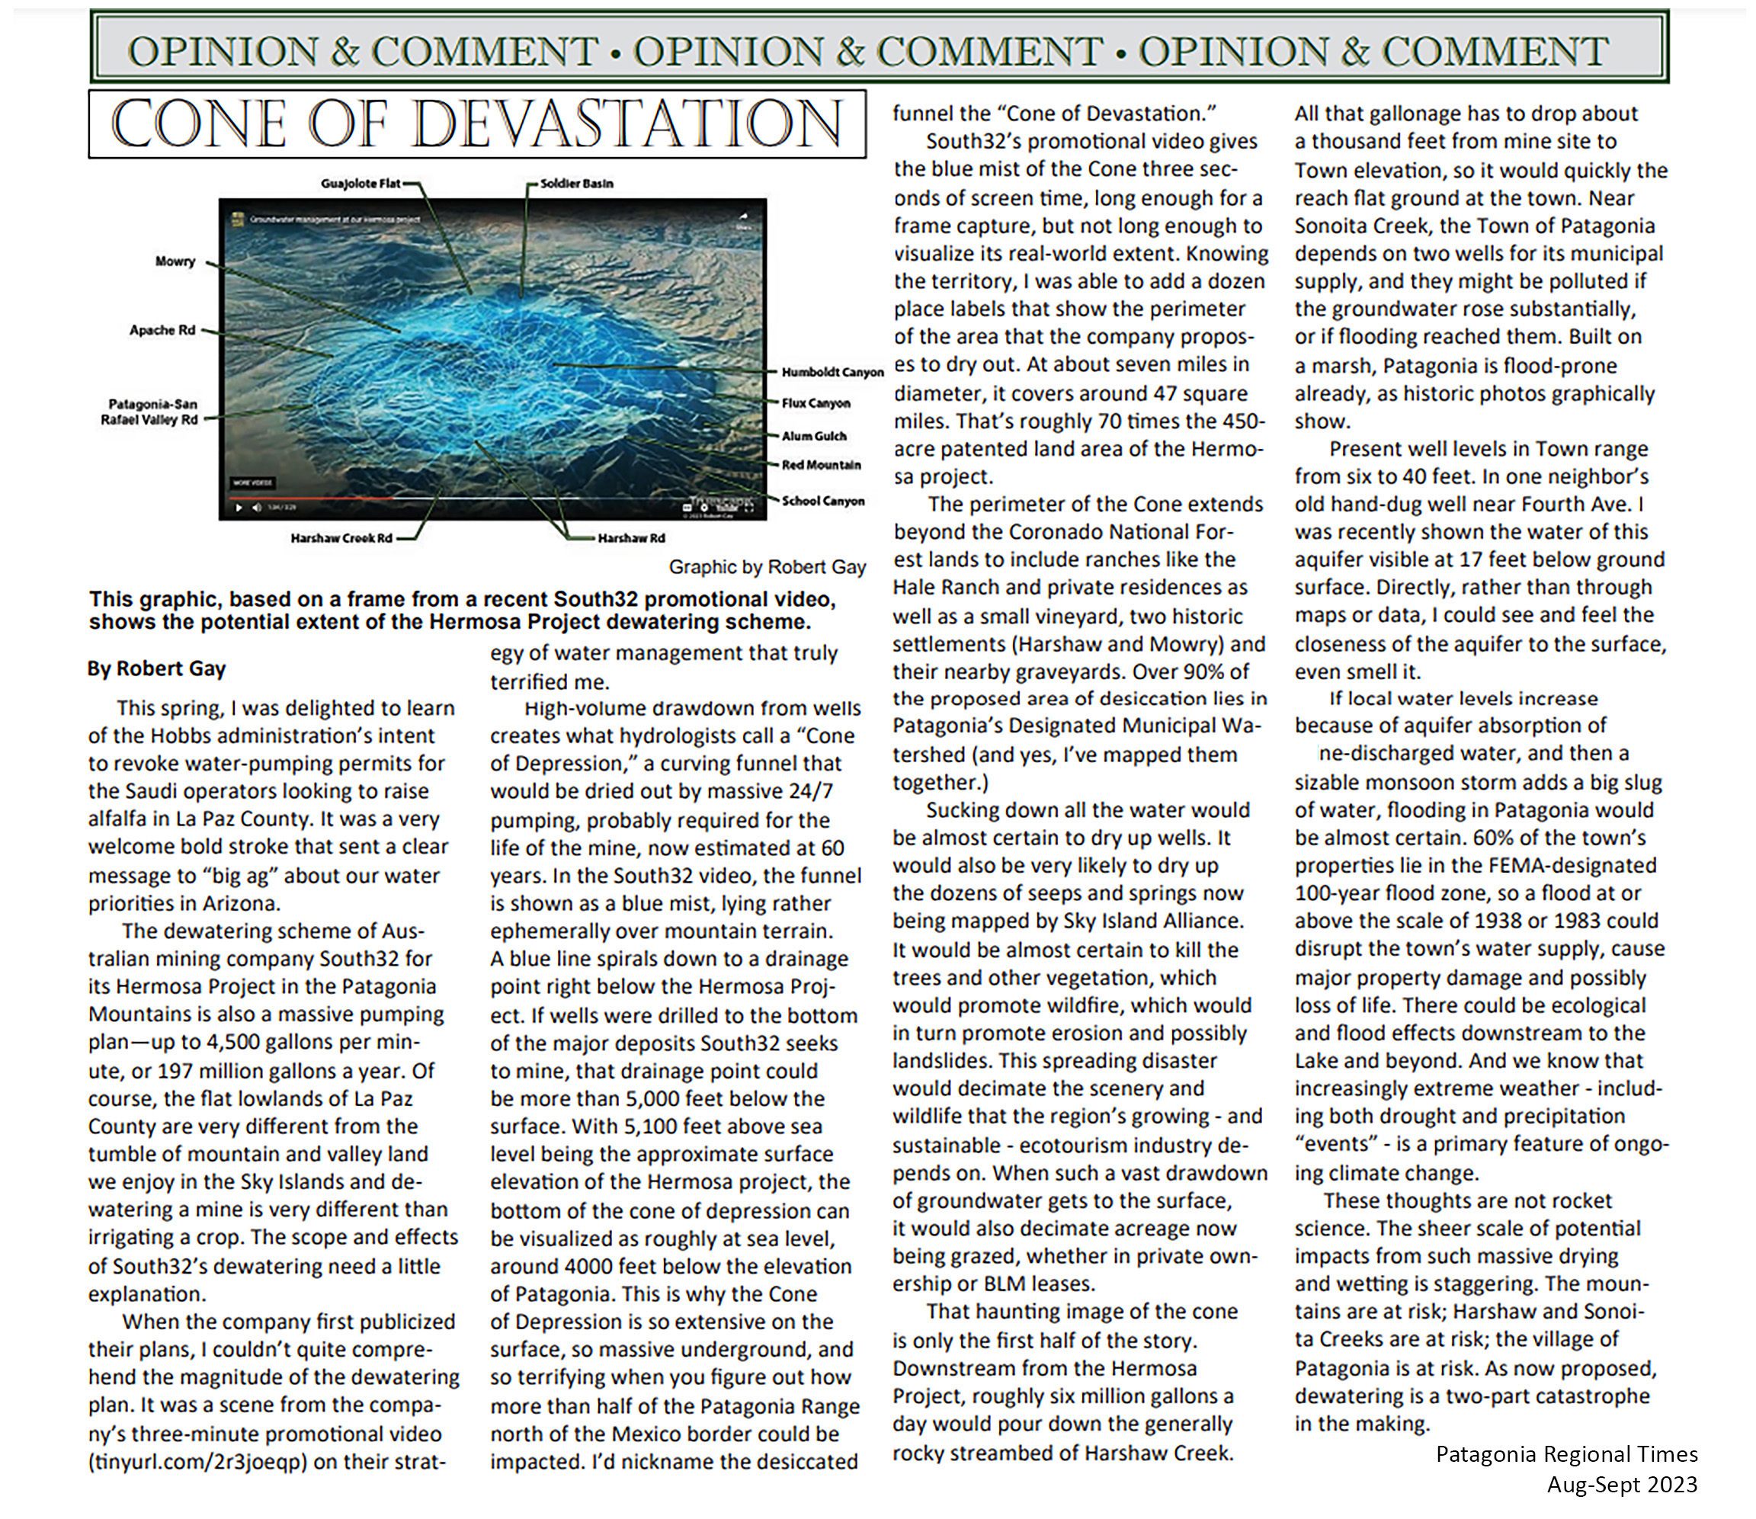

1. The 37-square-mile potential for radical ecological damage deserves very serious study of possible scenarios, at the level of a full environmental impact assessment which explores the potential of dewatering to dessicate the north portion of the entire Patagonia Mountains. To now issue a permit for the multi-decade dessication of this much territory is to give the company permission to evade the very sound and tested Federal provisions of the Environmental Protection Act. 37 square miles is 23,680 acres, roughly 43 times the project acreage currently undergoing its own scale of devastation. And I’d add that the company has not published any closure and remediation plans, so the Asarco-like legacy of enduring pollution, at a much bigger scale, seems guaranteed.
2. PARA’s parallel video, 5 minutes long, is at https://youtu.be/y2eeMLpPzpg
3. One of the speakers at the Jan 11 Patagonia Hearing, name of Kazarian (d’Antonio?), brought up, in a light way, the possibility that you as an agency, have the power to deny permits, or send them back to the applicant for any form of further study and modification you see as necessary. Were to reject the current version, you would then, in the view all 29 commenters last night, be showing that you serve citizens and wildlife more than corporations, and a foreign one at that.
4. A bit more Australian South32 history is relevant to know. In 2020, the New South Wales Planning dept rejected a South32 30-year extension plan for its long-producing Dendrobium Coal mine. With its second NSW coalmine, the Appin, about 6 miilion metric tons of metallurgical coal per year are produced, averaging recent years. Upon the rejection, the company appealed to another agency of the State, one concerned with defense and emergencies, and got around the rejection of their plans by getting coal declared a critical material, since most of their product goes to steel mills. As this was unfolding, they kept using water for mining, from the wetlands above their coal deposits. The wetlands are a part of the catchment area for the city of Sydney, and that city’s water utility at the time of the rejection mentioned above, had said of south32’s expansion plan, that it was flawed and should be sent back to the drawing board, the sequence I’m suggesting to you as a minimum, unless you find the courage and support for outright rejection.
5. In July of 2023, [as reported by ABC News of Australia](https://www.abc.net.au/news/2023-07-11/south32-agrees-to-record-payout-over-sydney-water-supply-take/102586374), South32 was fined 2.9 million (presumably Australian dollars) for diverting drinking water for 5 years without a permit, at the Dendrobium mine. The July 10 article states: *The agreement requires the miner to contribute almost $2.9 million towards improving local waterways in the Sydney water catchment as part of an enforceable undertaking.* *The agreement also includes a requirement to improve surface water management through investment in new technologies and to report the results of the monitoring annually.*
6. This bit of their global track record should make you very concerned about how the company might treat your permit. The Calabasas Alliance has gathered a list of about a dozen other “bad neighbor” behaviors and issues of South32’s various global ventures and it’s a startling pile of evidence on just what kind of entity we are dealing with. They can be reached at <https://youtu.be/y2eeMLpPzpg>, or through any of the Alliance’s speakers on the list from the January 11 hearing.

WHEN SOUTH32 RELEASED A 3-MINUTE FILM THIS SPRING, TITLED

GROUNDWATER MANAGEMENT AT OUR HERMOSA PROJECT.

3 SECONDS OF IT SHOWED THE CONE OF DEPRESSION, and as an amateur cartographer I located its extent on the ground: a 5 mile circle which

reaches from Red Mountain to Apache road, where I have friends and from

THREE-R canyon on the west to Harshaw Creek Road, where I also have friends.

This conceptual circle

https://patagoniaregionaltimes.org/cone-of-devastation/

Balaji Vaidyanathan