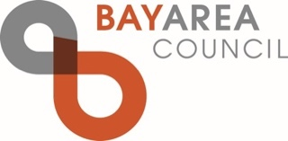

May 4, 2026

Chair Lauren Sanchez
California Air Resources Board
1001 I Street
Sacramento, CA 95814

Re: Proposed Amendments to the California Cap on Greenhouse Gas Emissions and Market- Based Compliance Mechanisms Regulation

Dear Chair Sanchez,

The Bay Area Council, which represents more than 370 of the region’s largest employers, appreciates the opportunity to comment on the California Air Resources Board’s (CARB) Proposed Amendments to the California Cap on Greenhouse Gas Emissions and Market- Based Compliance Mechanisms Regulation (known as the Cap-and-Invest Program).

For 80 years, the Bay Area Council has engaged business and civic-minded leaders to solve the most challenging regional issues to ensure the Bay Area is the most innovative, sustainable, inclusive, and globally competitive region for everyone who lives here.

While the 15-day changes to CARB’s proposal for the Cap-and-Invest Program make important improvements relative to the 45-day version, especially with respect to near-term cost impacts on energy and consumer goods, the Bay Area Council remains concerned that these Proposed Amendments have decreased, rather than increased, regulatory certainty for the post-2030 period. Removing 2031-2035 allocation decisions makes it more difficult for companies subject to the Program to evaluate future costs to inform long-lead time capital investments. This appears to represent a stark contrast to the petroleum stabilization efforts directed by Governor Newsom.
The Bay Area Council recognizes that it is not feasible to make additional changes in the current rulemaking given the timeline needed for implementing the near-term changes for 2027-2030. Given this constraint, the Bay Area Council urges CARB to provide positive long-term signals through appropriate implementation guidance and Board direction for future rulemakings. Subsequent proceedings to address the critical decisions that have been deferred from this rulemaking should commence as soon as possible.

As an overarching principle, California should adopt allowance budgets that reflect achievable near-term emissions reductions while minimizing emissions leakage and maintaining market stability and affordability. To achieve this, we respectfully provide the following policy recommendations to inform implementation of the current rulemaking as well as future rulemakings:
- Ensure the allowance budgets are based on achievable emissions reductions within the compliance period, particularly in the near-term.
- Minimize emissions leakage while preserving allowance supply, market stability, and affordability for covered entities.
- Establish stable, long-term Cap Adjustment Factors (CAFs) to support the investments necessary to meet California’s ongoing energy demands.
- Explicitly recognize petroleum refineries, crude extraction operations, and biorefineries as high leakage-risk sectors
- Consider implementing new or existing regulatory mechanisms to better prevent leakage based on the latest leakage studies and sector information.
- Ensure that carbon capture, utilization, and storage (CCUS) and carbon dioxide removal (CDR) projects are eligible to reduce covered emissions and are reflected in MRR net emissions reporting.
- Maintain the eligibility of CCUS projects for the Manufacturing Decarbonization Incentive that CARB added in the 15-day changes.
- Streamline reporting requirements to reduce administrative burden.
- CARB should clarify the type of operations to be included under a liquefied petroleum gas receiving facility.
- Eliminate MRR requirements that duplicate California’s Low Carbon Fuel Standard (LCFS)-specific data already reported under existing programs.

The Bay Area Council appreciates your consideration of these comments and welcomes the opportunity to discuss these concerns in more detail. Should you have any questions or comments regarding this position, please contact Adrian Covert, Senior Vice President, Public Policy acovert@bayareacouncil.org. Thank you for your consideration.

Sincerely,

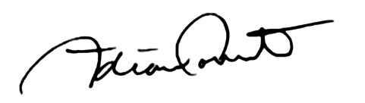

Adrian Covert
Senior Vice President, Public Policy
Bay Area Council

