CENTRAL CALIFORNIA ENVIRONMENTAL JUSTICE NETWORK – Comments

Due to the large number of in-person comments, our watch party attendees consented to providing written comments, seen on number 2 and 3.

- Maria Ruiz
Hello, my name is Maria Ruiz, and I am with Central California Environmental Justice Network. As a community resident, I am concerned about moving funding to bend the knee to industries that are without remorse hurting our communities in the name of business. These proposed changes are a direct attack to frontline communities that we work with: removing funding from AB617 CSC work, SAFER, and Cal. Climate Credit. I urge the board to reject the changes. Thank you.

2.
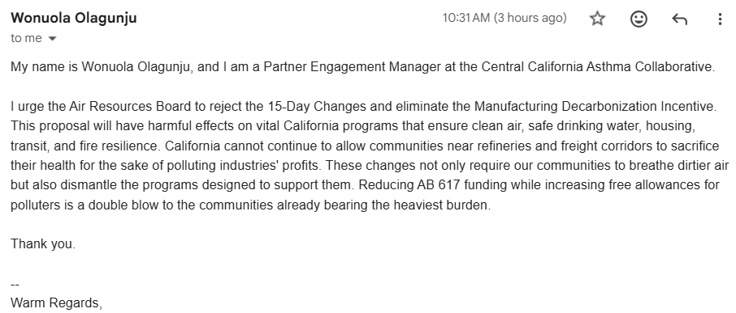
3.
