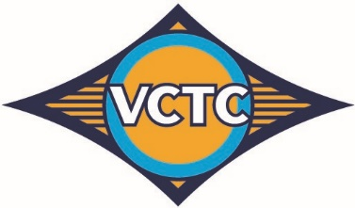

Ventura County Transportation Commission
VCTC is the regional transportation planning agency for Ventura County. In addition, VCTC operates intercity bus service and works with local bus operators on countywide transit programs.
VCTC respectfully opposes the proposed amendments due to their impact on Greenhouse Gas Reduction Fund revenues.
In Ventura County, the Low-Carbon Transit Operations Program directly supports the Youth Ride Free and College Ride programs, which are creating a new generation of transit riders while enabling transit agencies to maintain and expand service. LCTOP funds also support Free Fare Days for all riders and in the past have funded Metrolink weekend service and zero-emissions bus infrastructure.
If these amendments are approved, VCTC anticipates a loss of more than $1 million in revenue. Without LCTOP funding, we will be unable to continue the Youth Ride Free and College Ride Programs without identifying another funding source.
In Ventura County, the programs funded by LCTOP encourage mode shift from single-occupancy vehicles to public transit and support the transition to cleaner transportation technologies. They have particularly benefited people in disadvantaged and low-income communities by improving access to affordable, reliable, and environmentally friendly transportation options.
Combined, the LCTOP-funded Youth Ride Free and College Ride programs provided nearly 1.7 million rides in FY 2023-24. Ridership from these two programs continues to grow and has increased over 50% since the Youth Ride Free Program began. Since the inception of College Ride in 2018 and Youth Ride Free in 2022, these programs have provided over 5 million rides in Ventura County.
In conclusion, VCTC opposes the proposed amendments due to their impact on Greenhouse Gas Reduction Fund revenues.
We respectfully urge CARB to postpone adoption of the proposed amendments and release another 15-day amendments package that protects GGRF revenues.

