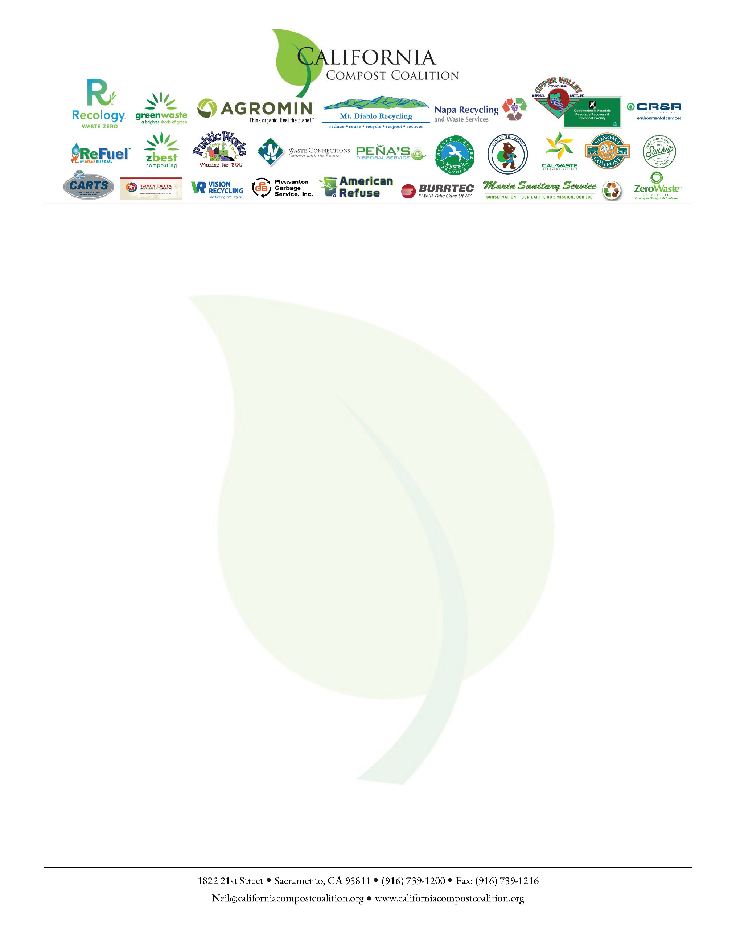

September 8, 2025
The Honorable Liane Randolph
California Air Resources Board Chair
California Air Resources Board
1001 I Street
Sacramento, CA 95814
RE: Support for the Repeal of Advanced Clean Fleets High Priority Fleets as applies to Waste Haulers Using Renewable Natural Gas (RNG)
Dear Chair Randolph,
On behalf of California Compost Coalition, I write in strong support of the repeal of the Advanced Clean Fleets rule as it applies to waste fleets running on renewable natural gas (RNG). This regulatory change will be critical in ensuring we can continue to be a carbon negative essential services and innovators.
The CCC is a statewide coalition of compost operators and organic material recyclers who work to promote sustainable organics recycling solutions. Our members include the state’s leading composting companies and waste haulers, some of whom are actively involved in anaerobic digestion projects that convert organic waste into renewable natural gas (RNG). We have been leaders in creating systems for source separation of waste organic material, preventing landfill methane emissions. Some of our members use that same material to make low-emission RNG to displace high emission diesel engines. Many of our members use RNG fleets supplied by other sources, a lower carbon-intensity source than diesel.
Regardless of the current fuel source, waste collection trucks provide an essential service enjoyed by every Californian. The massive investment that a conversion to zero emission vehicles would require would unavoidably be passed on to ratepayers. Organic waste collection and diversion, which is required by state law, is funded in most part by garbage collection rates. Anaerobic digestion projects can help offset these project costs, but only when they are allowed to fuel collection truck for the entire planned period. The ACF regulation, as it was written, would cause significant costs to be passed to every Californian. The proposed amendment would avoid this cost.
California is already struggling to meet the goals of SB 1383, our Short-Lived Climate Pollutant Reduction Strategy. There is not enough demand in non-agricultural areas for products created from diverted organic waste, such as compost. Our members help bridge that gap and reduce methane emissions by creating a product from diverted organics that can be used in urban areas – RNG.

We support CARB’s mission of reducing the state’s emissions, but we are best able to help achieve that goal when we can use our current trucks for our collection fleets. We urge the adoption of the proposed repeal of the High Priority Fleets section of the Advanced Clean Fleets regulation so that we can continue running our carbon-negative services.
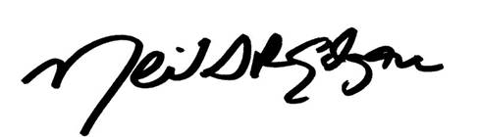
Sincerely,

Neil Edgar
Executive Director

California Compost Coalition

